

Sri Lanka Institute of Information Technology

Supermarket Management System

Final Report

Information Technology Project(IT2080)

2022

Group ID:WD_B02_ITP_03

Submitted by:

1. IT21006548 - Liyanage S.D.K
2. IT21004186 - Medawatta H.M.H.N
3. IT21002342 - Yapa D.G.A.B.S
4. IT21001802 - Panditharathne I.G
5. IT21446030 - Fernando W.C.S
6. IT21446108 - Fernando W.A.M
7. IT21060380 - Lakshan P.R.D
8. IT21050626 - Gamage A.G.R.U

# Declaration

# Declaration

This project report is our original work and the content is not plagiarized from any other resource. References for all the content taken from external resources are correctly cited. To the best of our knowledge, this report does not contain any material published or written by third parties, except as acknowledged in the text.

Authors:

|  |  |  |
| --- | --- | --- |
| Author SID | Author name | Signature |
| IT21006548 | Liyanage S.D.K | …………………. |
| IT21004186 | Medawatta H.M.H.N | Text, letter  Description automatically generated  …………………. |
| IT21002342 | Yapa D.G.A.B.S | Diagram  Description automatically generated  …………………. |
| IT21001802 | Panditharathne I.G | A picture containing text  Description automatically generated  …………………. |
| IT21446030 | Fernando W.C.S | Letter  Description automatically generated with medium confidence  …………………. |
| IT21446108 | Fernando W.A.M | A drawing on a white surface  Description automatically generated with low confidence  Text, letter  Description automatically generated…………………. |
| IT21060380 | Lakshan P.R.D | …………………. |
| IT21060626 | Gamage A.G.R.U | A picture containing text  Description automatically generated…………………. |

Date:………09/11/2022………………………….

# Acknowledgement

First and foremost, heartfelt gratitude to Mr.S.M.B Harshanath the lecturer for our group, for his constant support, as well as his patience, inspiration, dedication and extensive experience. Throughout the documentation and implementation of this project procedure, his counsel was crucial.

Aside from the advisor and our lecturer, special thanks to the rest of the lecture panel and the instructor’s panel for their help, insightful remarks, and challenging tasks.

And finally, a special thanks to the fellow group mates in the WD_B02_ITP_03 group who have supported from the beginning of this journey to success.

# Table Of Contents

Table of Contents

Declaration ii

Declaration ii

Acknowledgement iii

Table Of Contents iv

Table of Figures vi

List Of Tables ix

Chapter 1.Introduction 1

1.1.Problem and Motivation 1

1.1.1.Major Problems Supermarkets with manual systems are facing 1

1.1.2.Benefits of the System 2

1.1.3.Aim and Objectives 2

1.2.Product Scope 3

1.2.1.System Overview Diagram 4

1.3.System Functions 4

1.3.1.Stock and Inventory Management 4

1.3.2.Staff Management 5

1.3.3.Delivery Management 6

1.3.4.Marketing Management 6

1.3.5.Customer Management 7

1.3.6.Financial Management 7

1.3.7.Premises Management 8

1.3.7.Purchase and Sales Management 9

1.4.Non-Functional Requirements 9

1.5.Literature Review 10

1.6.Methodologies 10

1.6.1.Requirements engineering methods 10

1.6.1.1.Requirements elicitation and analysis 10

1.7.Object Oriented Design 11

1.8.Development tools and technologies 11

1.9.Testing methods 11

1.10.Gantt chart 12

1.11.Work Breakdown Chart 13

1.12.Project Report Structure 17

1.13.GitHub Repository Link 17

Chapter 2.Requirements 18

2.1.Functional Requirements 18

2.1.1.User Stories 18

19

19

19

2.1.2. Use Case Diagram of the System 20

2.1.3. Activity Diagrams 21

2.1.4.Sequence Diagrams 29

Chapter 3.Design and Development 37

3.1.ER Diagram 37

3.2.Class Diagram 38

3.3. High Level Architecture of the System 39

3.4.User Interfaces 40

3.4.1 Inventory and Stock Management 40

3.4.2.Sales and Purchase Management 46

3.4.3. Finance Management 50

3.4.4.Staff Management 53

3.5.5.Delivery Management 56

3.5.6.Marketing Management 61

3.5.7.Customer Management 69

3.5.8.Premises Management 72

Chapter 4.Testing 75

4.1.Stock and Inventory Management 75

4.2.Delivery Management 79

4.3.Marketing Management 83

4.4.Customer Management 87

4.5.Financial Management 92

4.6.Premises Management 96

4.7.Sales and Purchase Management 101

4.8.Staff management 106

Chapter 5. Conclusion 109

References 110

# Table of Figures

figure 1-System Overview Diagram 4

figure 2-Gantt Chart 12

Figure 0‑1-2.8.2 20

figure 4-Use Case Diagram of the System 20

figure 5-Activity Diagram for Store Items 21

Figure 0‑1-2.8.3 21

figure 7-Activity Diagram for Premises Management 22

Figure 0‑1-2.8.4 22

figure 9-Activity Diagram for purchase and Sales Management 23

figure 10-Activity Diagram for Generate Records 24

Figure 11-Activity Diagram for Manage Staff Members 25

figure 12-Activity Diagram for Making Order 26

figure 13-Activity Diagram for Entitle for Discounts and Promotions 27

figure 14-Activity Diagram for Customer Management 28

figure 15-Sequence Diagram for Store Items 29

figure 16-Sequence Diagram for Premises Management 30

figure 17-Sequence Diagram for Purchase and Sales Management 31

figure 18-Sequence Diagram for Generate Records 32

figure 19-Sequence diagram for Staff Management 33

figure 20-Sequence Diagram for Making Order 34

figure 21-Sequence Diagram for Entitle for Discounts and Promotions 35

figure 22-Sequence Diagram for Customer Management 36

figure 23-ER Diagram of the System 37

figure 24-Class Diagram of the System 38

figure 25-High Level Architecture of the System 39

figure 26-Home Page 1 40

figure 27-Home page with Item Selection Option 40

figure 28-Delivery and Pickup Information 41

figure 29-Items in Home page to Select 41

figure 30-About Us Section 42

figure 31-Footer 42

figure 32-Shopping cart 43

figure 33-All Items Page 43

figure 34-Update Item 44

figure 35-Report Generation 44

figure 36-All Items Page with Update and Delete Options 45

figure 37-Add Items 45

figure 38-Add Sales 46

figure 39-Add Purchases 46

Figure 40-Update Purchases 47

Figure 41-Update Sales 47

figure 44-Purchase Page 48

Figure 42-Generate Sales Report 48

figure 43-Sales Page 49

figure 45-Asset Report 50

figure 46-Add Assets 50

figure 47-Generate Assets Report 51

figure 48-Employee List Page 51

figure 49-Add Employee Details 52

figure 50-Calculate Net Income 52

figure 51-Admin Login Page 53

figure 52-All Staff Member Page with Update and Delete Option 53

Figure 0‑3-3.1.6 53

figure 54-Staff Generate report 54

figure 55-Staff Overview Page 54

Figure 56-Update Staff Member Details 55

figure 57-Add Staff Member Details 55

figure 58-Extended Shopping Cart 56

figure 59-Checkout Page 56

figure 60-Orders Overview Page 57

figure 61-Update Order 57

figure 62-Delete Order 58

figure 63-All Orders Page 58

figure 64-All Orders Page with Report Generation Option 59

figure 65-Orders Report Generation 59

figure 66-Track Order 60

figure 67-Coupons Report Generation 61

figure 68-All Coupons Page 61

figure 69-All Comments Page 62

figure 70-Marketing Dashboard Page 62

figure 71-Update Notice Page 63

figure 72-Delete Notice Confirmation 63

figure 73-Coupons Overview Page 64

figure 74-Coupons Page with Generate Report Option 64

figure 75-Add Notice 65

figure 76-All Notices Page 65

figure 77-Coupons Generate Report 66

figure 78-Coupons Page with Report Generation 66

figure 79-Coupons Overview Page 67

figure 80-Delete Coupon Confirmation 67

figure 81-Add Coupon 68

figure 82-Add Comments 68

figure 83-Delete Customer Confirmation 69

figure 84-Add Customer 69

figure 85-All Customers 70

figure 86-Update Customers 70

figure 87-Customers Overview Page 71

figure 88-Customer Report Generation 71

figure 89-Inspect Maintenance 72

figure 90-Add Maintenance 72

figure 91-Progress Maintenance 73

figure 92-All Maintenance 73

figure 93-Maintenance Overview Page 74

figure 94-Maintenance Generate Report 74

Figure 96-Add Items Success Message 77

Figure 95-Add Items Form Authentication 77

Figure 97-Update Success Message 78

Figure 98-Added Item fetched 78

Figure 99-Order Added Success Message 81

Figure 100-Checkout Page Name Authentication 82

Figure 101-Requested Format Authentication 82

Figure 103-Add Comment Name Authentication 85

Figure 102-Comment Submitted Success Message 85

Figure 104-Add Comment Email Authentication 86

Figure 105-Customer Added Success Message 90

Figure 106-Customer Adding Process 90

Figure 107-Phone Number Authentication 91

Figure 108-Password Authentication 91

Figure 109-Add Employee Form Authentication 94

Figure 110-Add Employee Phone Number Authentication 94

Figure 111-Employee Added Success Message 95

Figure 112-All Employee List 95

Figure 113-Insepect Maintenance Form Authentication 98

Figure 114-Maintenance Form Authentication 99

Figure 115-Maintenance Added Success Message 99

Figure 116-Manage Maintenance 100

Figure 117-Add Sales Form Authentication 103

Figure 118-Add Sales Id Authentication 104

Figure 119-Sales Added Success Message 104

Figure 120-Manage Sales Page 105

Figure 121-Staff Member Added Message 108

Figure 122-System Admin Login Authentication 108

Figure 0‑3-3.6.2 108

Figure 0‑4-3.6.2 108

Figure 0‑5-3.6.3Figure 0‑6-3.6.2 108

Figure 0‑7-3.6.2 108

Figure 0‑1-3.6.2 109

Figure 0‑2-3.6.3Figure 0‑3-3.6.2 109

Figure 0‑4-3.6.3 109

Figure 0‑5-3.6.4Figure 0‑6-3.6.3Figure 0‑7-3.6.2 109

Figure 0‑8-3.6.3Figure 0‑9-3.6.2 109

Figure 0‑10-3.6.3 109

Figure 0‑11-3.6.4Figure 0‑12-3.6.3 109

Figure 0‑13-3.6.4 109

Figure 0‑14-3.6.4Figure 0‑15-3.6.3 109

Figure 0‑16-3.6.4Figure 0‑17-3.6.3 109

Figure 0‑18-3.6.4 109

Figure 0‑19-3.6.4 109

Figure 0‑20-3.6.4 109

Figure 0‑21-3.6.4 109

# List Of Tables

Table 1-Work Breakdown Cha 16

Table 2-Inventory and Stock Management Stock Management 76

Table 3-Inventory and Stock Management Test Cases 76

Table 4-Delivery Management Test Cases 80

Table 5-Marketing Management Test Cases 84

Table 6-Customer Management Test Cases 87

Table 7-Financial Management Test Cases 93

Table 8-Premises Management Test Cases 98

Table 9-Purchase and Sales Test Cases 103

Table 10-Staff Management Test Cases 107

# Chapter 1.Introduction

## 1.1.Problem and Motivation

In supermarkets there are various activities going around in a single day. Many people are interacting with their services and many information need to be stored and managed in order to provide a satisficing service towards customers. This is a tedious task to be done using a manual system. With the improvement of online based services, it is crucial to manage the information and other service-related processes and information using an online based system.

With the inclinations of using automated systems for company’s activities, customer-based services have become very effective, reliable, accurate and safe. Therefor developing a system to manage all the tasks of supermarket is crucial. With the expansion of customers and service it is intricate to keep files, cabinets, and all other physical items to store data and it is not wise to take this sort of approach since it can raise security depravities. Many unauthorized personals can view and access data, and it is unable to analyze the past data since secrecy is not guaranteed to all information and data. The staff can face difficulties with storage, and it can raise a negative impact on the company’s good name. With given circumstances it is not easy to update, delete, and edit using manual methods.

Manual systems use considerable amount of paperwork and many human computational errors when entering and calculating data and the cost to maintain a company with a manual methods are very high and the time consumption to use manual methods are also high these sort of approach can cost a company its loss of profit as well.

### 1.1.1.Major Problems Supermarkets with manual systems are facing

Inventory loss

* The inventory and stock can be misplaced or lost due to mismanagement or lack of management in the system.

Time and storage consuming manual process

* With large amount of stocks, it can waste lot of quality time of staff and requires extra space to store the records.

Lack of efficiency and reliability of using manual system

* Comparing to automated systems manual systems can never achieve the efficiency and reliability of automated system.

Insufficient security

* The user access levels cannot be monitored using a manual system. Unauthorized access is possible. Sensitive data can be accessed by unauthorized users.

Data inconsistencies

* It is not possible to maintain a manual database with large number of staff and stock and inventory details.
* The risk of record discrepancy is substantially higher.

### 1.1.2.Benefits of the System

* Real – time data
* Availability
* 24/7 Availability of service
* Easy and Accurate
* Storing data and accessing them are more accurate
* Reduce Cost
* Less money needed than using a manual system and help in increasing the profit
* Data security
* Ease of Management
* Easy to manage day to day information
* Improve Effectiveness and reliability

### 1.1.3.Aim and Objectives

As a result of issues mentioned above, we have decided to develop an automated system for a supermarket. The system is robust, user friendly and simplifies day to day activities of the supermarket. The goal is to provide an effective standardization and efficiency secrecy to the supermarket, which will benefit when managing staff, stock, and registered customers. This system will store all the information about staff, registered customers and stock information and other company related information. This systems helps in managing lot of functions of a supermarket and suitable for automating financial management, marketing management, delivery management, maintenance management etc. This system allows registered customers to deliver items of their choosing to their doorstep. The system keeps list of all information about above functions and manage them with utmost surety. This system also manages databases to appropriate functions and keep track of all the necessary data and information.

## 1.2.Product Scope

This System will cover all aspects of supermarket management. This system will eliminate all the current flows and increase the productivity of the system by introducing more functions under single system. Inventory and stock will be managed by this system in an efficient manner. Keep track of all the information related to a product, its manufacturer distributor, buyer details, warehouse details, stock details, transport cost labor charges and all the information regarding stock and inventory. Financially this systems keeps track of revenue lost and profit details, billing, salaries and fund details all information needed in financial management. This system manages all the maintenance details of the supermarket under premises management. This system covers all the registered client information and staff information as well. This system allows registered customers to make online deliveries to their homes. And to promote the business this system will cover all the information and activities of marketing management. And manages all the details about security measures undertaken in the supermarket to provide a better and reliable service. This system consists of,

1. Stock and Inventory Management
2. Purchase and Sales Management
3. Financial Management
4. Premises Management
5. Delivery Management
6. Marketing Management
7. Staff Management
8. Client Management

### 1.2.1.System Overview Diagram

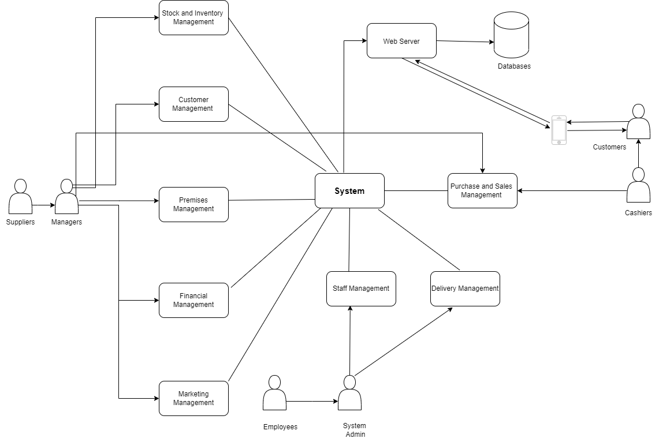

figure -System Overview Diagram

## 1.3.System Functions

### 1.3.1.Stock and Inventory Management

Stock and inventory management mainly based on managing all the items in a supermarket. This basically stores information about stocks and other related information. System Admin and Supermarket manager are responsible for managing this information and updating it whenever necessary. The System admin and manger can Add, Delete, Update, and view all the information regarding stocks. All items are gets serial numbers before stocking them in shelfs this will help in what gets sold through registers. All registered and unregistered users can view the stocks available to sell at the moment and registered customers can order items via application. Also, there are some safety stocks for emergency purposes. In order to add stocks to the list there should be some information needed to save in the database of that particular item. Adding Bar code to each item manages the database when items get sold. [1]

* Item type
* Item ID
* Serial number
* Item Serial Number
* Expire date
* No of Items bought
* No of Items returned
* Price
* Wight / volume
* Date and time when stocks received

In addition to these information there can be some directly related information stored under this function. Whenever there is new stock arrival admin or manger should update the details. In addition to these details system should store information about departments those stocks belong and categories them under each department. And some items like vegetables and fruits can be packed and sell as packages. And keep details about remaining stocks and out of them how many items can be put up to sell for upcoming months, how many waste items are there (non – usable) such as rotten fruits and vegetables and meat etc. At the end of the month Store manager or System Admin Generate the Stock report for that particular month. Some additional information can be saved under stock management. [2]

* No of departments
* No of items reserved as safety stock
* Stock shelf information
* Applying bar codes to the items
* Packaged items
* Waste products
* Remained items from previous month
* Theft items

### 1.3.2.Staff Management

Staff management means otherwise Human Resource management. Mainly, Staff Management Considered How to Help Staff Manage Their Workload and Achieve the Goals of the Company.

Staff Member Has to Enter Staff ID and Password. Therefore, System Can Prevent Unauthorized Access. If Not in the Already Staff Member, You Have to Register to the Grocery System. When Staff Member Registering System, System Admin Has to Get Following Details from the Staff Member. [3]

• First Name

• Last Name

• Date of Birth

• Contact Number

• Email Address

• Home Address

• Staff Member Type

• Staff Member Position

If Staff Member New to the Company, Staff Member Should Enter as Trainer. After Ending 1 Month, Grocery System Shows Upgrade to The Permanent.

If You are in the Trainer Period, You Get a Basic Salary Only. After End of Trainer Period, Staff Member Want to Resign from The Company. Therefore, System Remove Staff Member in System. Not Only That, but Staff Member also Wants to update in Trainer Statue to Permanent Statue System Can Update It.

After End of The Month, System Will Generate Report in Each Staff Member’s Account. Report Has Total Number of Working Days in the Month and Salary. [4]

### 1.3.3.Delivery Management

First, the customer has to register to the system by giving the following details.

* ‌First name
* ‌Last name
* ‌username
* ‌email
* ‌password

Customer is able to browse through the content. The customer can add items that he/she wishes to purchase into the shopping cart. The customer can proceed with the payments once he/she decides to Purchase an item.

The payment is made by the following details:

* ‌payment method
* promo code
* ‌phone number

The customer's order status will be displayed also allowing it to be tracked. The customer can Cancel the order within 15 minutes from the time the purchase was made, and the customer will be prompted with an error message upon clicking the 'Cancel order' button after 15 minutes. If any delays occur with the delivery, the customer will be notified through a text message. The estimated delivery time will be updated accordingly

### 1.3.4.Marketing Management

Customer management is an important function of the supermarket management system. Customer should register to the system so that he can get a better shopping experience. And also, the supermarket can provide them a better service . Supermarket provides special discounts and promotions for their registered customers.

First the customer should create an account by providing a username and a password. Then he should register to the system by providing his

* First Name
* Last Name
* Email Address
* Phone Number
* Home Address

Already registered customers can log in to the system by giving their username or email address and the password .

Customer management admin can view all the customer details in the system . He can add  customers to the system and update customer details in the system . He has the right to remove or block customers from the system. Then he generates the report of the customer. [5]

### 1.3.5.Customer Management

Customer management is an important function of the supermarket management web application. Customer should register to the system so that he can get a better e shopping experience and the supermarket management can provide them a better service. First the customer should register to the system by giving the [6]

* First name
* Last name
* Email address,
* phone number

Customer should create his account by providing his username and a password.

Already registered customers can log in to the system by giving their username or email address and the password . Customer management administrator can view all the details of the customers registered to the system . He can update customer details. System admin can view all the customer details so that he can find out the total number of customers registered to the system. He has the right to delete or block  customers from the system [7]

### 1.3.6.Financial Management

Financial management is the main division in any organization. It’s prioritized mainly the activities of a firm are one of the most heavy and complex activities. In order to focus on them, the management performs all the necessary activities. There are key principles in financial management. Some of them are Market prices reflect information, Risk return trade off, Cash flows are source of values, Individuals respond to Incentives and Money has time value. Based on these principles, management can take decisions such as,

* + - Allocation of Funds
    - Profit planning
    - Raising of Funds
    - Understanding capital markets.

Following these actions will affects the profitability, Growth, and wellbeing of the organization. And also, it’s important to maintain a good balance between equity and debt. Once the funds are raised through different sources and sells, the next important function to execute is allocate the funds in a proper manner. [8]

To handle all the insights, Managers receives admin privileges in the system. First, they need to access the finance directory through root directory. In order to login, managers have to enter their Staff Id and password as the login credentials. Accessing to the system will authorize to make changes in the system. The system generally creates reports regarding to the customers transactions and keeping records of sells invoice.

* Calculate the net profit at the end of month.
* Keeping reports of staff member’s salary sheets
* Keeping records of fixed assets.
* Keeping records of income statements and cash flow statements.

At the end of the month, A full report will generate for future analysis.

### 1.3.7.Premises Management

Premises management ensures that it manages company premises and equipment in an efficient, and compliant way. Maintenance and smooth running of premises uses are mainly managed by Premises Management. [9]

The manager is stands for ensuring relevant risk assessment are conducted and for reporting to the department .

The manager has to register to the system by entering Staff ID and Password.

When the manager discovered about inspected issues following details should be stored and analyze by the manager for a better maintenance.

* inspected issue.
* inspected area or item.
* inspected date.
* maintenance work routine.
* replacement and upgrades.
* estimated date of maintenance.

The site manager responsible for inspecting and maintaining the company premises, assign maintenance workers to inspected maintenances, notify managers about maintenance, generate monthly report on done maintenances details, and update maintenance routine progress. [10]

### 1.3.7.Purchase and Sales Management

This functionality manages all the information of sales details and purchasing items of the company. This function also allows us to keep track of our supplier details such as supplier type (large scale / small scale), products we purchase, and the quantity purchased. And the admin will be able to update, delete suppliers and to add by giving the following information:

* Supplier ID.
* Name.
* Type (Large scale / small scale).
* Product.

This function provides sales reports and purchase reports to monitor both income and expenses of the company such as costs, number of items sold, total sales of each item, with keeping track of all the sales records and the expenses of the company and with provided sales reports and income reports the company to identify unnecessary expenses and get rid of them by helping the company to maximize profit as well as to deliver the best possible value to customers. This allows us to keep track of all the sales made products sold in which quantity. The admin will be able to update, delete sales information and to add by giving the following information: [11]

* Date.
* Product.
* Customer.
* Quantity.

## 1.4.Non-Functional Requirements

Security

* the initially proposed system consists of a cheque system where the clients can pay their bills and the security of these payment details should be handled by keeping them secured all the confidential data should be able to access by authorized personals only.

Reliability

* the system should be able handle all the business operations without performance lack. Managing all business operations under given conditions without any constant repairs.

Scalability

* If the client is expanding their business, it is important to increase the performance parallelly to the expansion performance should not be decreased with the demand.

Availability

* the system should be able to access at anytime from anywhere around the world and the system should not fail while operating. Maintaining the system often could lead to client unsatisfaction and can cost the process.

Ease of use

* The Client will be able to use it even without the help of expertise. Should be easily manageable and understandable.

Speed

* The responsiveness of the system is crucial if the system is too slow or lagging too much client will not be happy about the outcome and it will cost lot of money to take it back to where it is supposed to

## 1.5.Literature Review

The main objective of building this system is to mange the inside functions in a supermarket in an efficient way when looking at other retail companies like Walmart and Ikea and local companies such as keels super and Arpico, the main strategy that affects all of those businesses is inventory management and buying and selling. Like Walmart our main concern should be keeping a small margin between buying and selling rates and sell more items. This could help us in high foot fall, quick stock movement which will benefit in adding more fresh , new items to the shop and adding more new products to the store. We will also be planning on allowing customers to self-weighing the grocery items when purchasing specially vegetables, fruits meat and fish. So, this will reduce number of staff members need to be assigned for that task which will helps us in reducing the operating cost. When buying products to the store buy the products directly from the manufacturer also going to save us some money. With keeping less margin when tagging the prices will increase in selling more products which will leads to buying more products from the supplier which will benefit in when bargaining. This will help us in increasing fast moving products in the store, also

Use discounts and offers method to attract customers to buy slow and non-moving inventory and use package offer method by attaching fast moving products with slow or non-moving targets. Since we are building a supermarket management system, large and complicated systems like in Ikea and Walmart wound not be suitable for the system we are about to build. But there are common processes that are similar to each systems, such as managing inventory and using methods to attract more customers, cutting unnecessary maintenance costs off. [12] [13] [14]

## 1.6.Methodologies

## 1.6.1.Requirements engineering methods

### 1.6.1.1.Requirements elicitation and analysis

All the requirements for this system were found by observing existing systems and we are aiming to build fully functioning Supermarket managements system with highest reliability and efficiency.

Requirements specification

* User stories
* Use case diagram
* Activity diagram

### 1.7.Object Oriented Design

#### 1.7.1.Structural Models

* Class Diagram

#### 1.7.2.Dynamic models

* Use case diagram
* Activity Diagram
* Sequence diagram

draw.io use as the tool to design these diagrams

## 1.8.Development tools and technologies

MERN Stack (MongoDB, Express, React, Node)

* MongoDB – document database (cloud Database)
* Express.js – Node.js web framework (Back end)
* React.js – a client-side JavaScript Framework (Front end)
* Node.js – the premier JavaScript web server (Back end)
* Development IDE – Visual Studio Code

## 1.9.Testing methods

* Integration testing
* System Testing

## 1.10.Gantt chart

figure -Gantt Chart

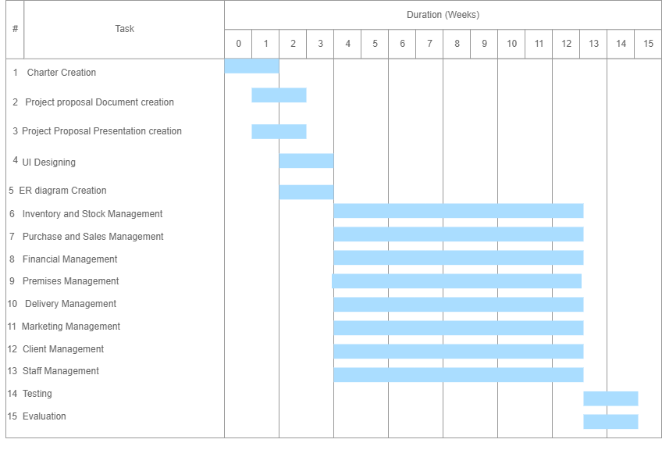

## 1.11.Work Breakdown Chart

|  |  |  |
| --- | --- | --- |
|  | **Student ID & Name with initials** | **Brief Description of the Function** |
| 1 | IT21006548 Liyanage S.D.K | **Inventory and Stock Management**   * **Add** stock details, stock sample details of every item. * **Update** stock and inventory details, update the current stock details according to remaining amount * **Delete** unwanted records of stocks and inventory. * **Retrieve** all the information about sold stocks and remaining stocks * Generate monthly **report** of stocks and inventory according to sales details. |
| 2 | IT21002342 Yapa D.G.A.B.S | **Purchase and Sales Management**   * **Add** suppliers to the system * **Update** supplier information and supply information * **Delete** resigned suppliers form the system. * Generate supplier details and supply details **report** every month * **Retrieve** all supplier and supplied items details monthly |
| 3 | IT21060380 Lakshan P.R.D | **Staff Management**   * **Add** staff members to the system, * **Update** staff member details when a staff member leaving the company or joining the company * **Delete** non existing staff members from the system * Generate monthly **report** of staff   Details   * **Retrieve** all the existing staff information monthly |
| 4 | IT21050626 Gamage A.G.R.U | **Customer Management**   * **Add** registered customers to the system * **Update** customer information * **Delete** customers from the system * **Generate** customer details report * **Retrieve** all existing customer information monthly |
| 5 | IT21446030 Fernando W.C.S | **Delivery Management**   * **Add** drivers and vehicles to the system * **Update** driver and vehicle details * **Delete** resigned drivers and vehicles from the system * **Generate** monthly driver and vehicle report * **Retrieve** driver and vehicle details monthly |
| 6 | IT21004186 Medawatta H.M.H.N | **Financial Management**   * **Add** staff member salary records * **Update** staff member salary records * **Delete** resignedstaff member salary records * Calculate monthly salary and **Generate** Staff member salary details reports * **Retrieve** Staff member salary information monthly |
| 7 | IT21001802 Panditharathne I.G | **Premises Management**   * **Add** maintenance and maintenance workers * **Update** maintenance details * **Delete** completed maintenance * **Generate** monthly done details report * **Retrieve** all the maintained details reports monthly |
| 8 | IT21446108 Fernando W.A.M | **Marketing Management**   * **Add** promotion notices and points to the system * **Delete** promotion notices and points from the system * **Update** points and notices * **Generate** reports on promotion details * **Retrieve** all the details about given promotions and discounts monthly |

Table -Work Breakdown Cha

## 1.12.Project Report Structure

Rest of the report contains six main sections where more furthermore detailed sub sections included.

1. Requirements

stakeholder analysis, requirement analysis, requirements modeling

1. Design and Development

Diagrams of components, processes, workflows, databases, and development aspects.

1. Testing

Test cases and results

1. Evaluation and Conclusion

evaluate with test results and/ or user/expert feedback. Conclude how the objectives met ad the aim is achieved.

1. References

All the source materials used when creating report include in here.

1. Appendixes

All the additional information regarding the project is included here. More test results and selected code

## 1.13.GitHub Repository Link

<https://github.com/SLIITITP/y2_s2_wd_it_02-itp2022_s2_b02_g17>

# Chapter 2.Requirements

## 2.1.Functional Requirements

### 2.1.1.User Stories

As a system admin I want to predict and forecast the demands of the products that we sell so I can avoid losing money from products being out of stock or spending too much money on excess stock.

As a Financial Manager I want to analyst income and cash flow statements, so that I can identified potential investment opportunities to invest the capital.

As a Financial Manager I want to keep tracking the external financial statements such as balance sheets, statement of stockholder’s equity. So that I can ensures that the organization has sufficient cash to meets its short-term operating costs.

As the manager I want to store the stocks in a Organizable manner so that customers will not spend too much time on looking for items and products they are looking for

As a system admin I want to add a new sale record to the sales records to get a total sales of each item and number of items sold.

As a system admin I want to add a new product and a new supplier to our company so we can offer different choices and more products for our customers.

As a System Admin, I Want to Add Submission Links and Countdown for Workers to Submission Their Daily Works So that I Can Measure Who Most Efficient Worker in the Company.

As a System Admin, I Want to Add Staff Members to the System So that I can Easily Generate Reports in Each Staff Member.

As a customer service manager, I want to add every registered customer to the system so that I can give them a better customer service.

As a customer, I want to log in to the web application so that I can get a better e shopping experience in the supermarket.

As an admin, I want to notify customers about any delays with their orders so that I can maintain a good relationship with the customers and avoid any further inconveniences.

As a customer, I want to see the estimated time for order to arrive, so that I can manage my schedule accordingly

## 

As a site manager, I want to notify managers about maintenance so that I can take action to keep the maintenance process efficient.

As a site manager, I want to assign maintenance workers to inspected maintenances so that I can conduct the workers to the repairs and maintenance, and it can be done well.

## 

As a Customer, I want to use the text messaging medium so that I can have a direct and instant conversation with a Customer Care agent without having to wait on hold in case the line is busy

As a Customer Care Agent, I want to provide replies to customer comments and reviews so that I can acknowledge their feedback and maintain good customer relationship

### 2.1.2. Use Case Diagram of the System

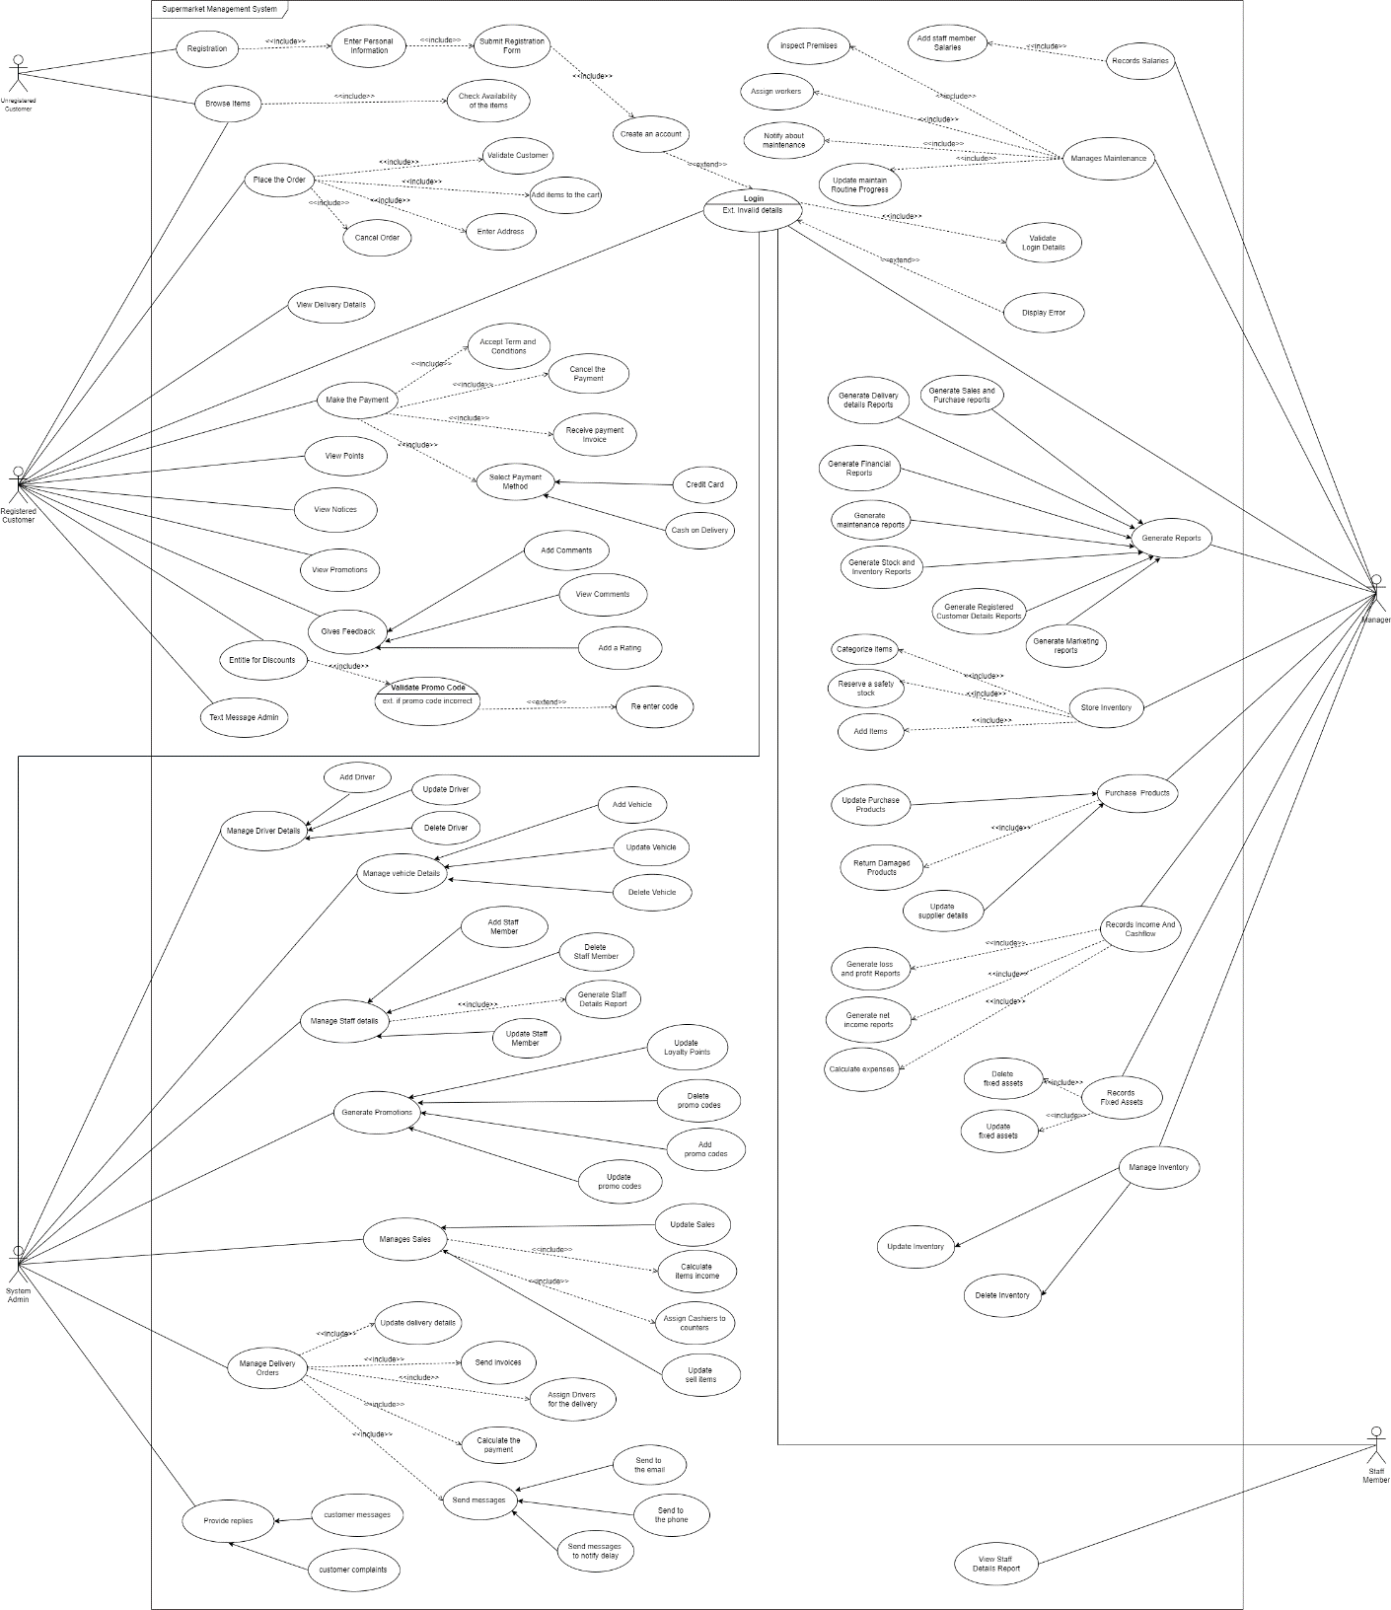

Figure ‑-2.8.2

figure -Use Case Diagram of the System

### 2.1.3. Activity Diagrams

#### 2.1.3.1 IT21006548 – Liyanage S.D.K

figure -Activity Diagram for Store Items

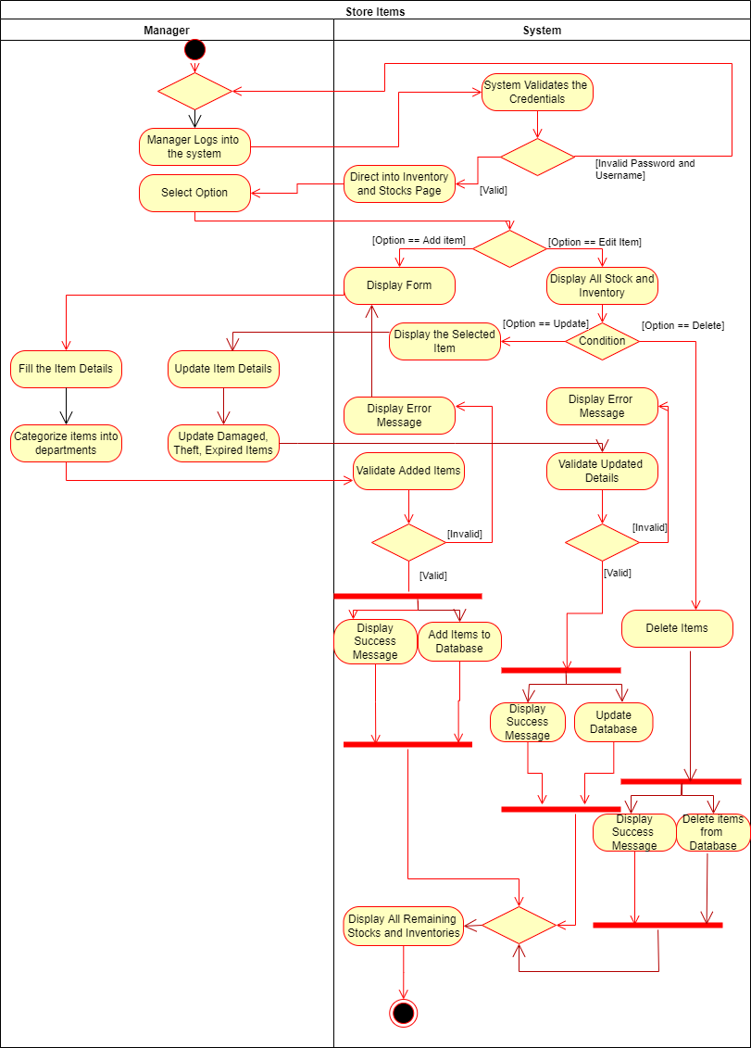

Figure ‑-2.8.3

#### 2.1.3.2. IT21001802 – Panditharathne I.G

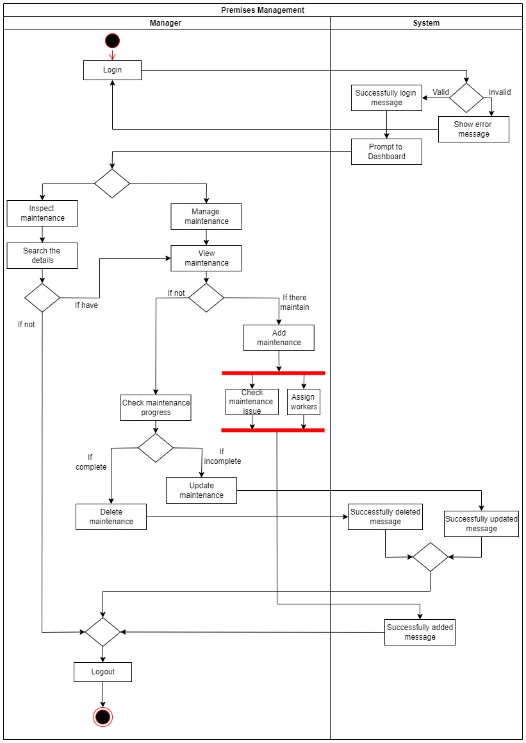

figure -Activity Diagram for Premises Management

Figure ‑-2.8.4

#### 2.1.3.3 IT21002342 - Yapa D.G.A.B.S

figure -Activity Diagram for purchase and Sales Management

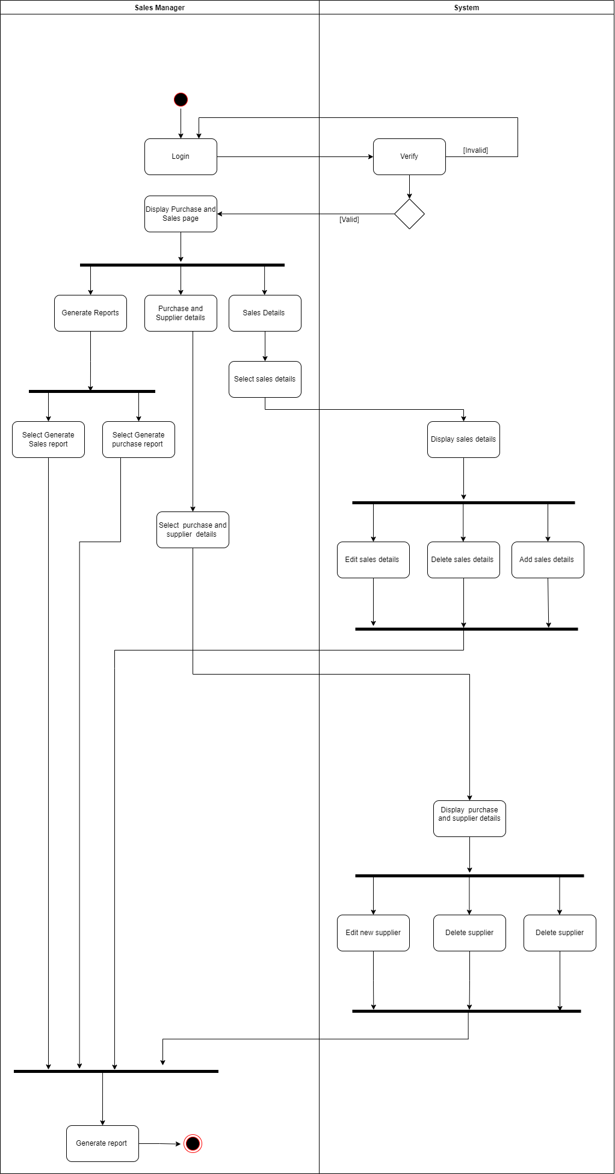

#### 2.1.3.4. IT21004186 – Medawatta H.M.H.N

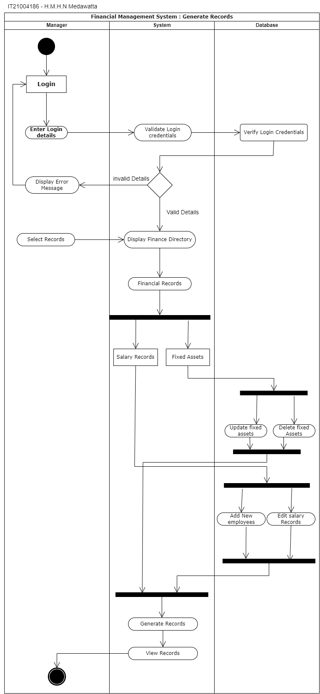

figure -Activity Diagram for Generate Records

#### 2.1.3.5.IT21060380 - Lakshan P.R.D

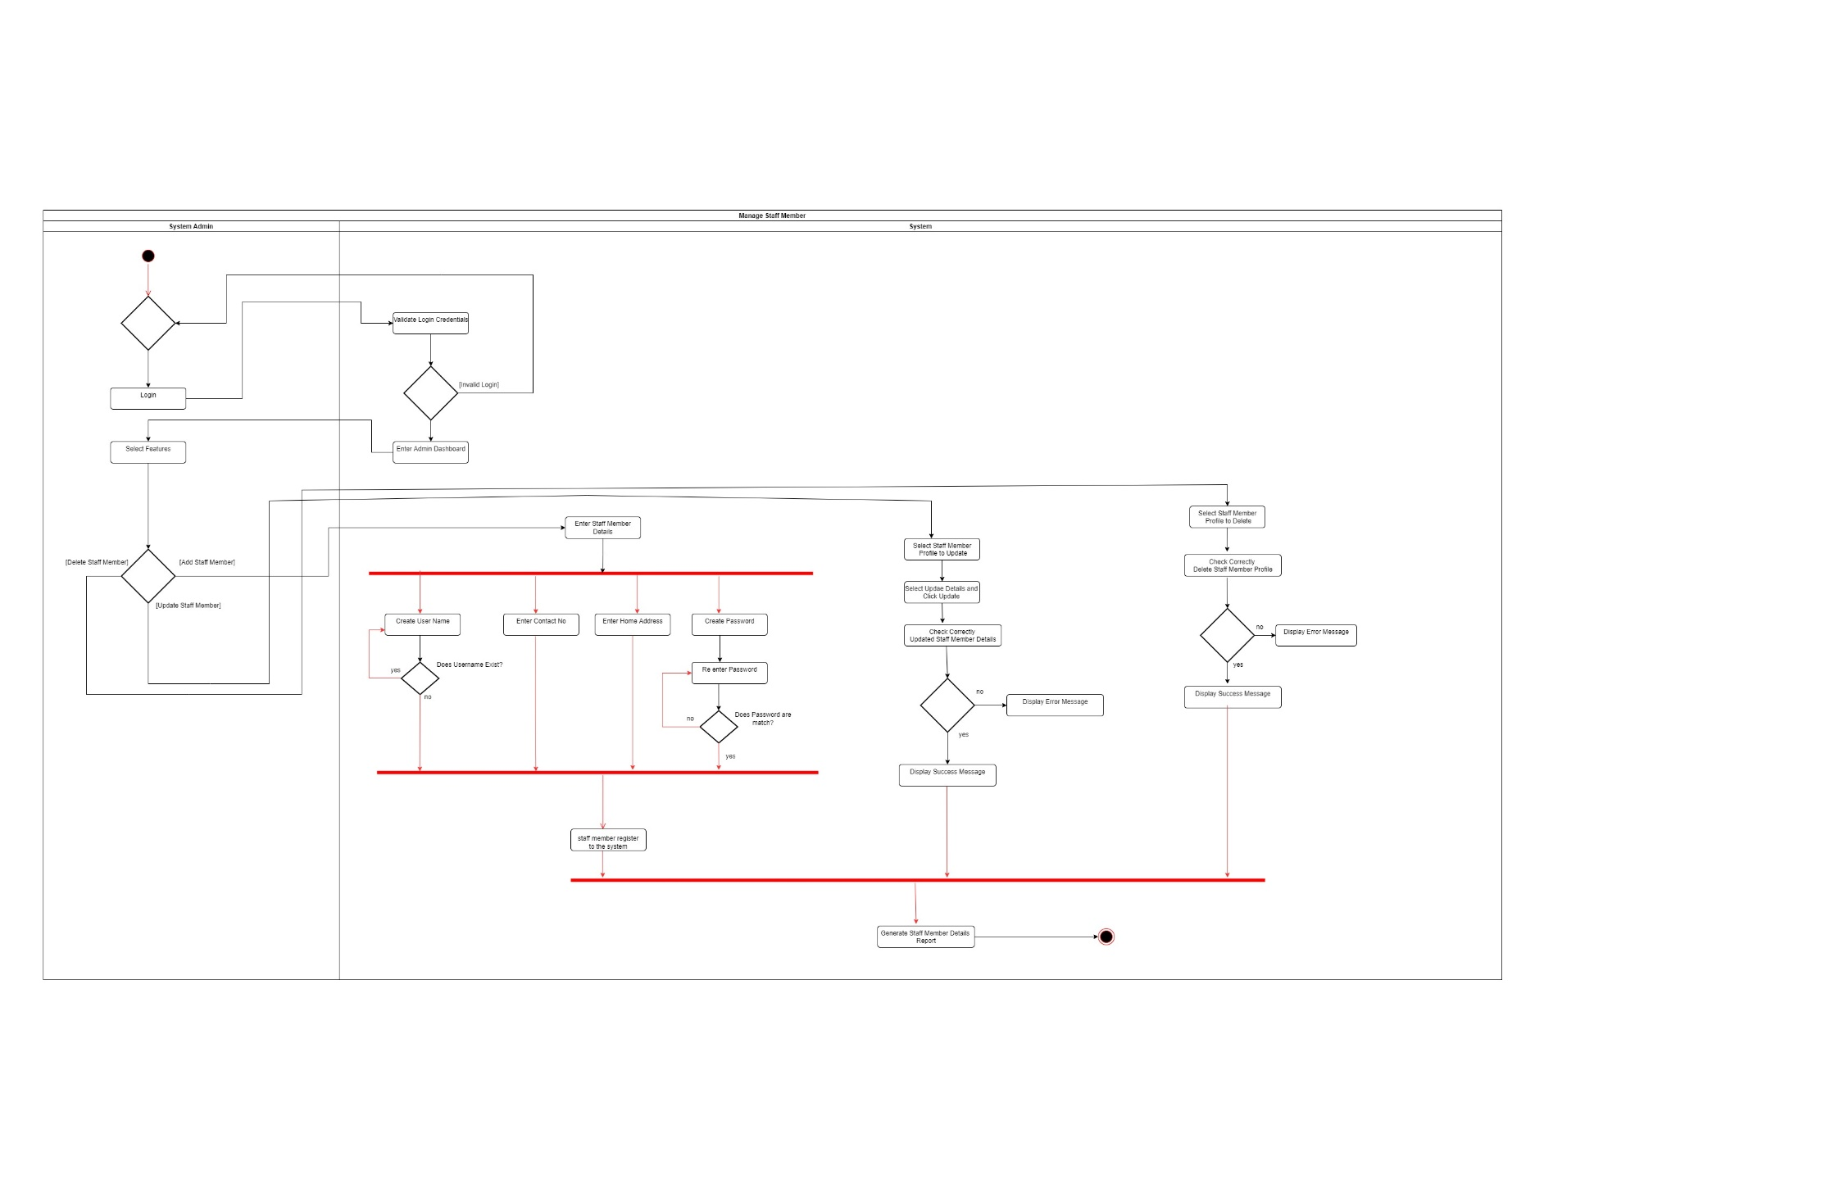

Figure -Activity Diagram for Manage Staff Members

#### 

#### 2.1.3.6.IT21446030 - Fernando W.C.S

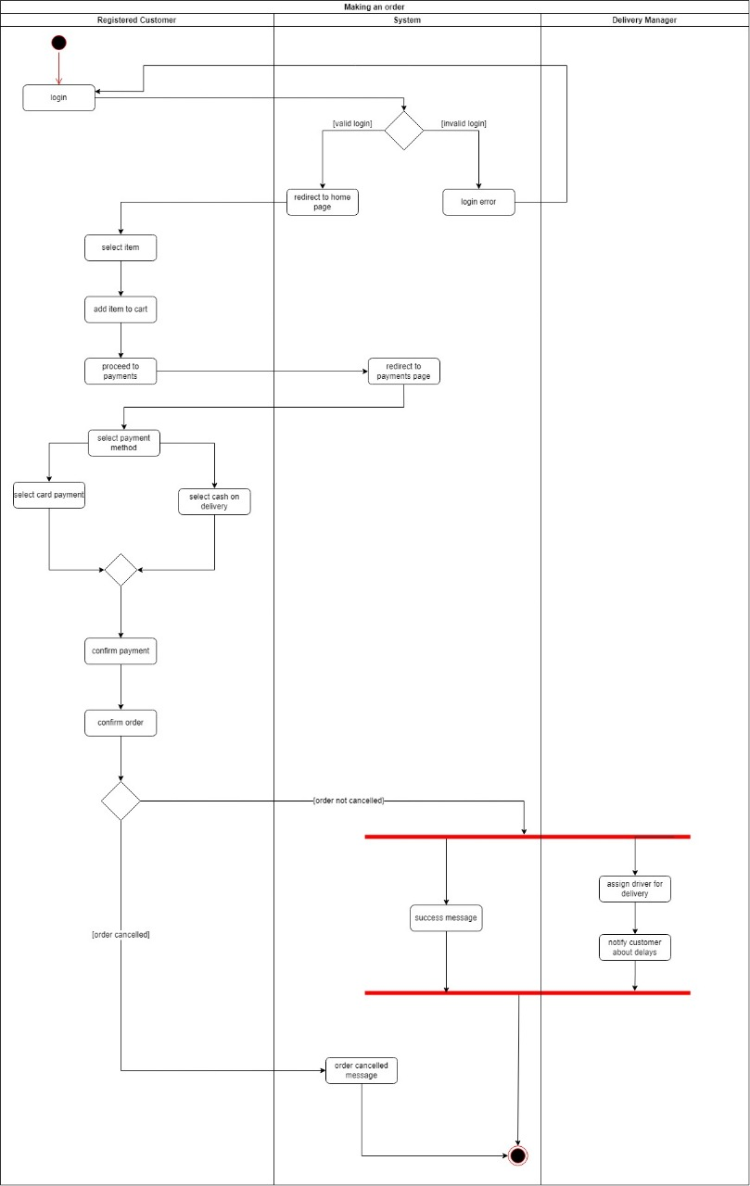

figure -Activity Diagram for Making Order

**2.1.3.7.IT21446108 - Fernando W.A.M

figure -Activity Diagram for Entitle for Discounts and Promotions

#### 2.1.3.8.IT21050626 - Gamage A.G.R.U

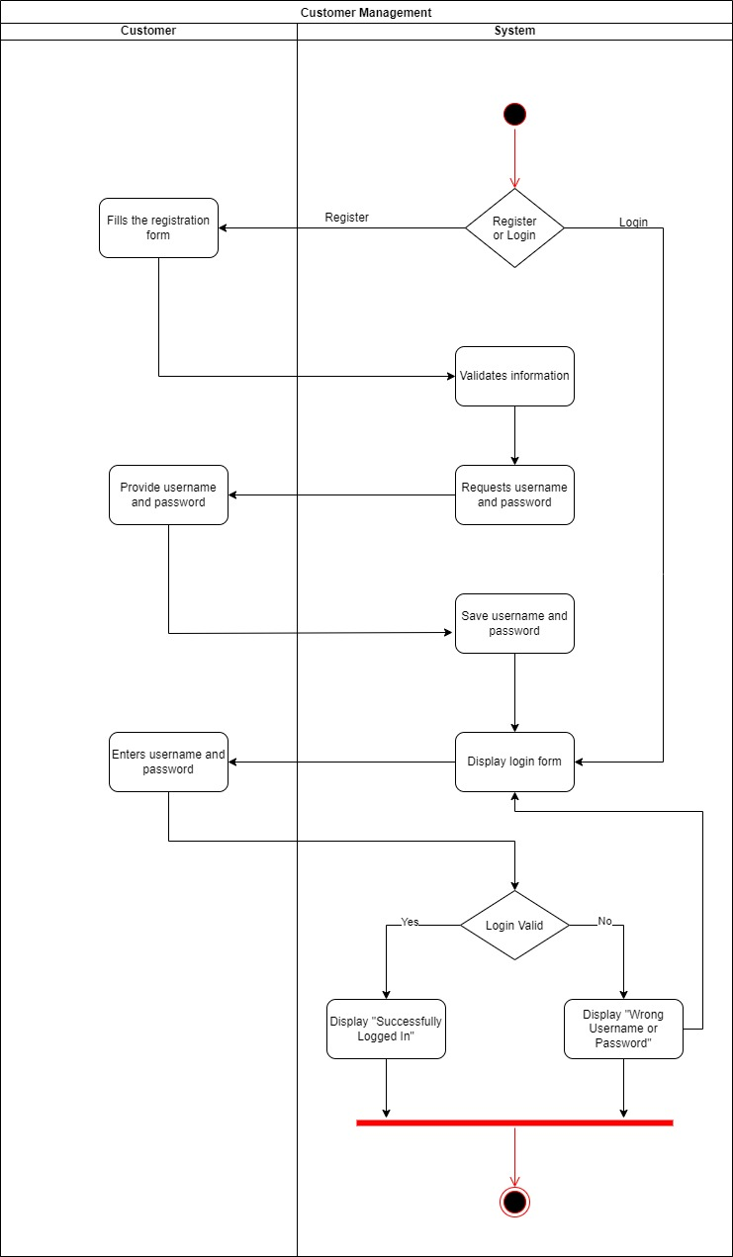

figure -Activity Diagram for Customer Management

### 2.1.4.Sequence Diagrams

#### 2.1.4.1.IT21006548 – Liyanage S.D.K

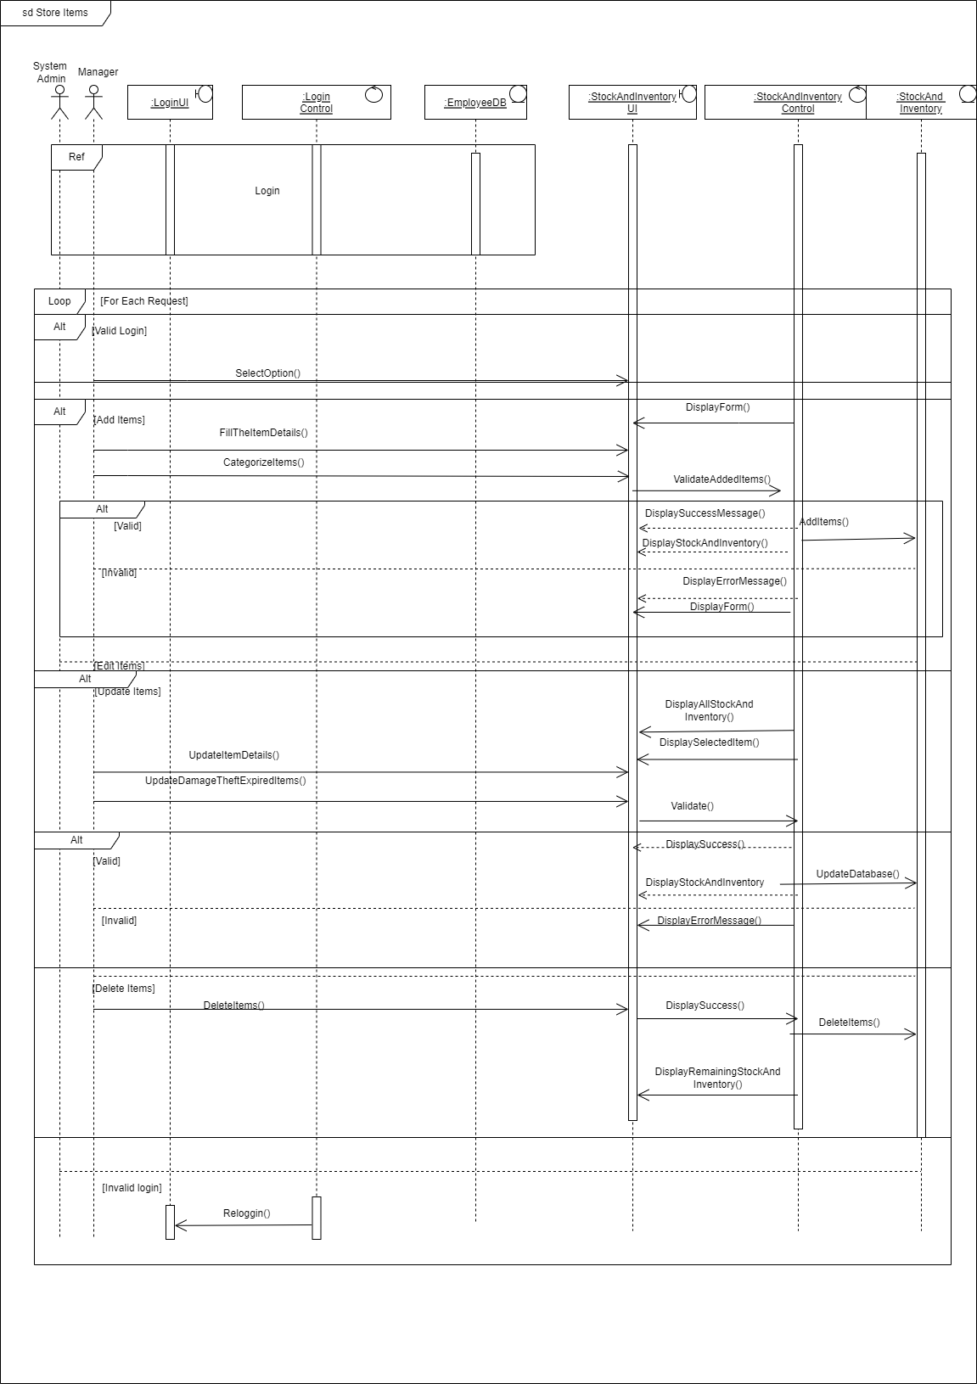

figure -Sequence Diagram for Store Items

#### 2.1.4.2.IT21001802 – Panditharathne I.G

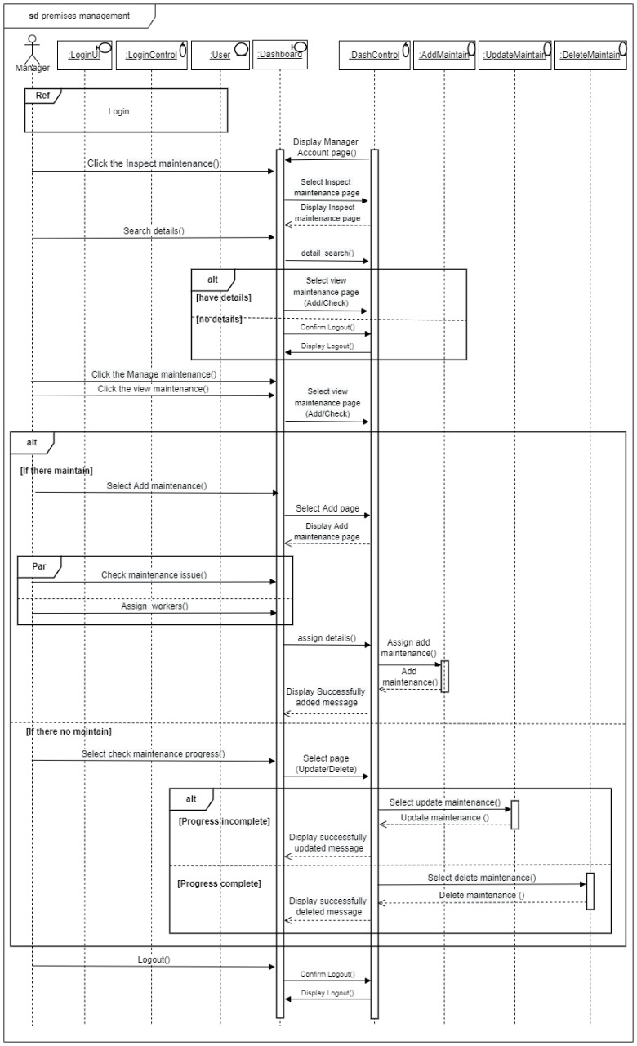

figure -Sequence Diagram for Premises Management

#### 2.1.4.3.IT21002342 – Yapa D.G.A.B.S

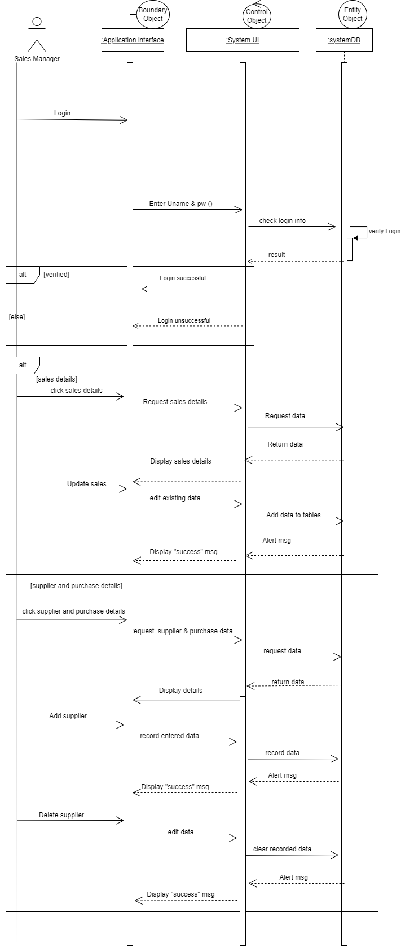

figure -Sequence Diagram for Purchase and Sales Management

#### 2.1.4.4.IT21004186 – Medawatta H.M.H.N

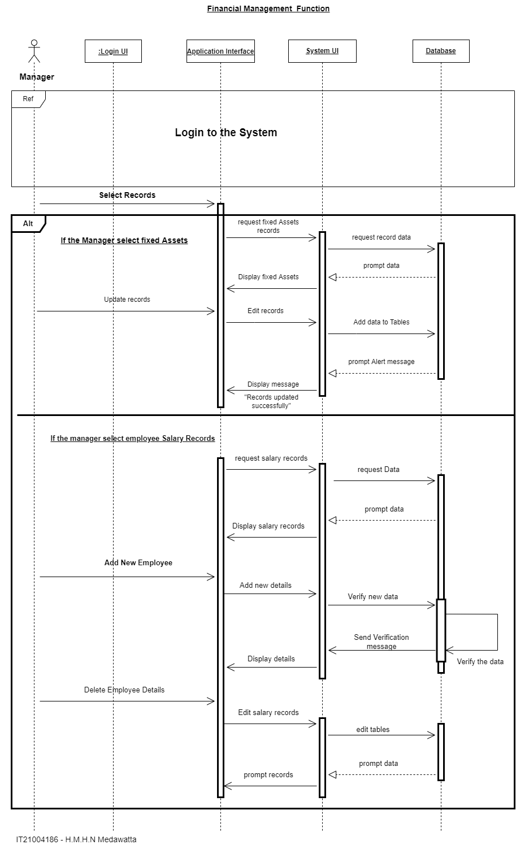

figure -Sequence Diagram for Generate Records

#### 2.1.4.5.IT21060380 - Lakshan P.R.D

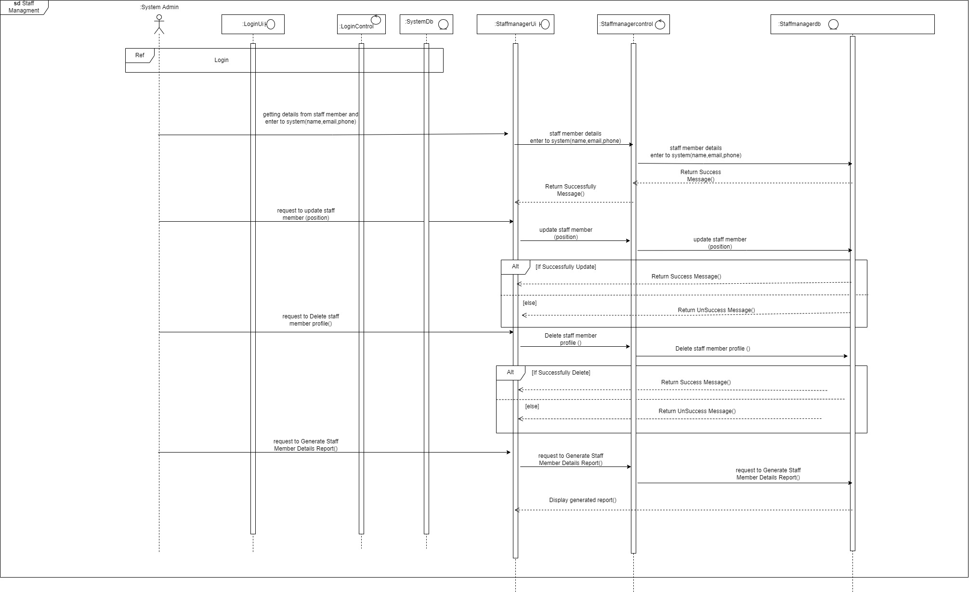

figure -Sequence diagram for Staff Management

#### 2.1.4.6.IT21446030 - Fernando W.C.S

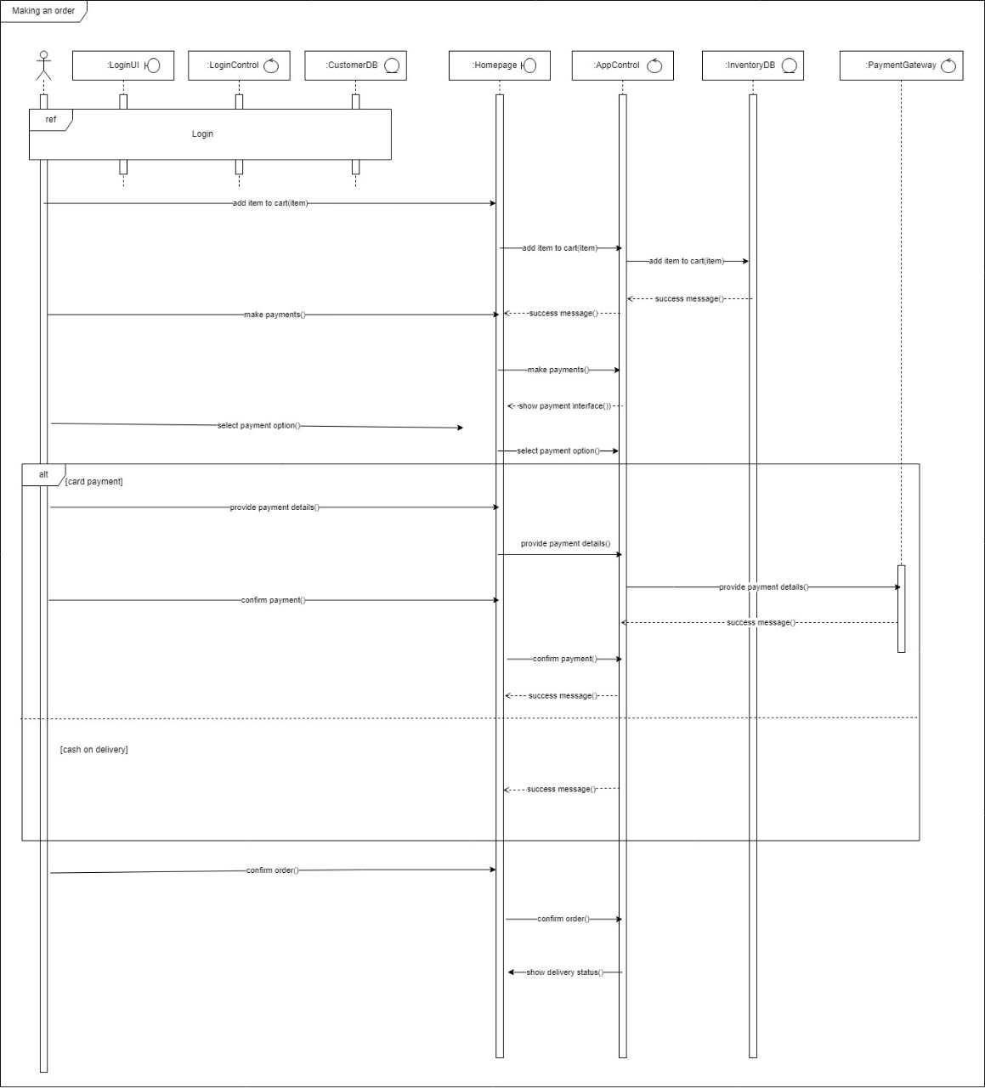

figure -Sequence Diagram for Making Order

#### 2.1.4.7.IT21446108 - Fernando W.A.M

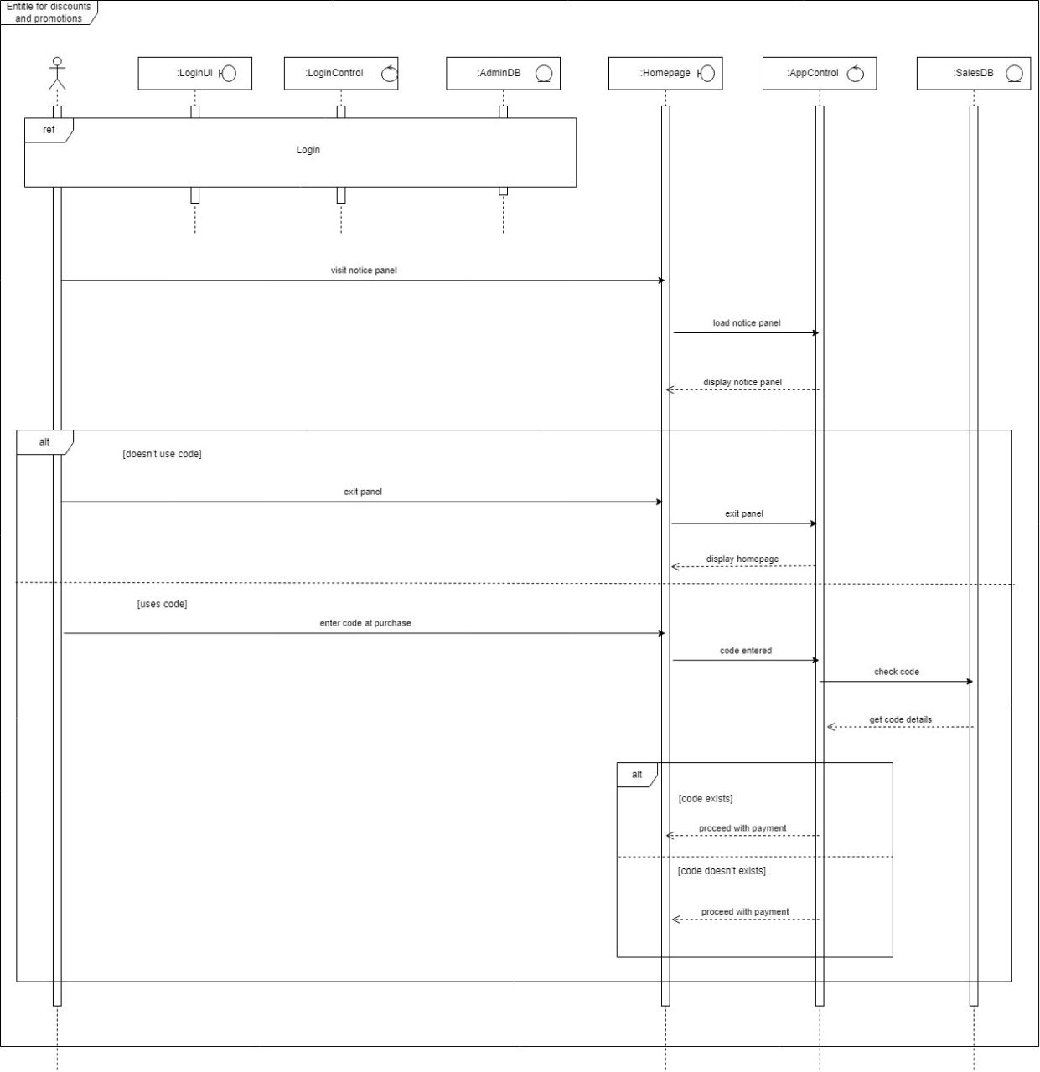

figure -Sequence Diagram for Entitle for Discounts and Promotions

#### 2.1.4.8.IT21050626 - Gamage A.G.R.U

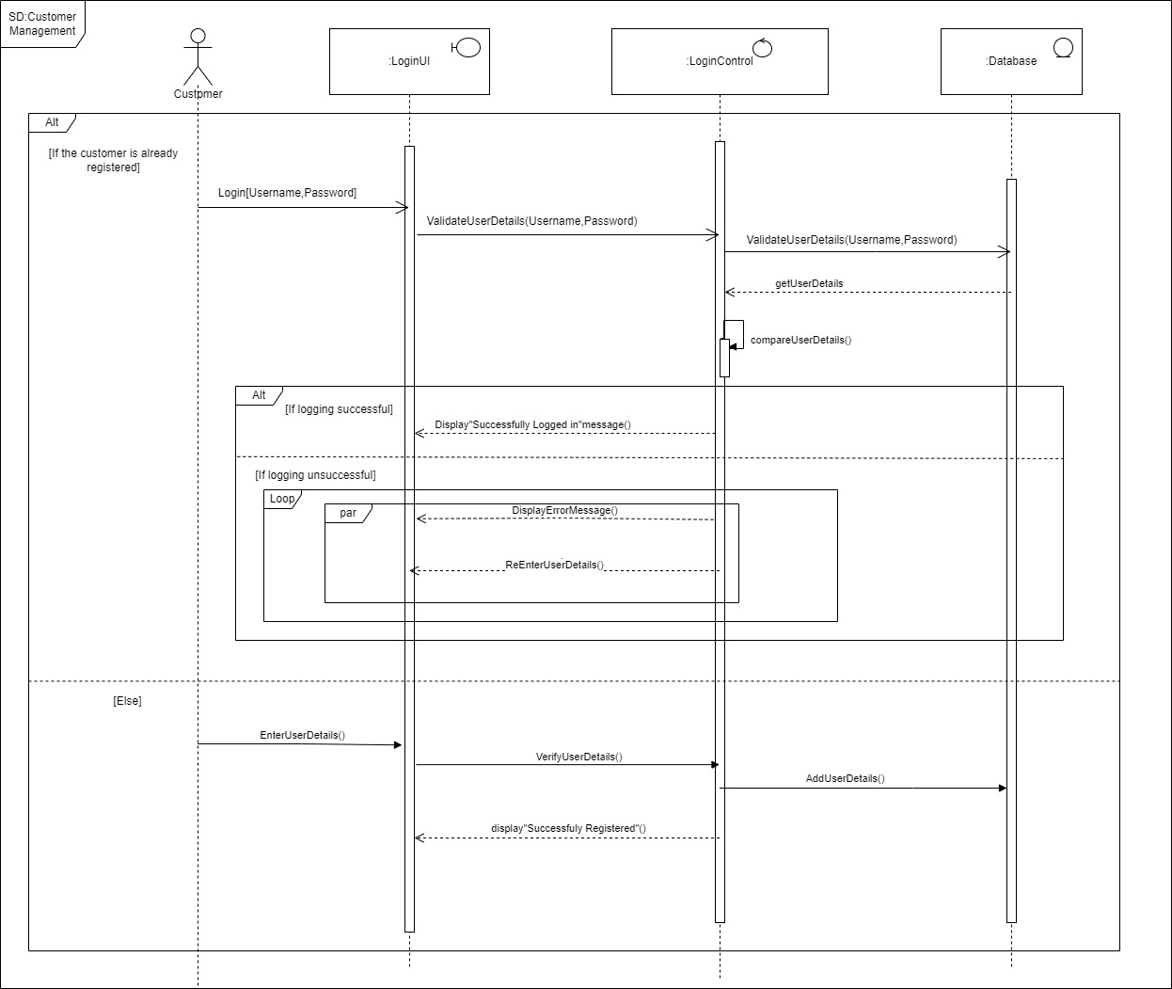

figure -Sequence Diagram for Customer Management

# Chapter 3.Design and Development

## 3.1.ER Diagram

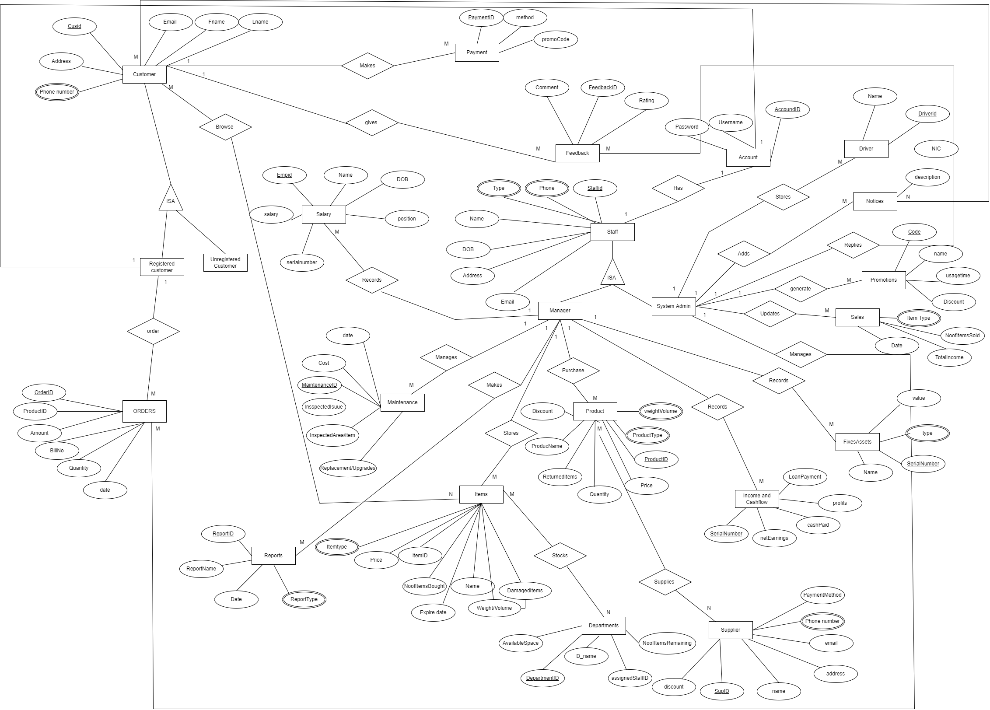

figure -ER Diagram of the System

## 3.2.Class Diagram

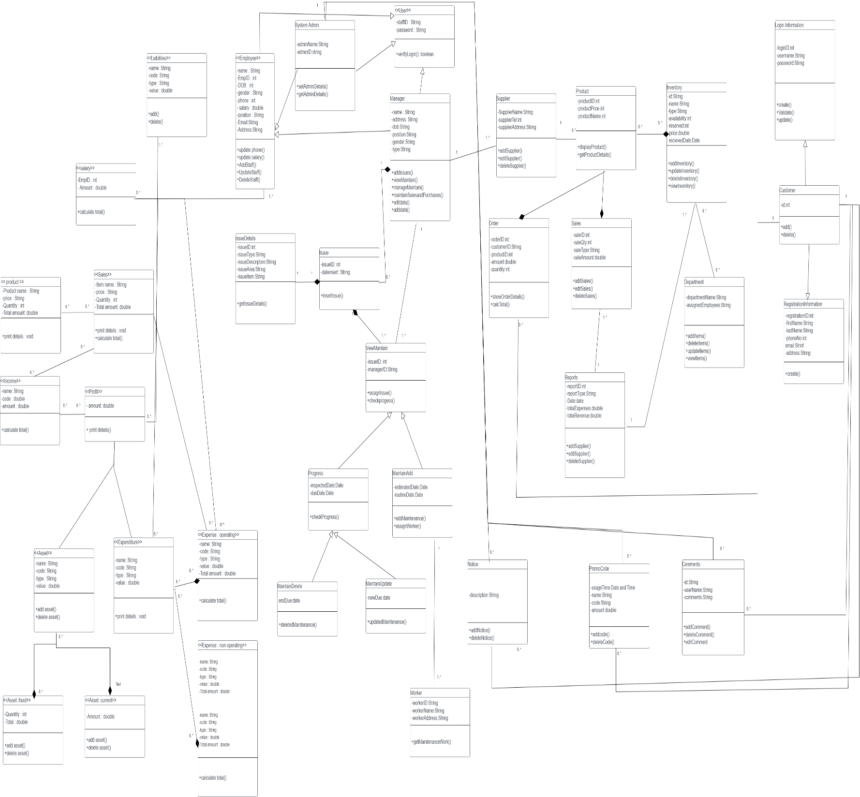

figure -Class Diagram of the System

## 3.3. High Level Architecture of the System

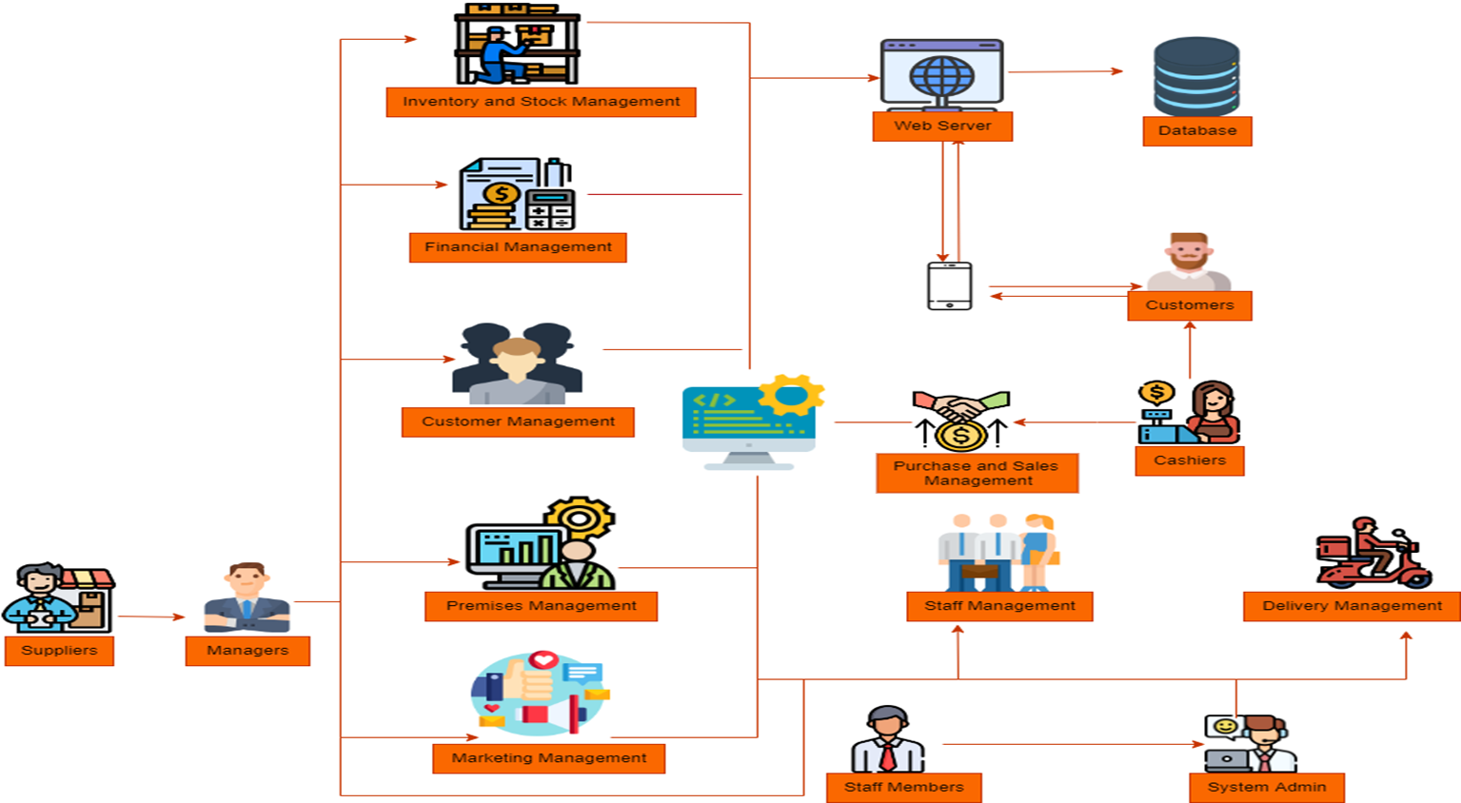

figure -High Level Architecture of the System

## 3.4.User Interfaces

### 3.4.1 Inventory and Stock Management

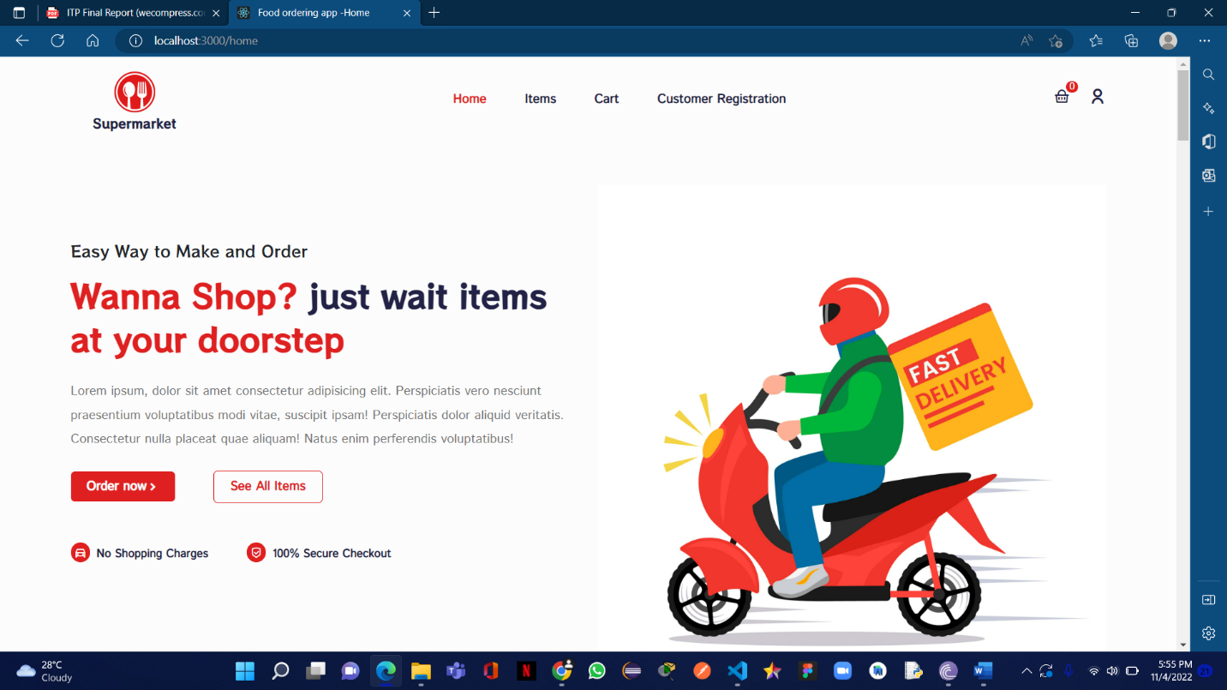

figure -Home Page 1

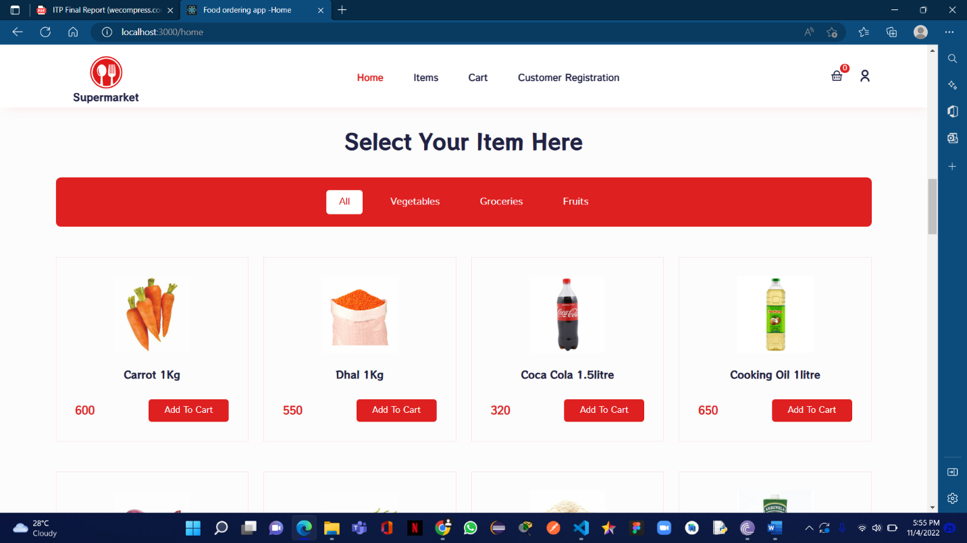

figure -Home page with Item Selection Option

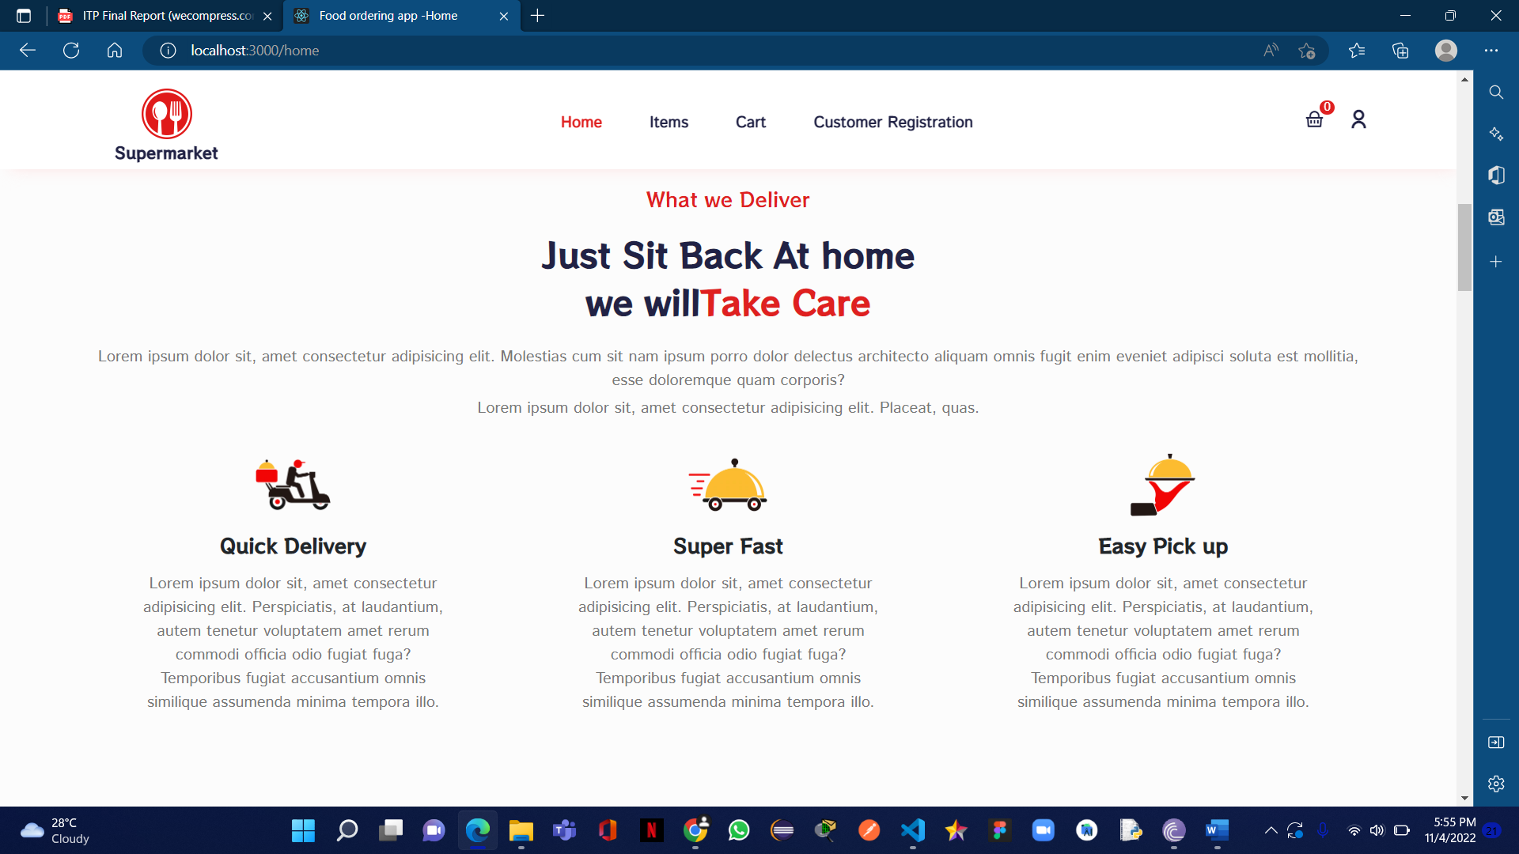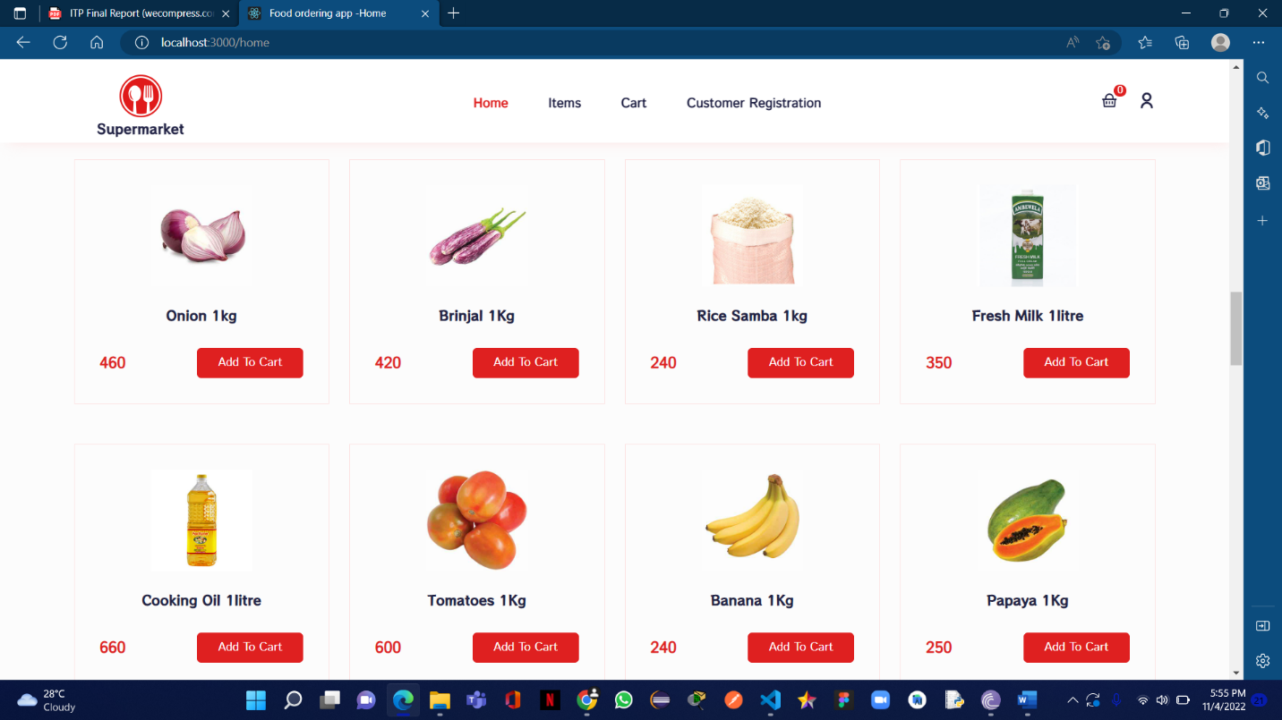

figure -Delivery and Pickup Information

figure -Items in Home page to Select

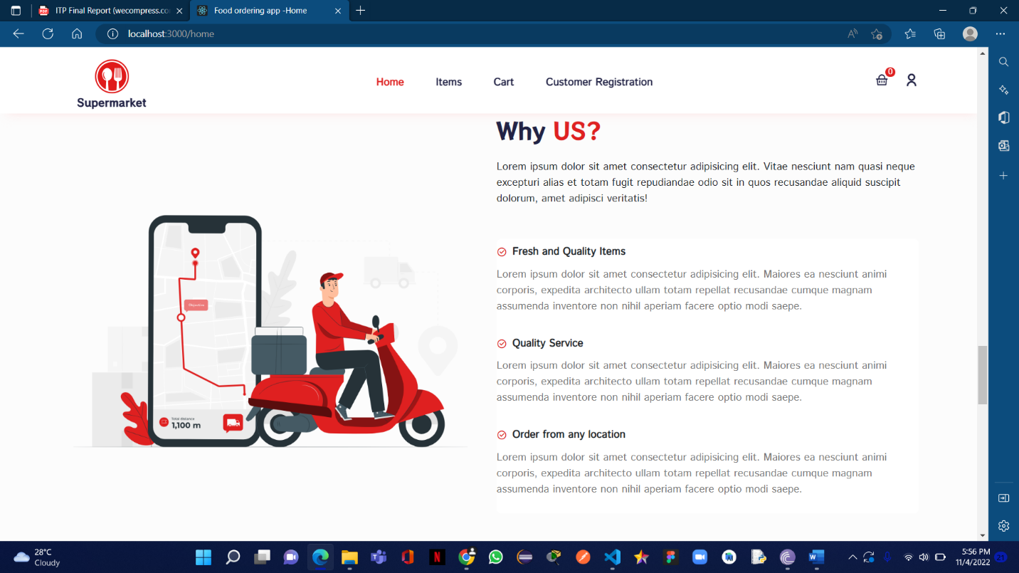

figure -About Us Section

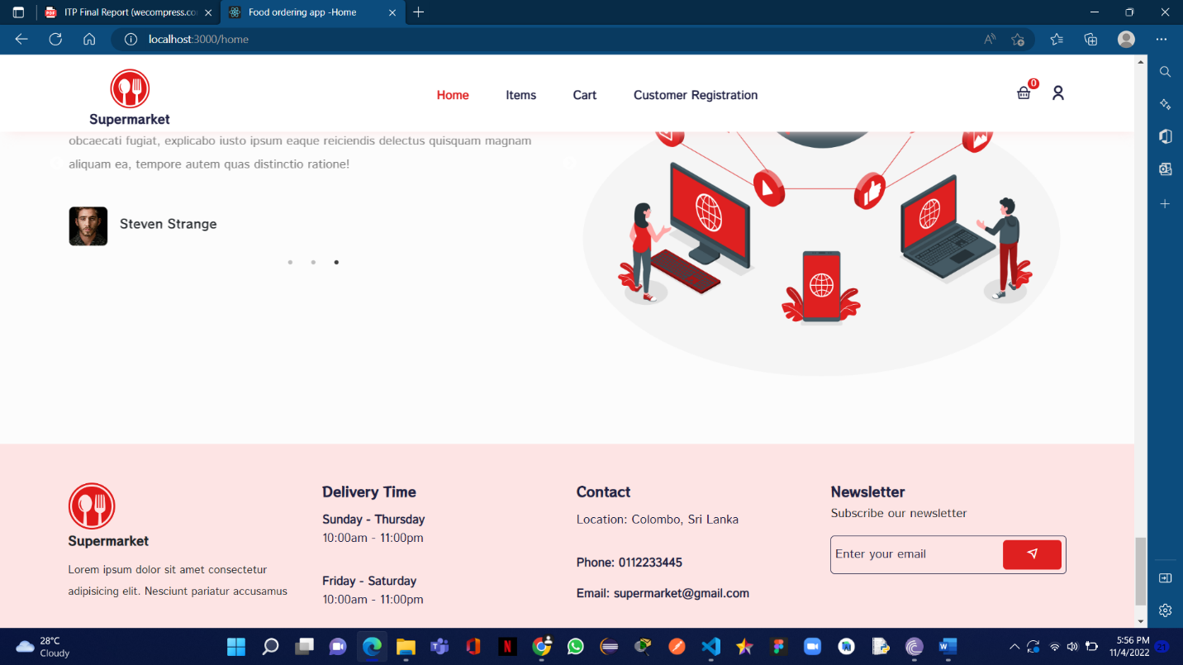

figure -Footer

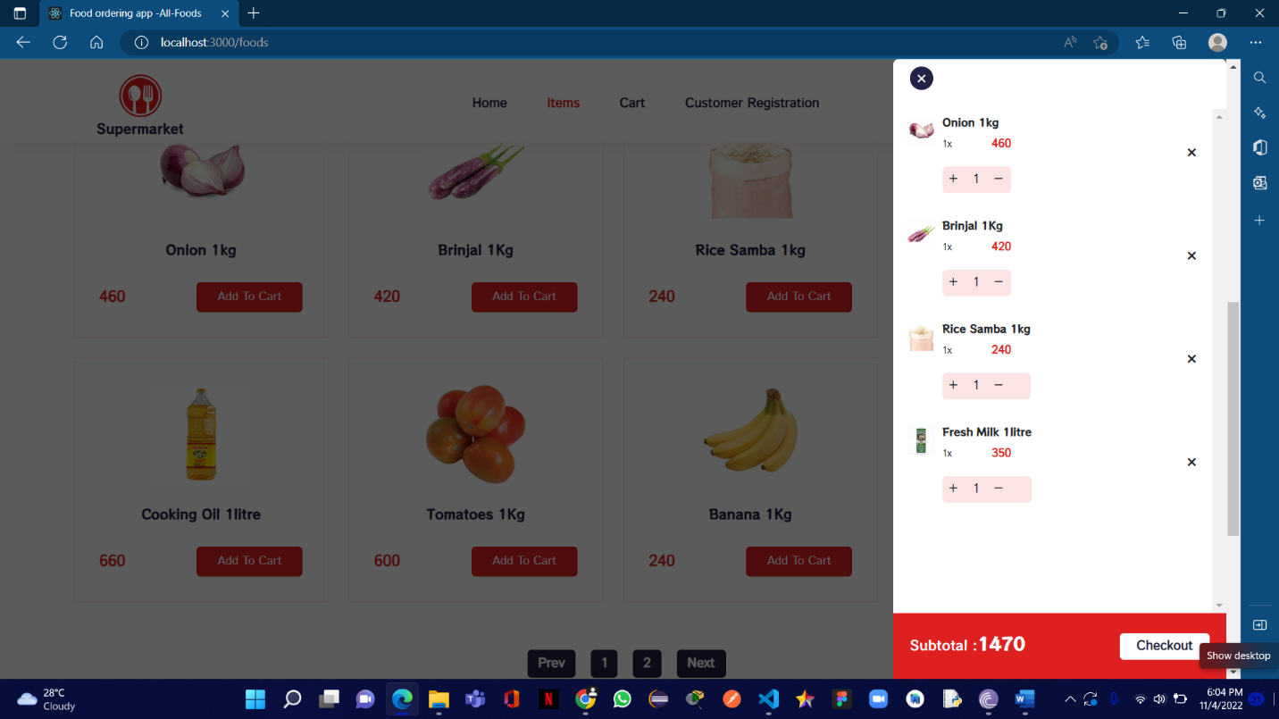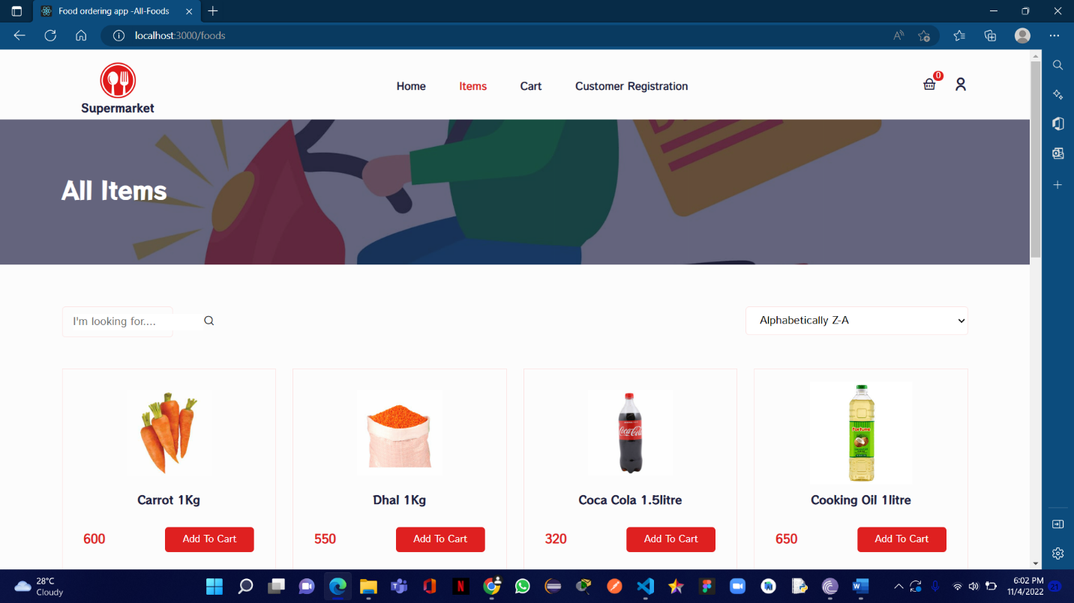

figure -Shopping cart

figure -All Items Page

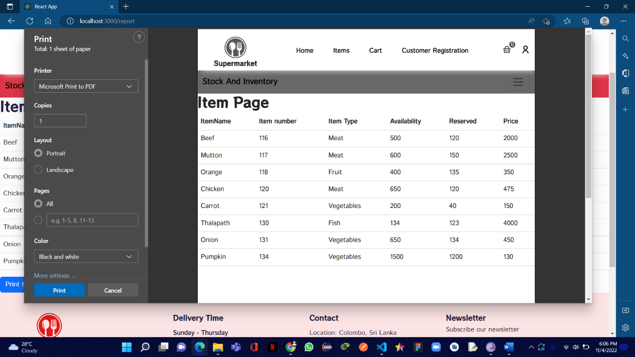

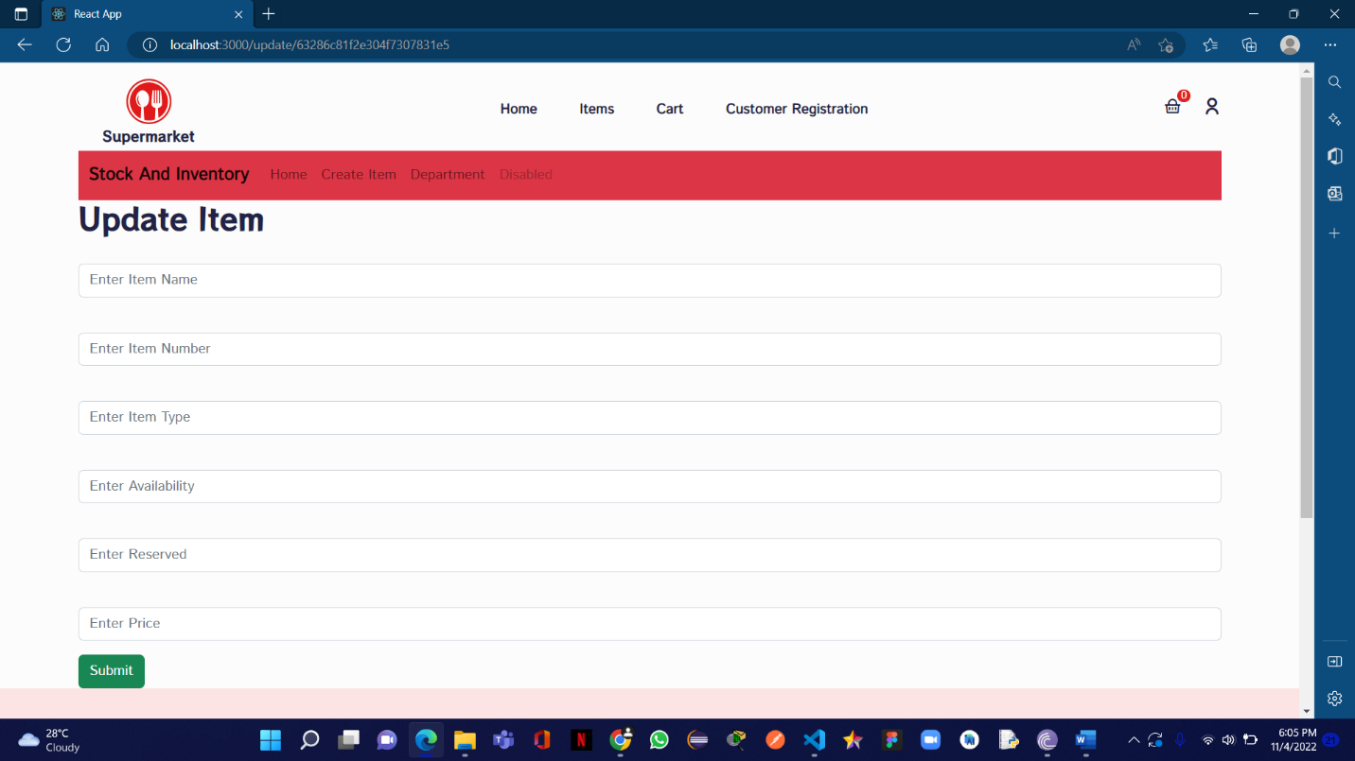

figure -Update Item

figure -Report Generation

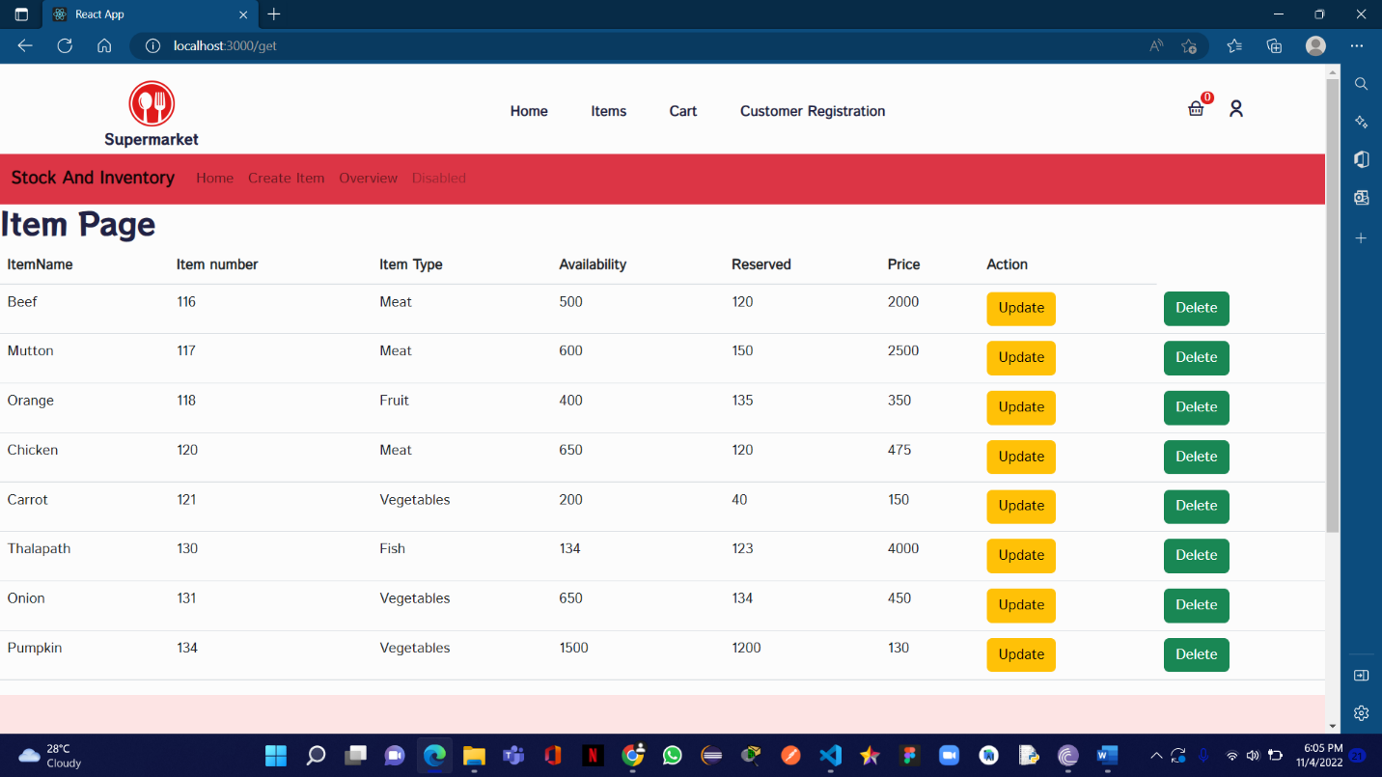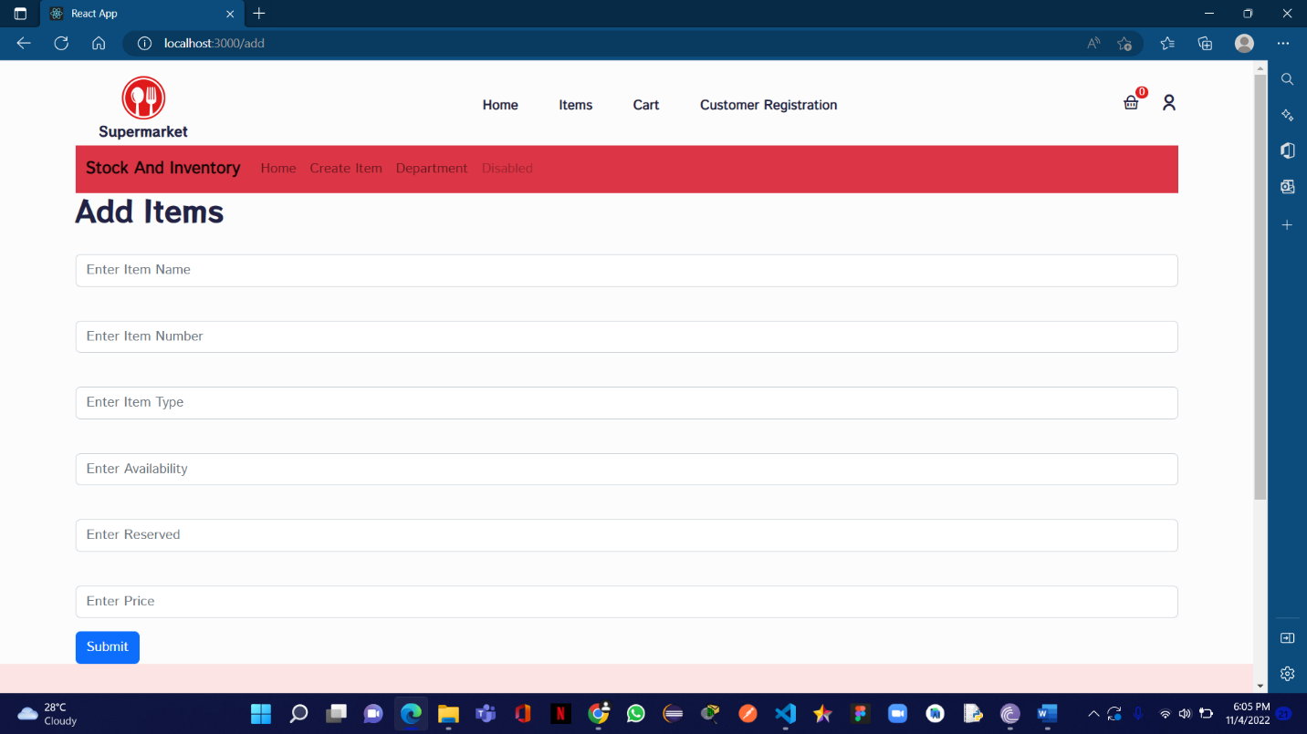

figure -All Items Page with Update and Delete Options

figure -Add Items

### 3.4.2.Sales and Purchase Management

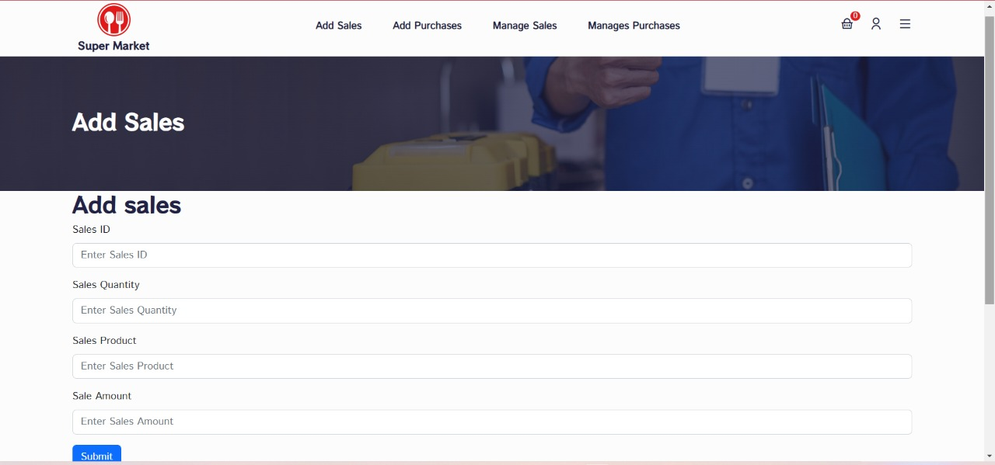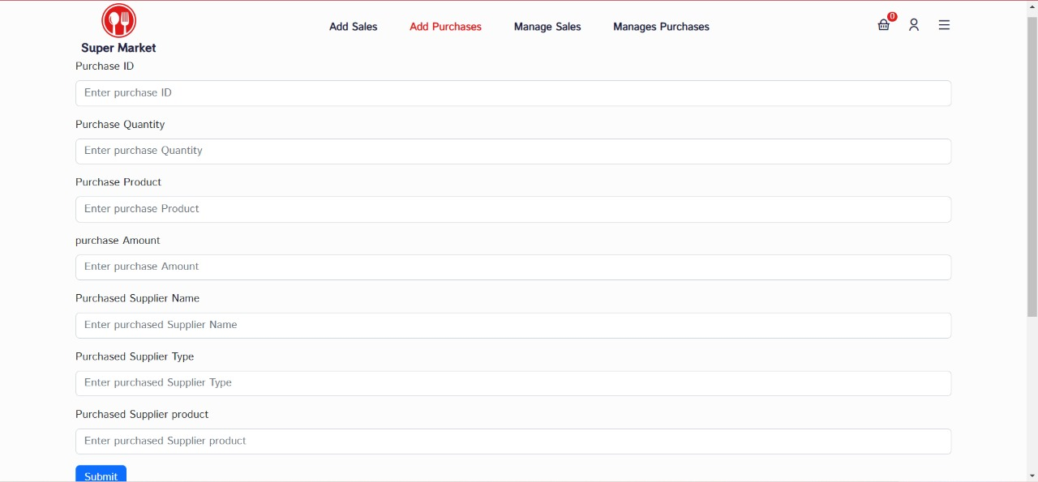

figure -Add Sales



figure -Add Purchases

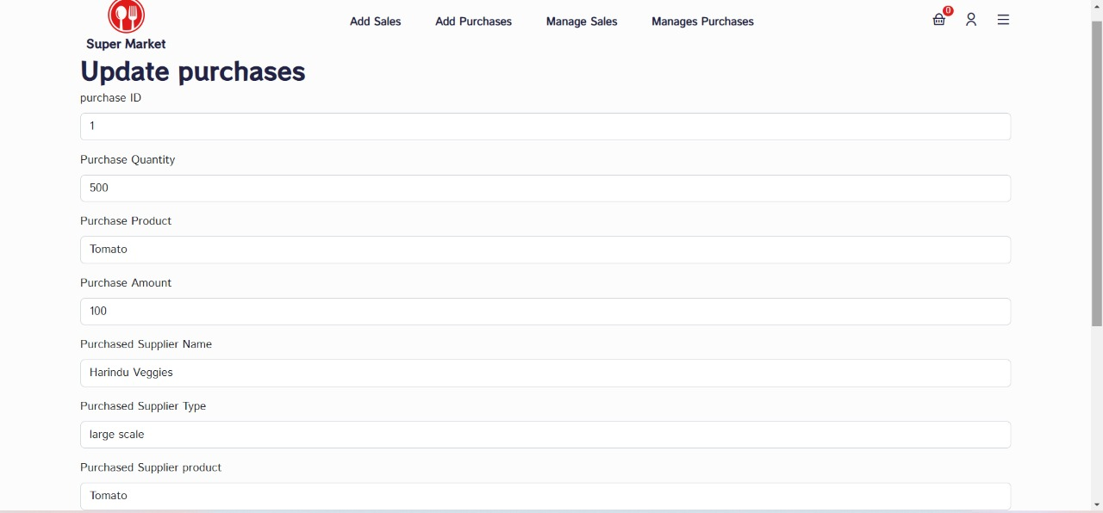

Figure -Update Purchases

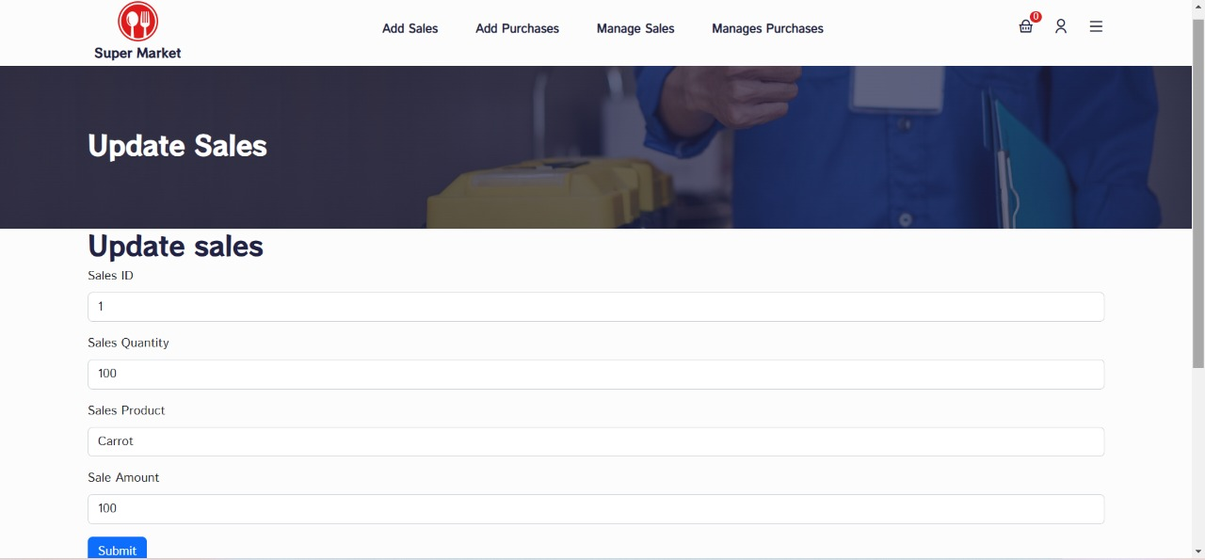

Figure -Update Sales

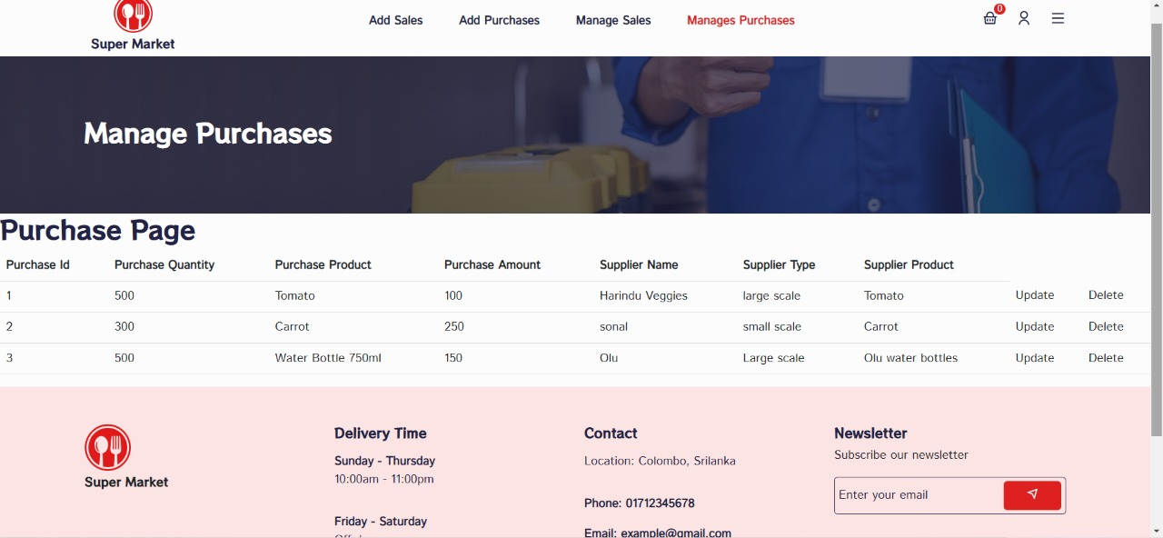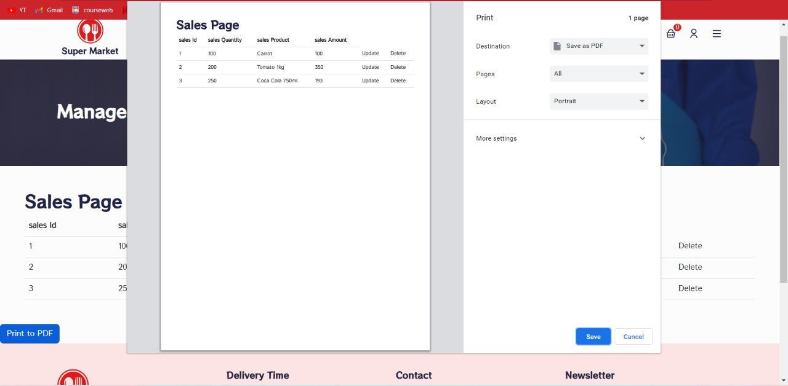

figure -Purchase Page

Figure -Generate Sales Report

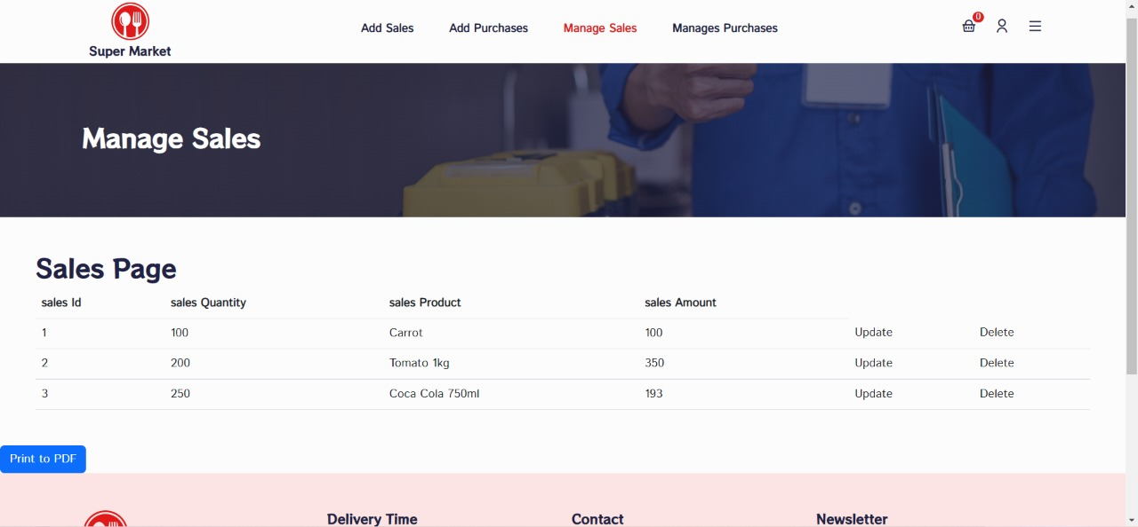

figure -Sales Page

3.4.3. Finance Management 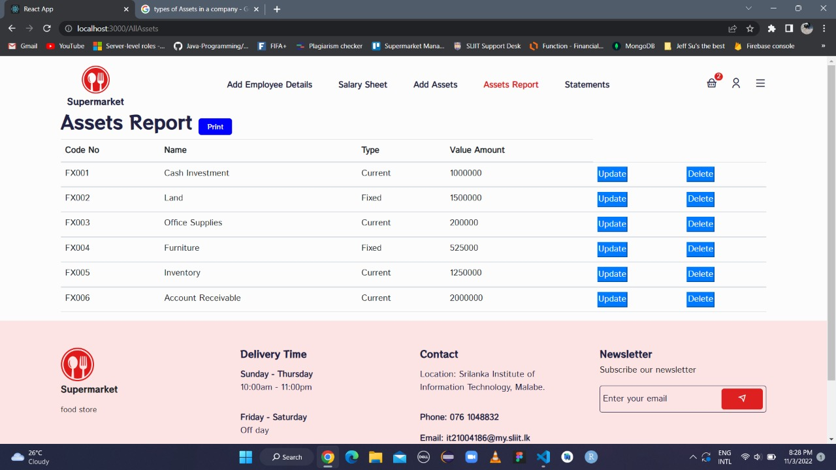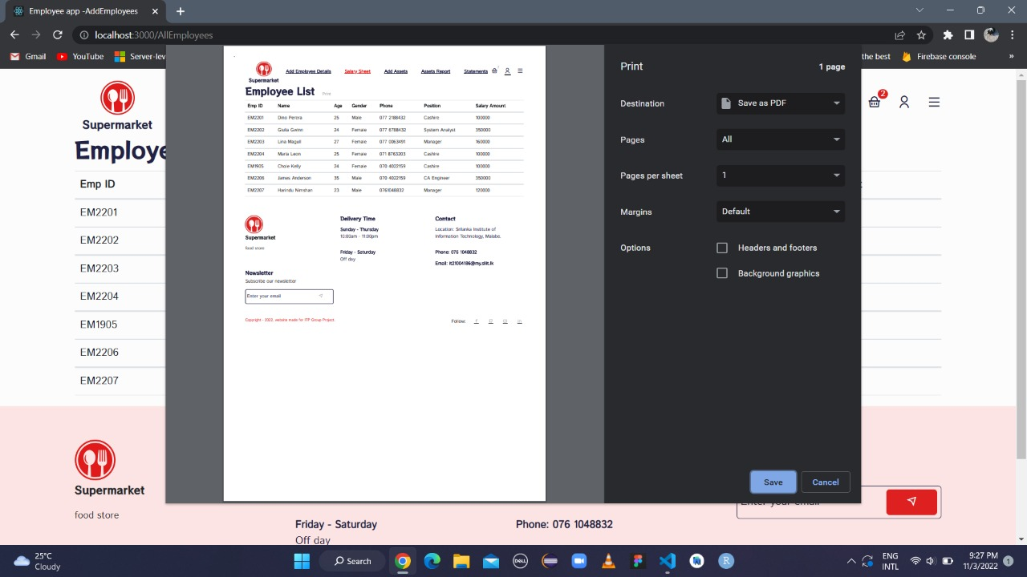

figure -Asset Report

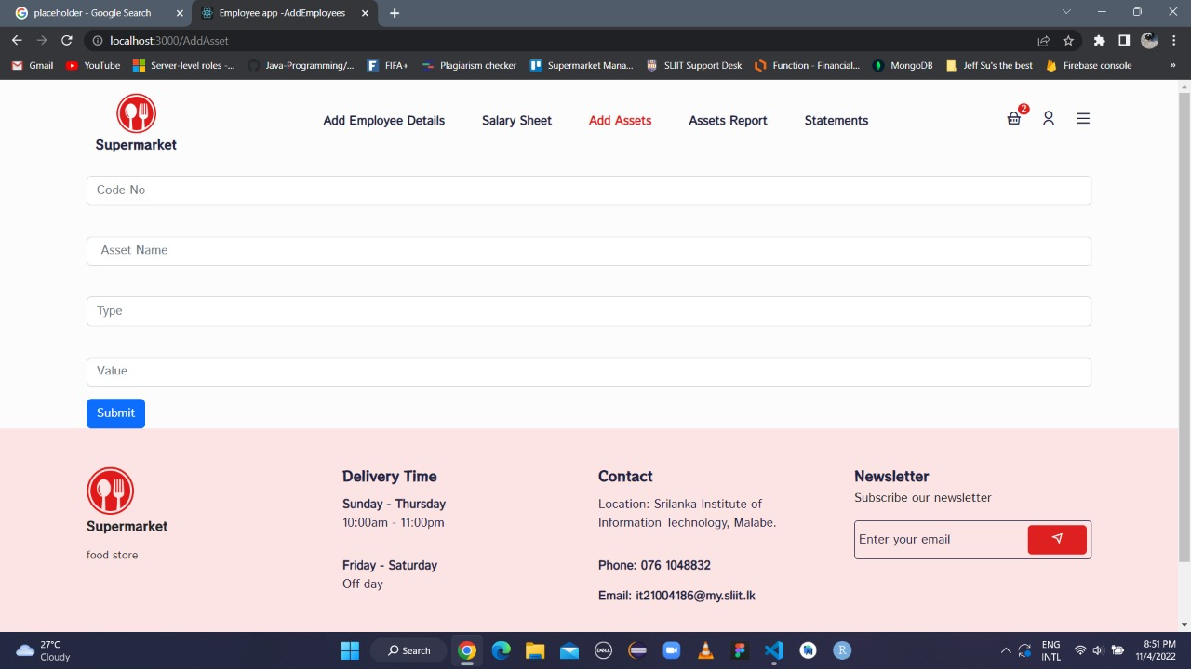

figure -Add Assets

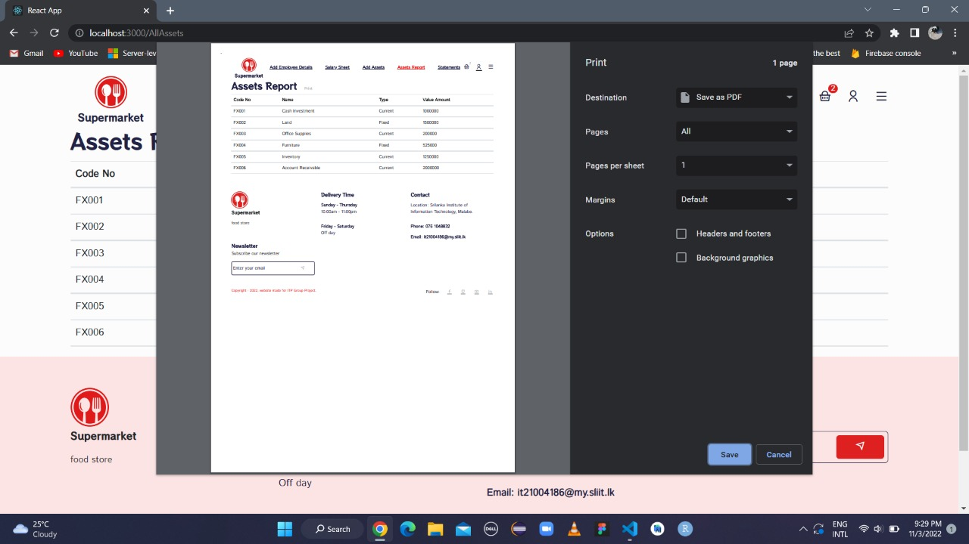

figure -Generate Assets Report

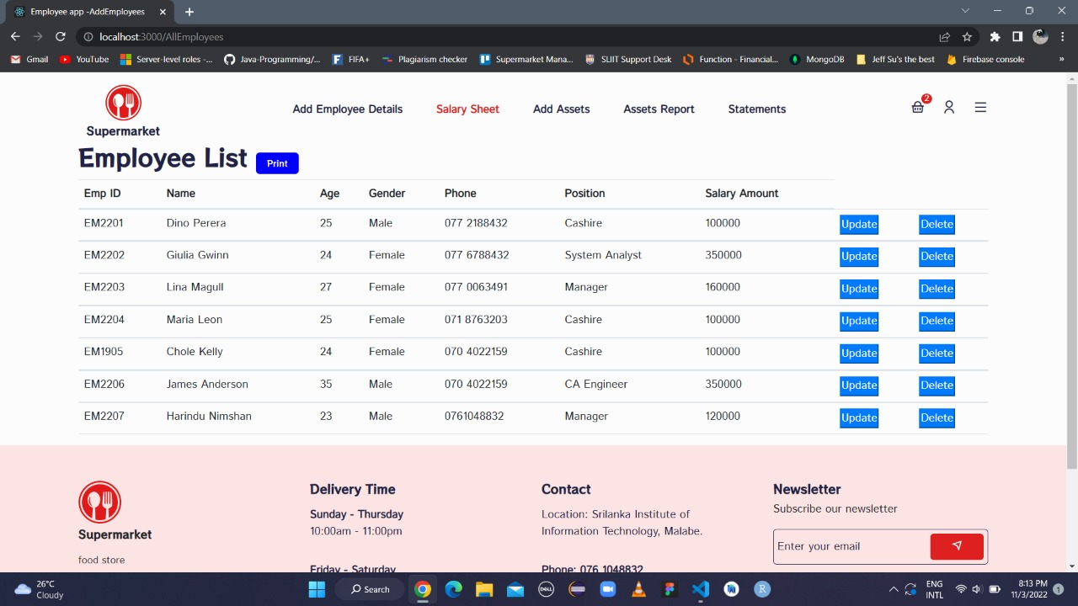

figure -Employee List Page

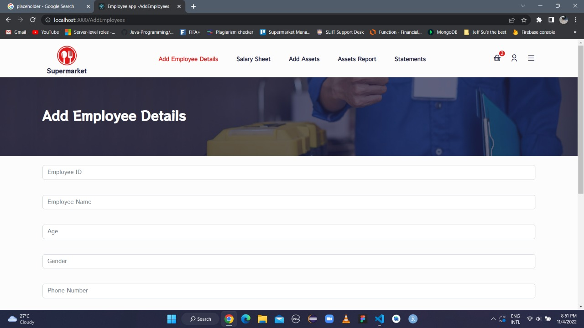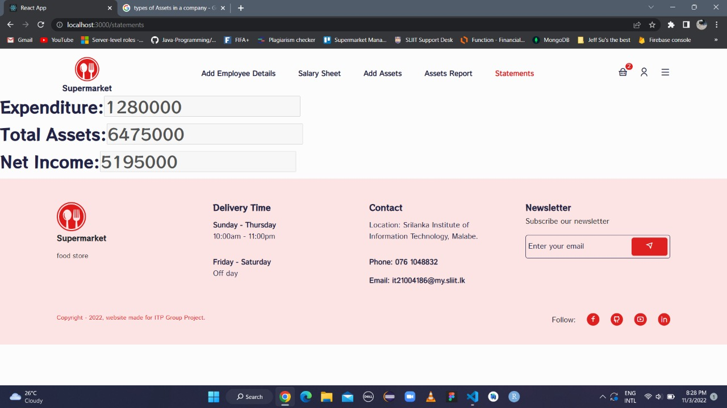

figure -Add Employee Details

figure -Calculate Net Income

### 3.4.4.Staff Management

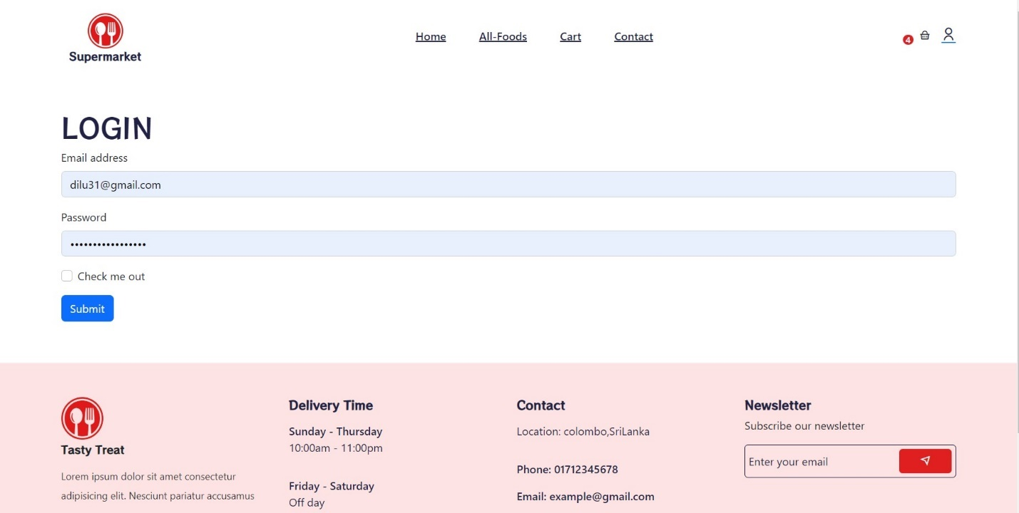

figure -Admin Login Page

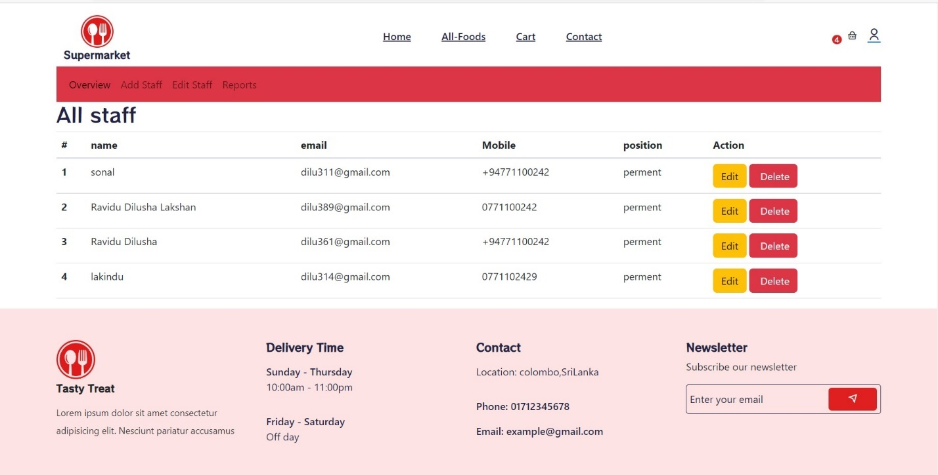

figure -All Staff Member Page with Update and Delete Option

Figure ‑-3.1.6

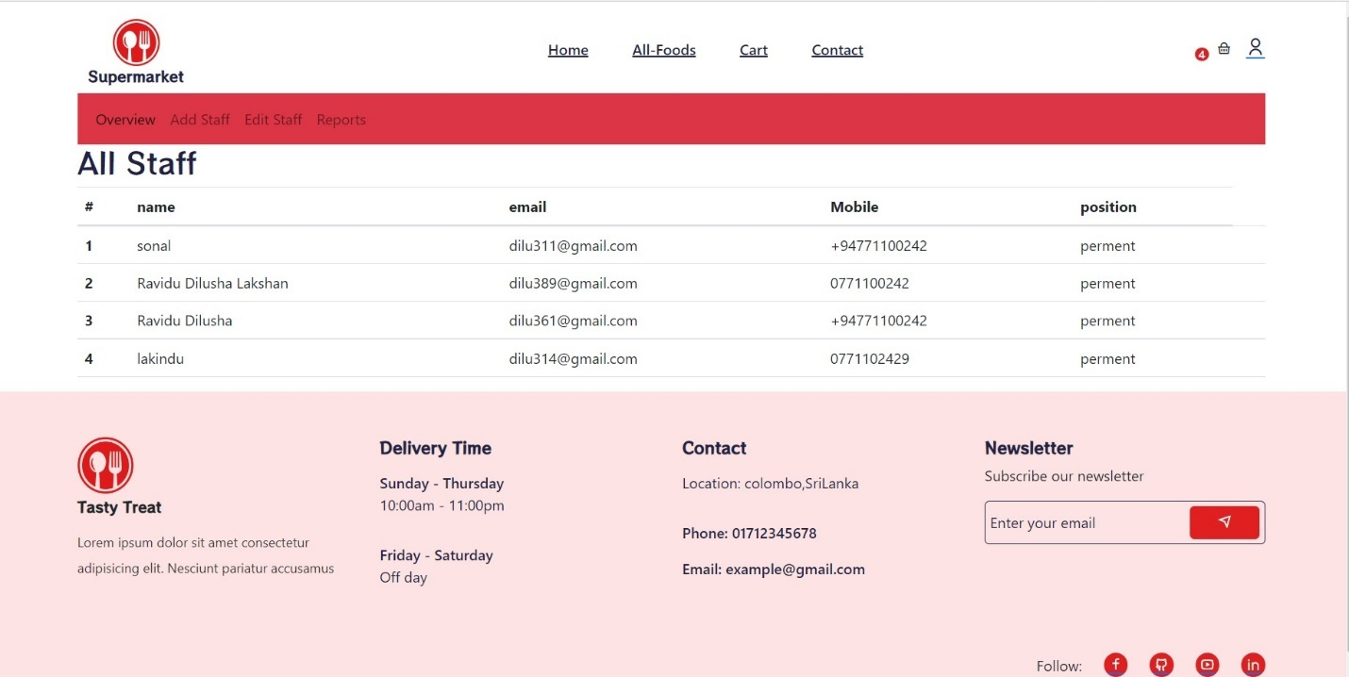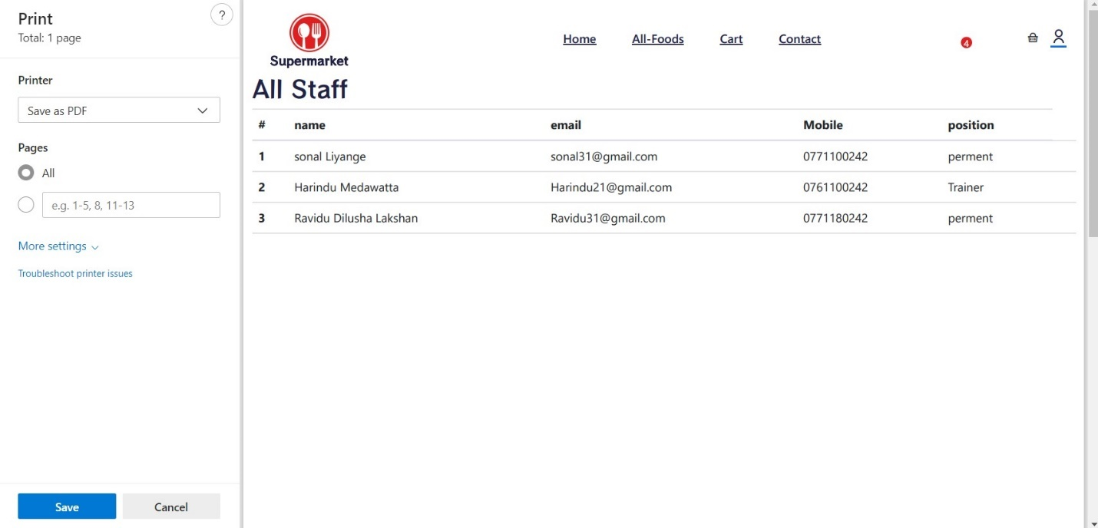

figure -Staff Generate report

figure -Staff Overview Page

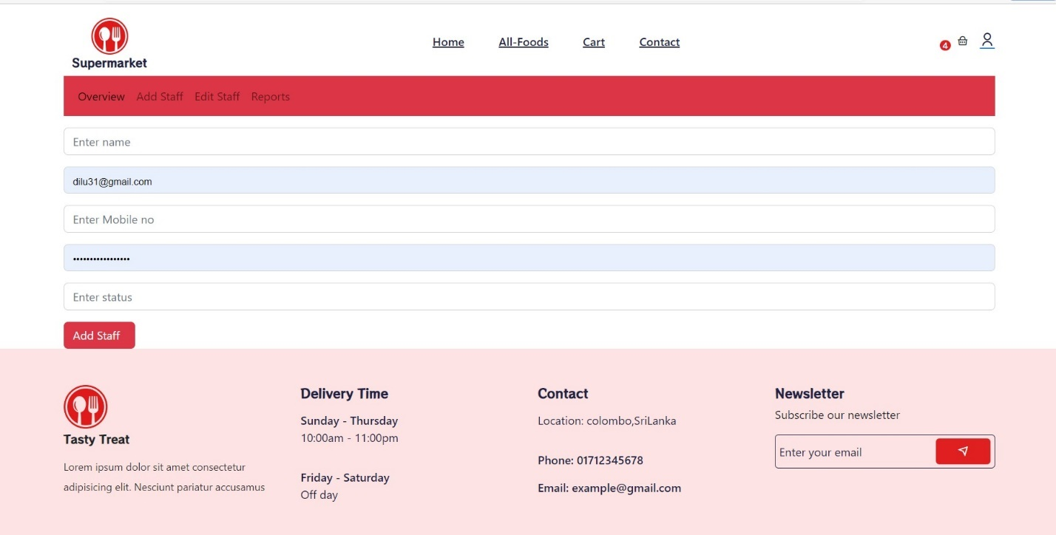

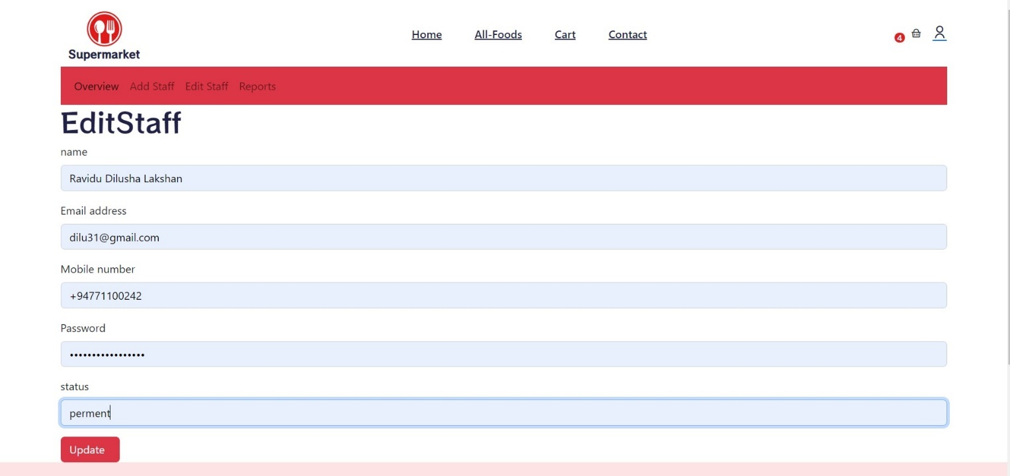

Figure -Update Staff Member Details

figure -Add Staff Member Details

### 3.5.5.Delivery Management

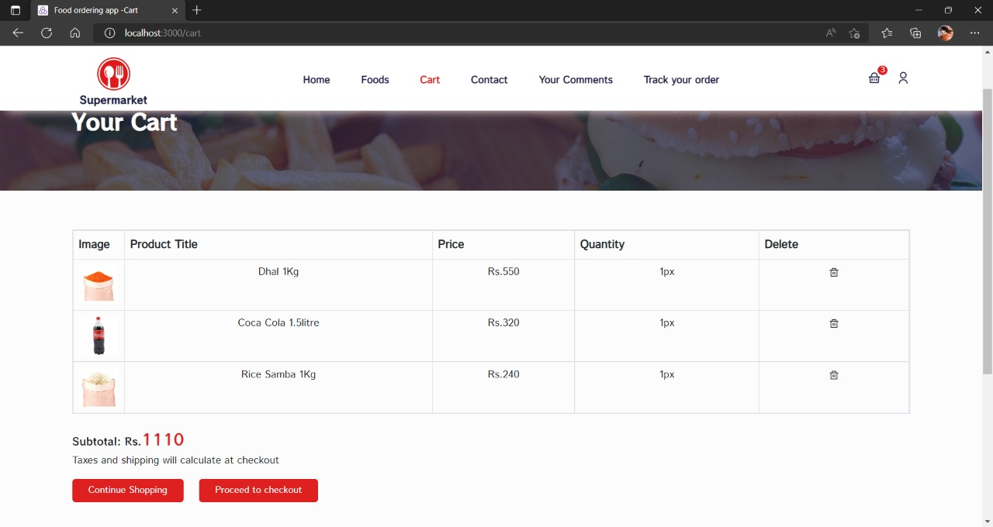

figure -Extended Shopping Cart

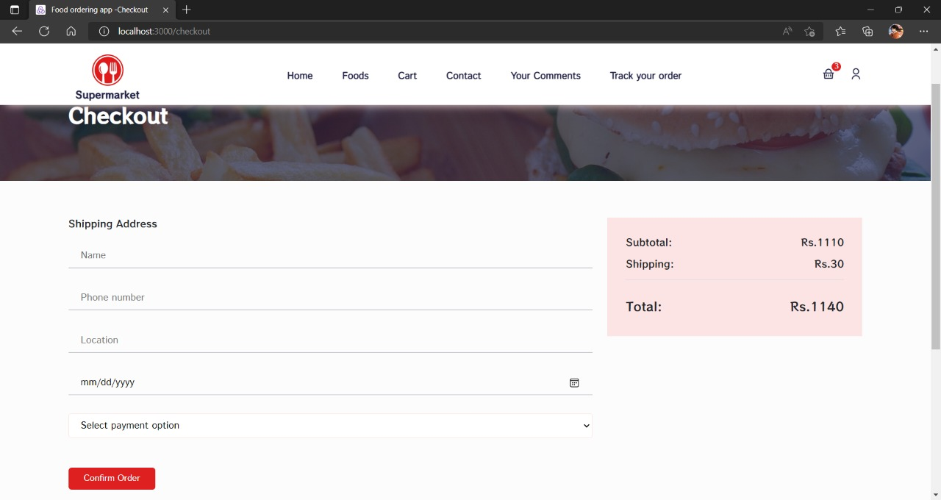

figure -Checkout Page

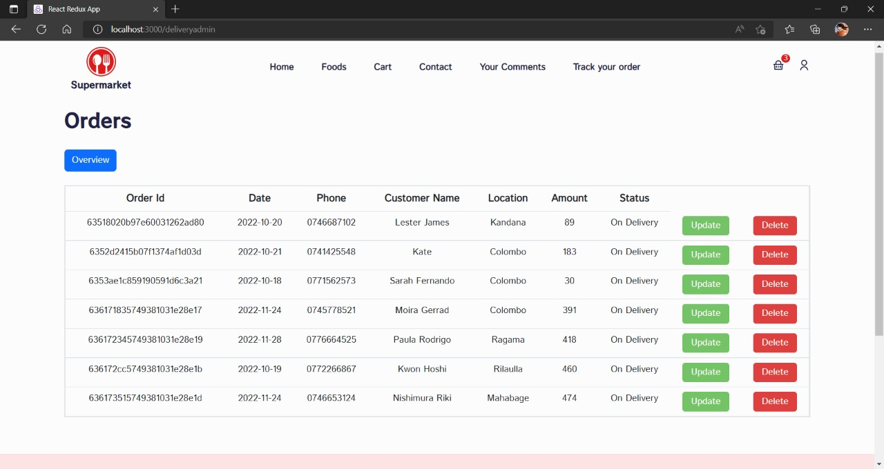

figure -Orders Overview Page

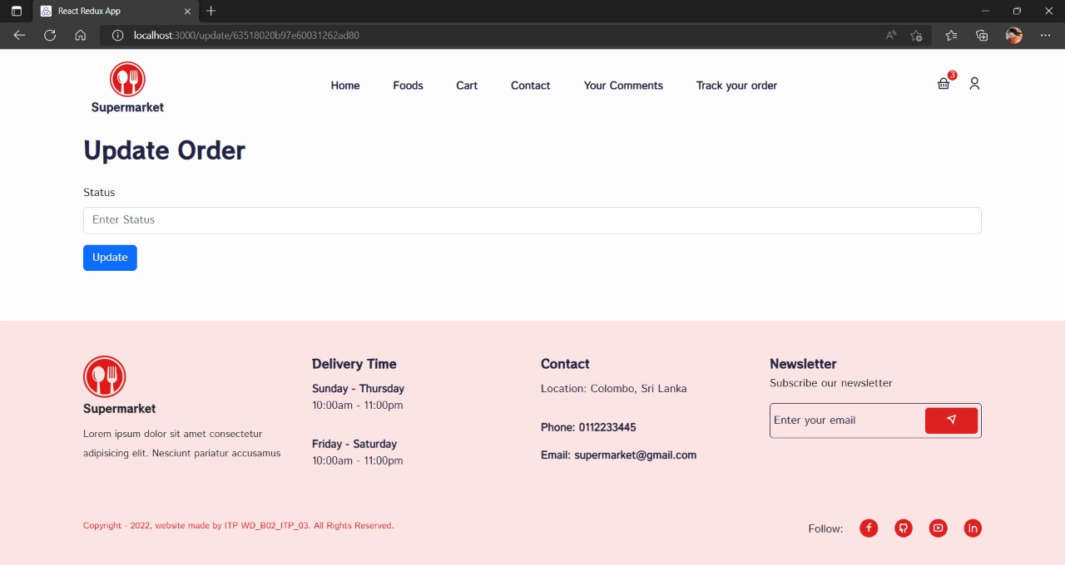

figure -Update Order

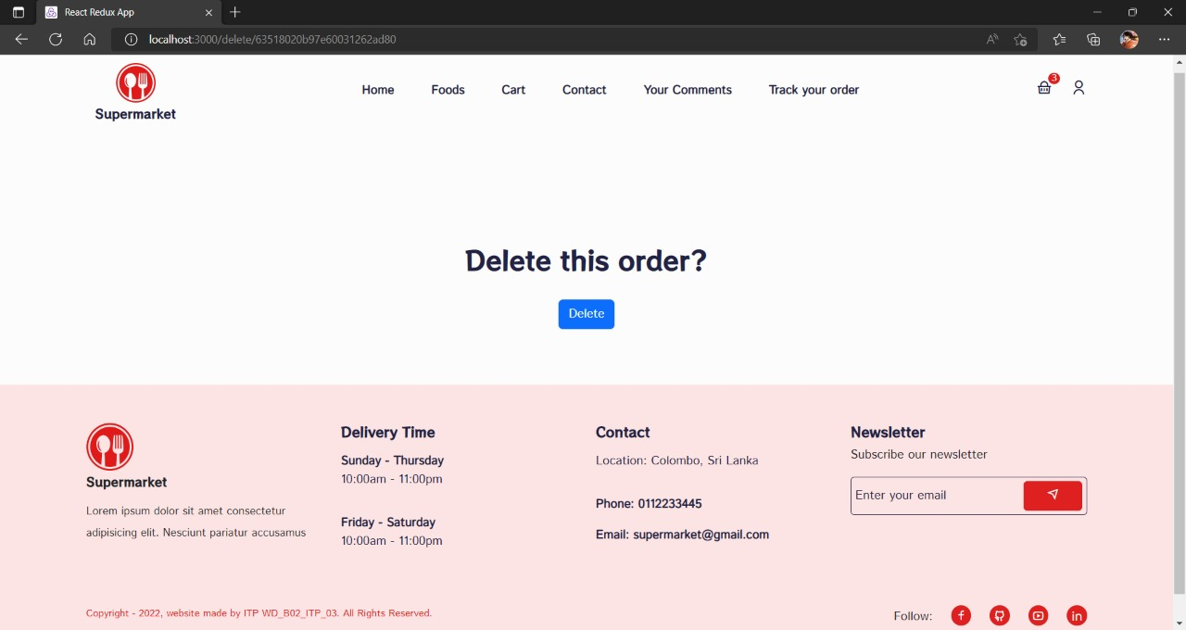

figure -Delete Order

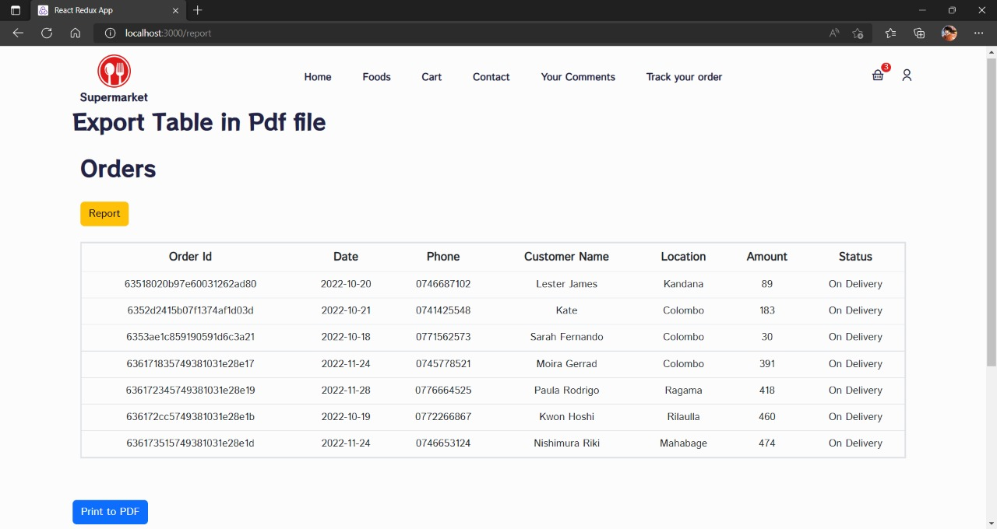

figure -All Orders Page

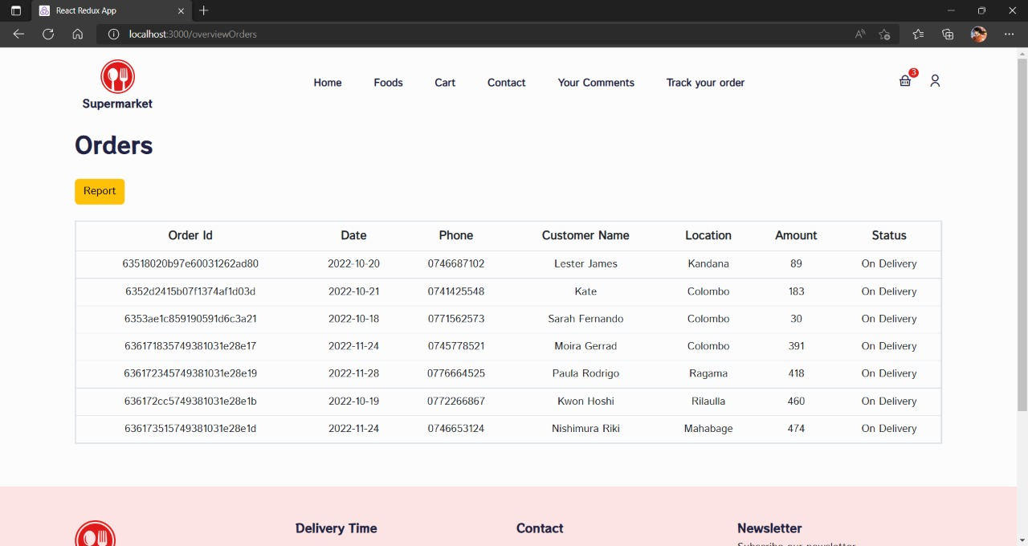

figure -All Orders Page with Report Generation Option

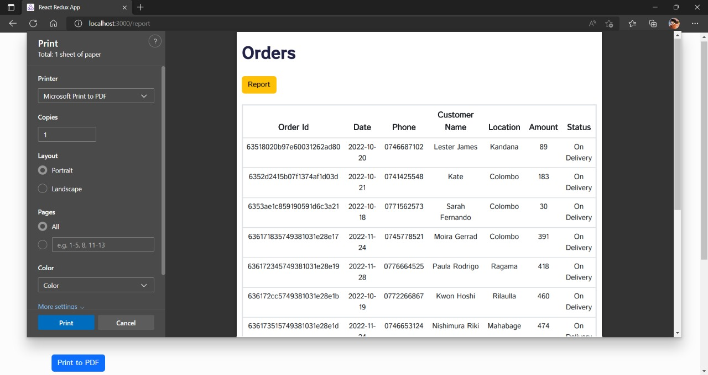

figure -Orders Report Generation

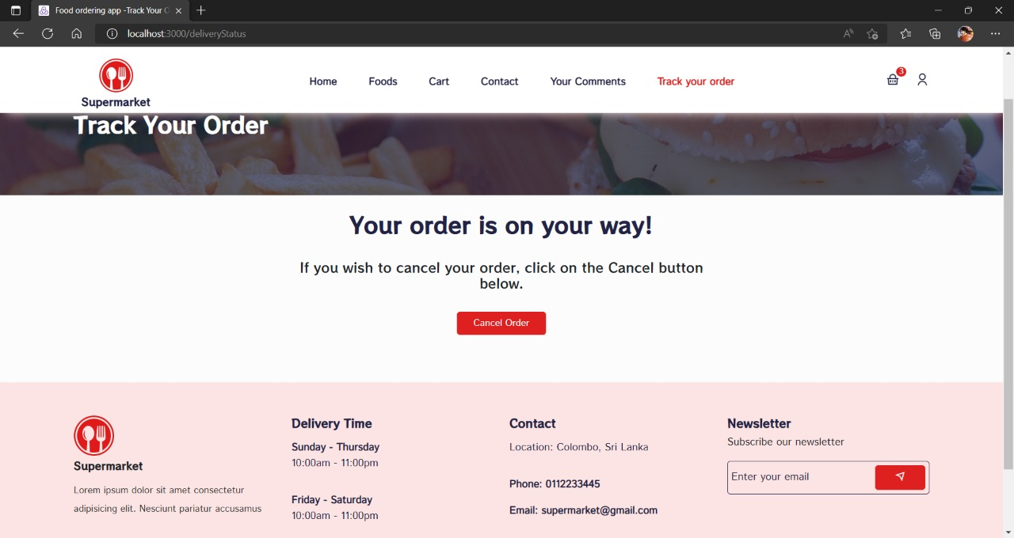

figure -Track Order

### 3.5.6.Marketing Management

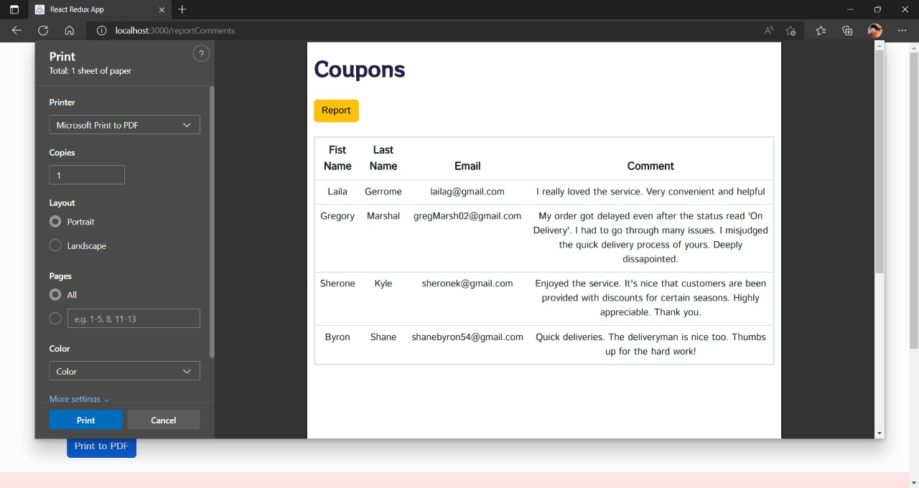

figure -Coupons Report Generation

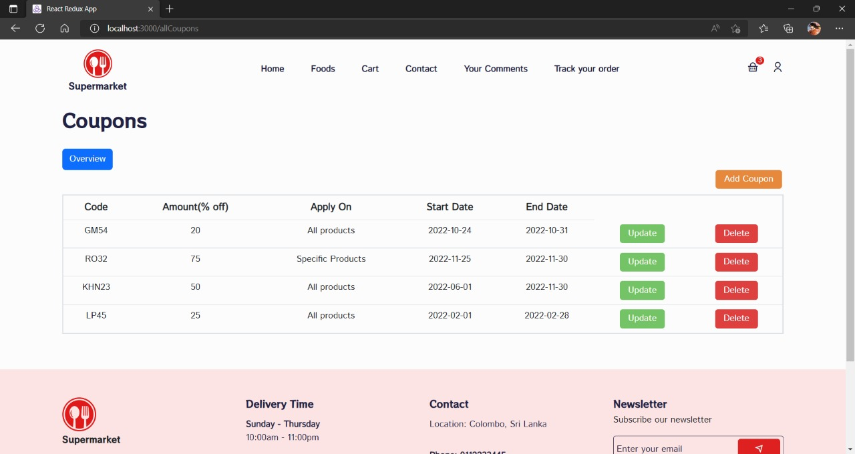

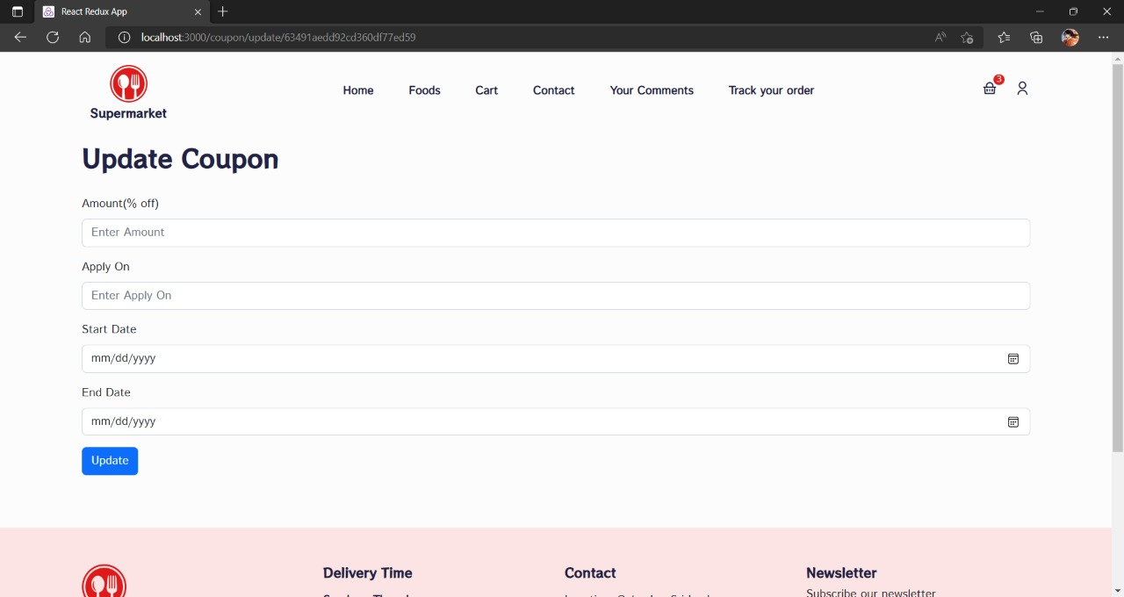

figure -All Coupons Page

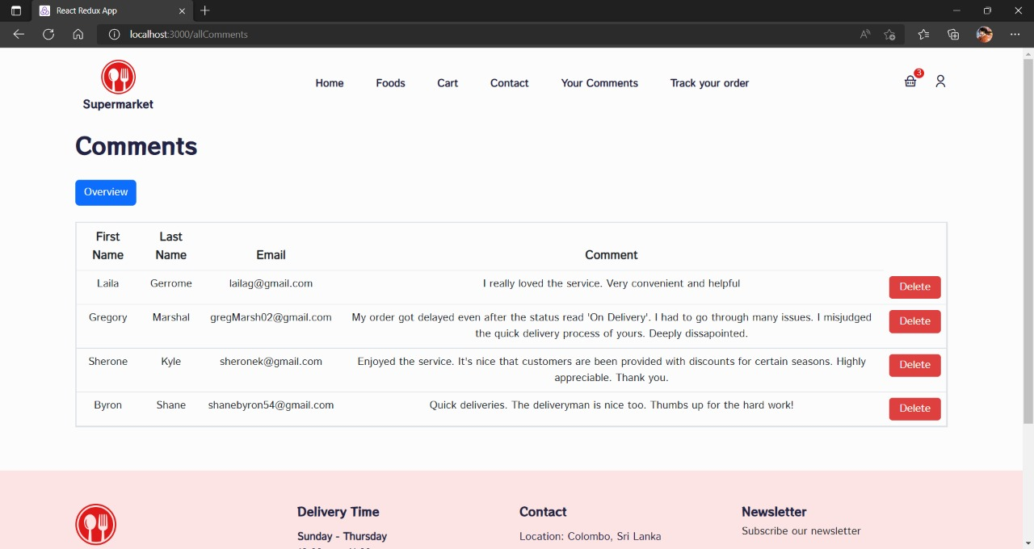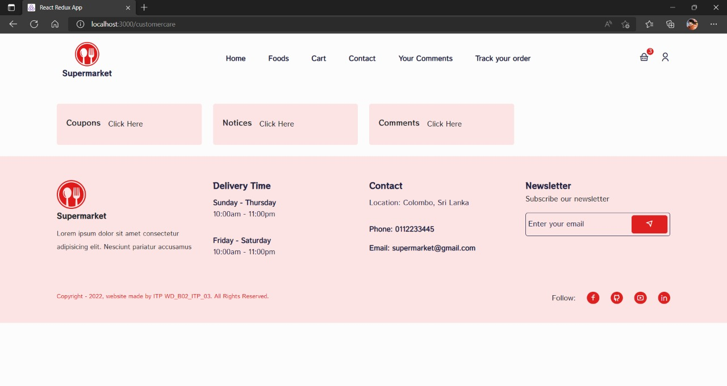

figure -All Comments Page

figure -Marketing Dashboard Page

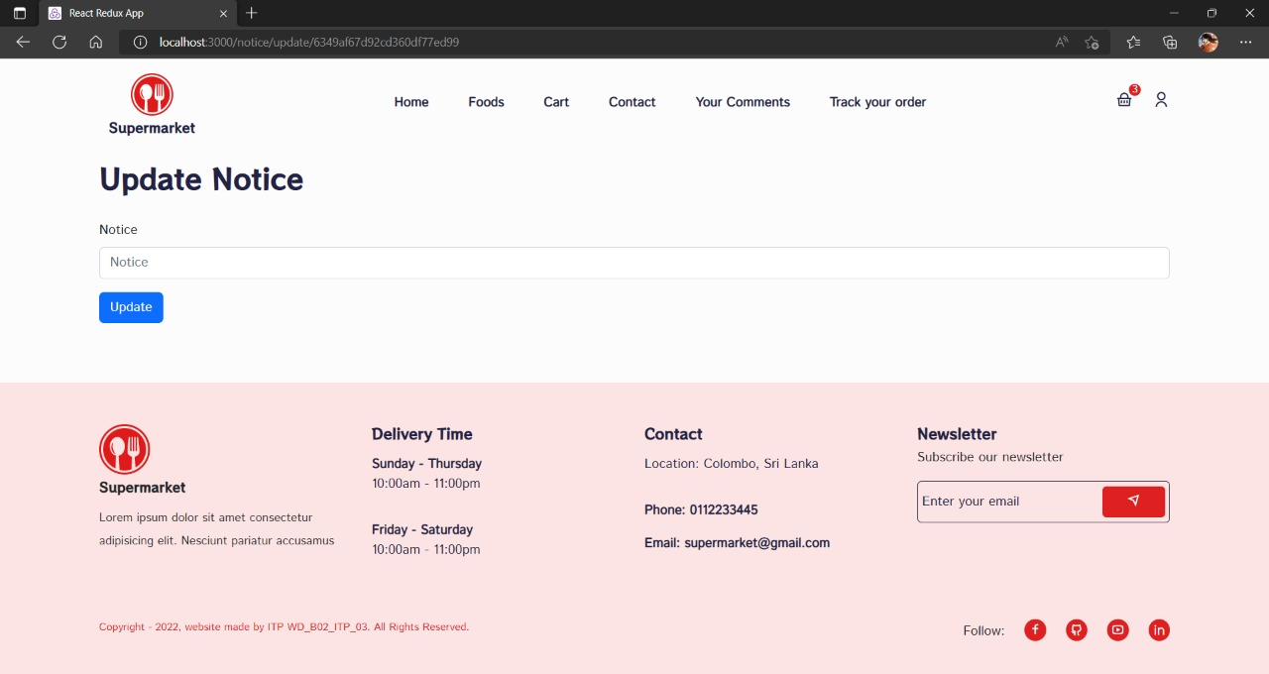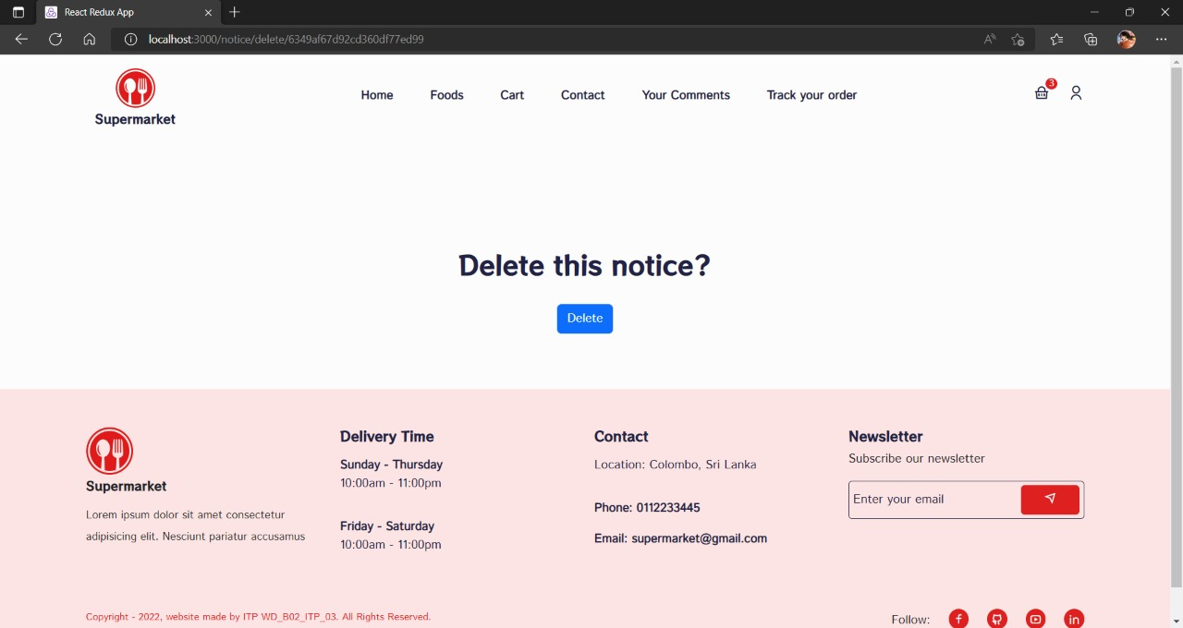

figure -Update Notice Page

figure -Delete Notice Confirmation

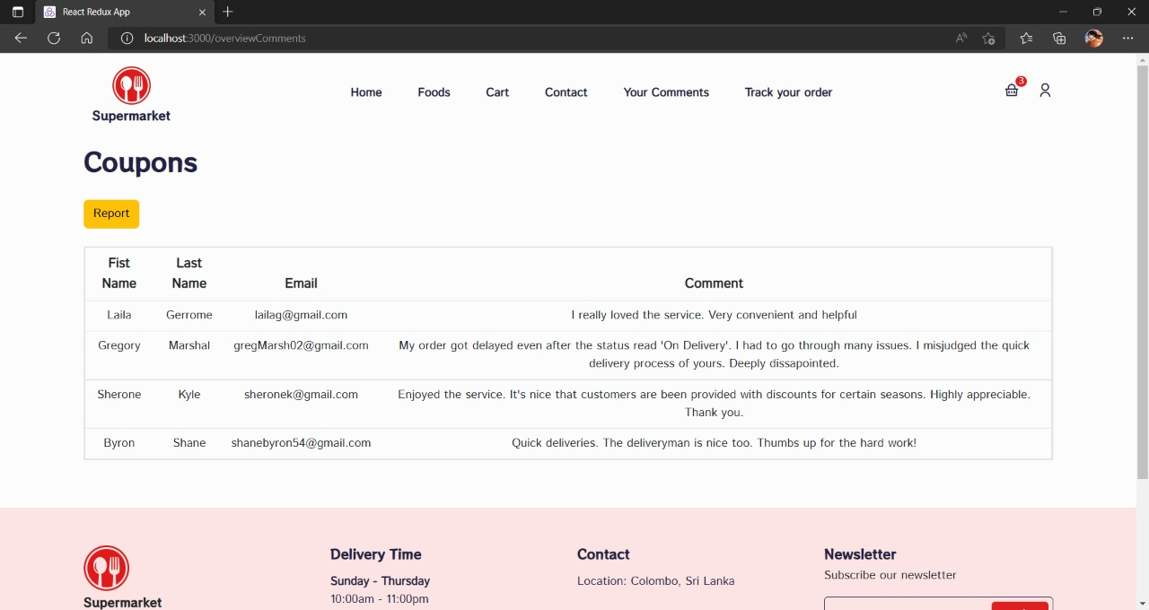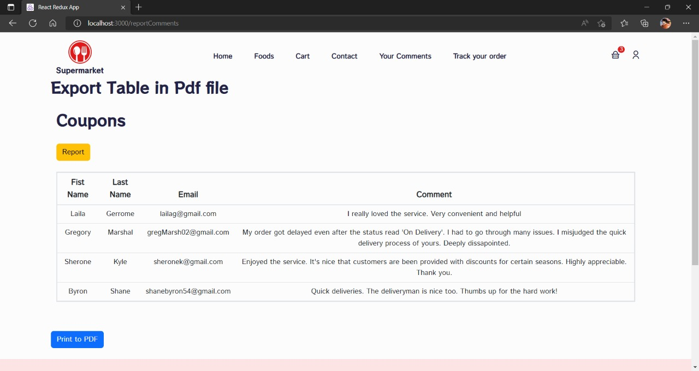

figure -Coupons Overview Page

figure -Coupons Page with Generate Report Option

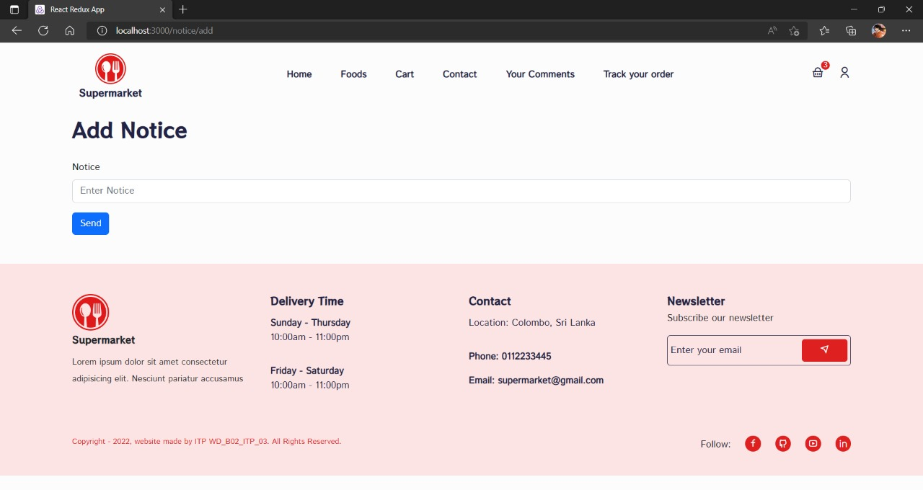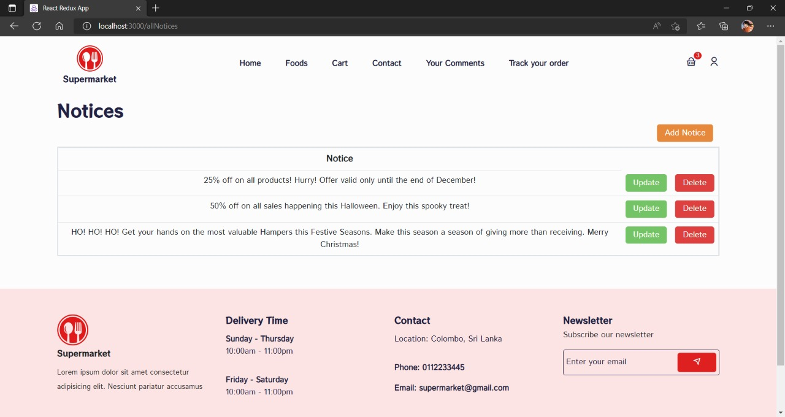

figure -Add Notice

figure -All Notices Page

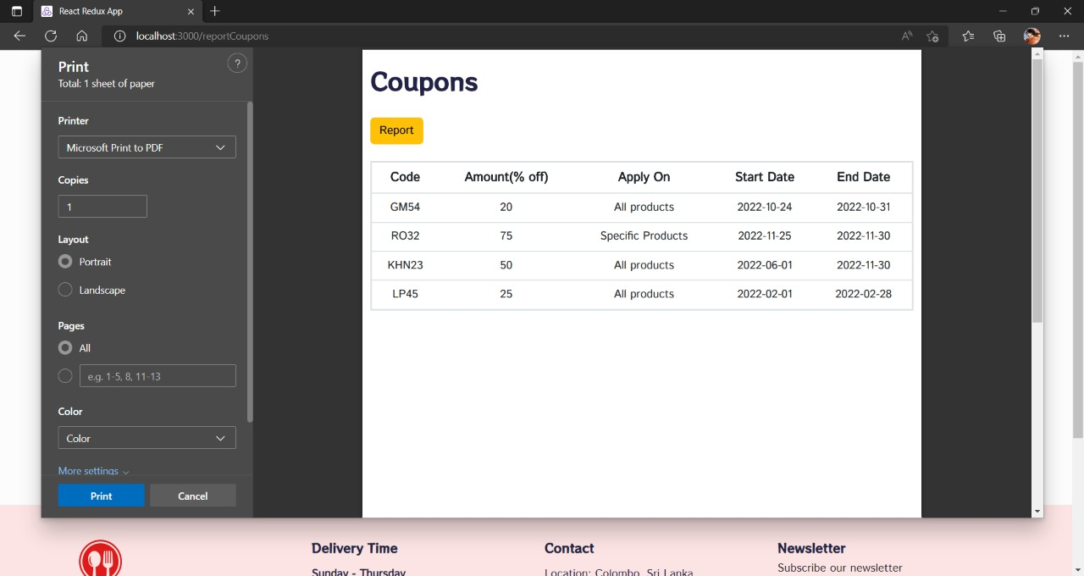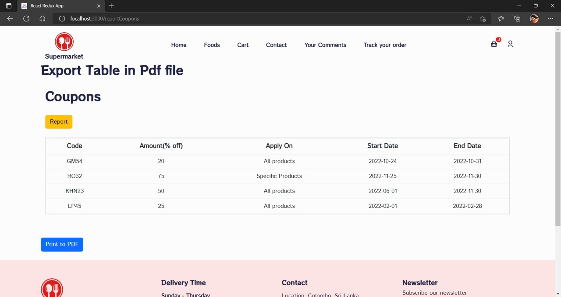

figure -Coupons Generate Report

figure -Coupons Page with Report Generation

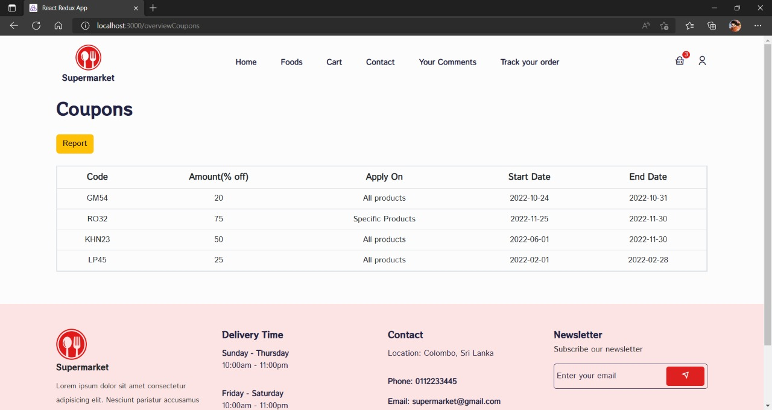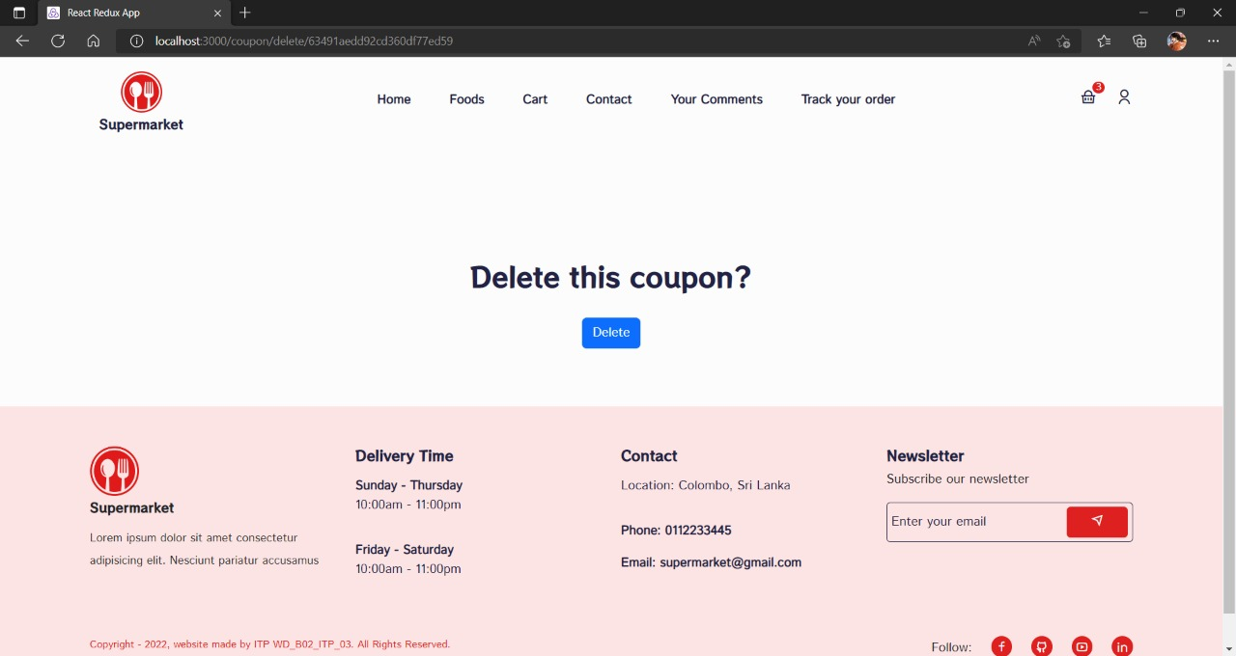

figure -Coupons Overview Page

figure -Delete Coupon Confirmation

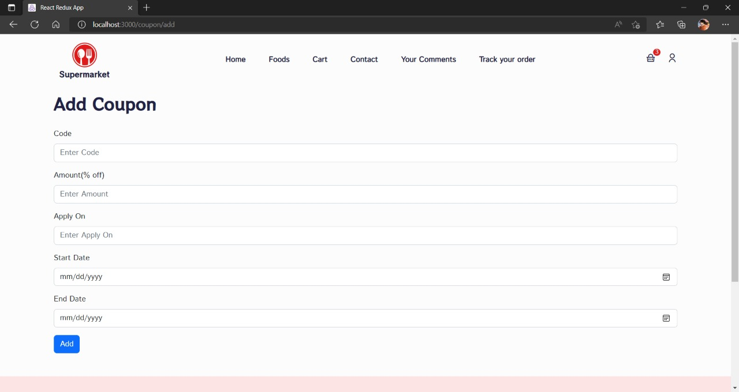

figure -Add Coupon

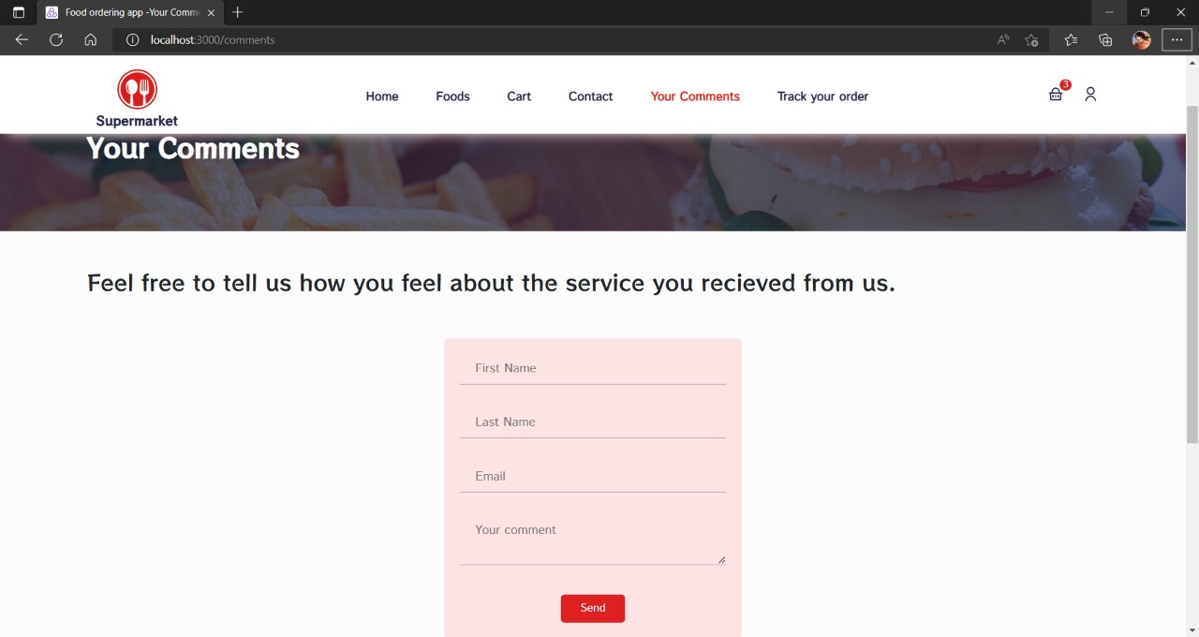

figure -Add Comments

### 3.5.7.Customer Management

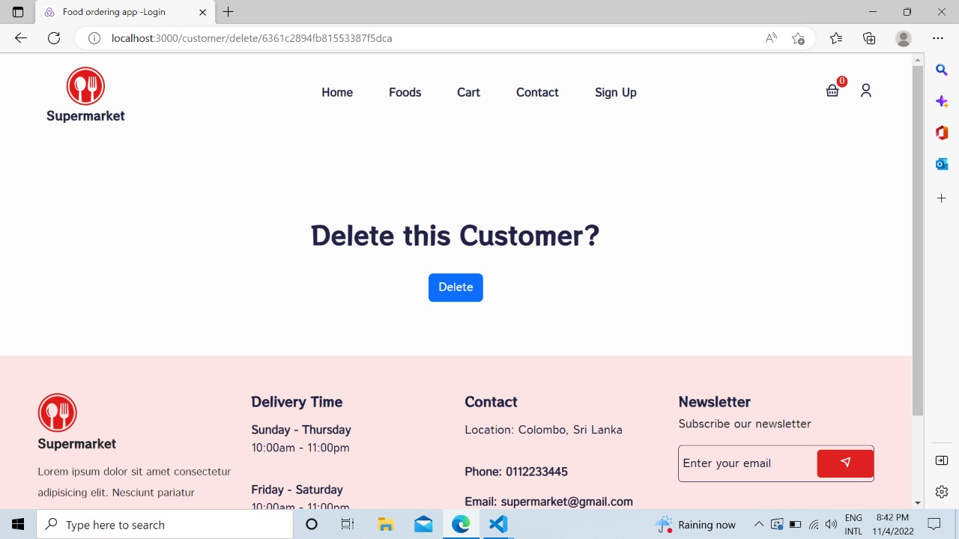

figure -Delete Customer Confirmation

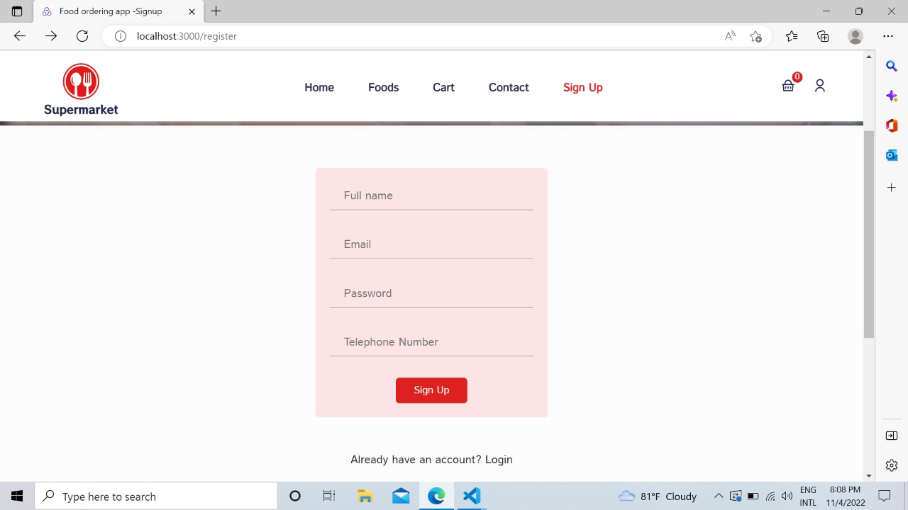

figure -Add Customer

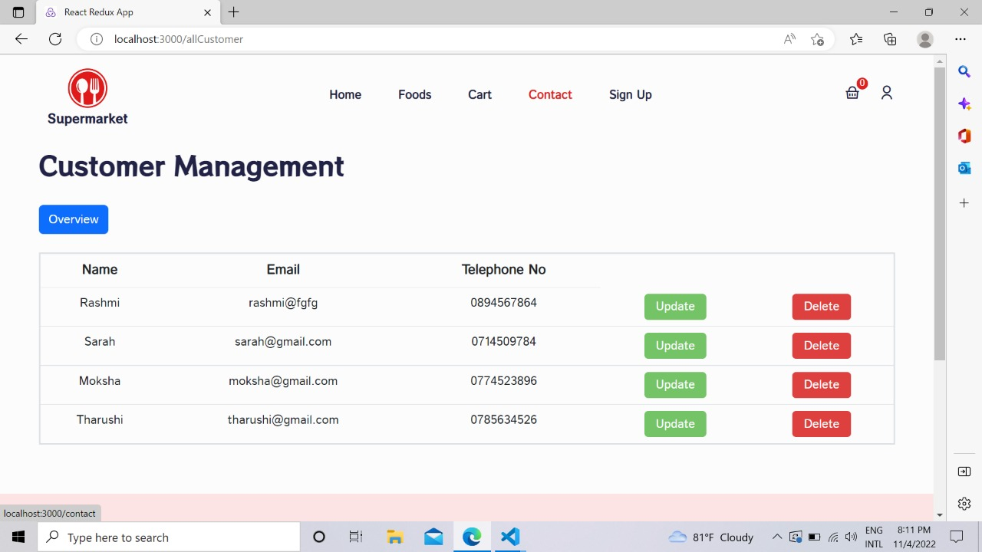

figure -All Customers

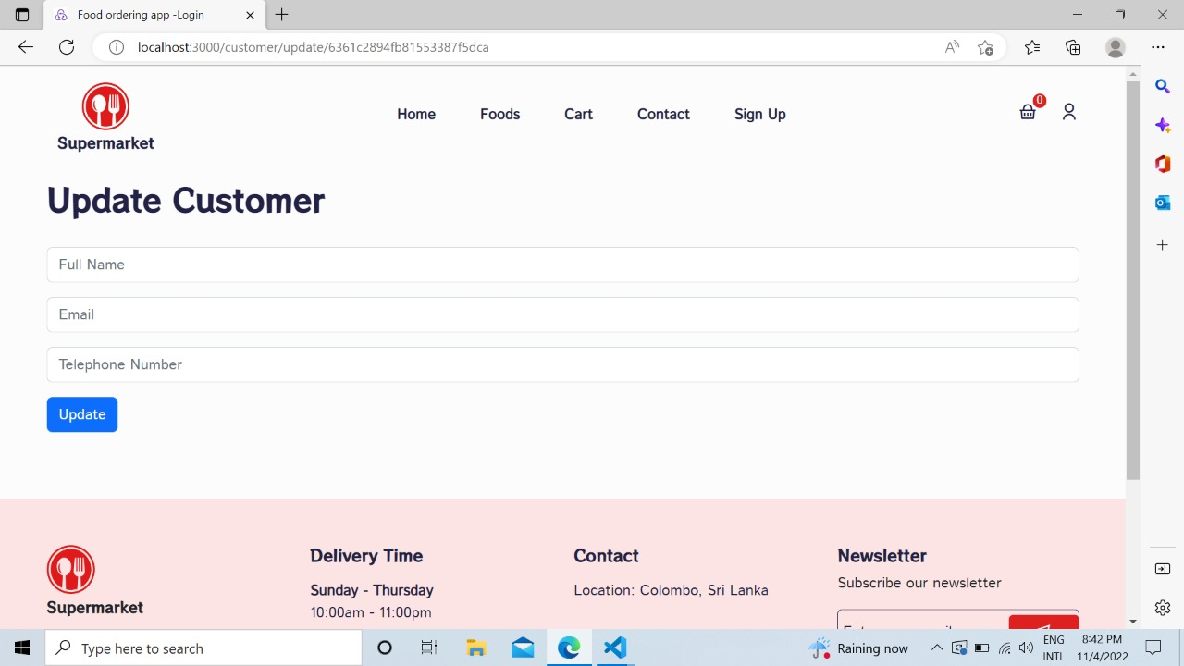

figure -Update Customers

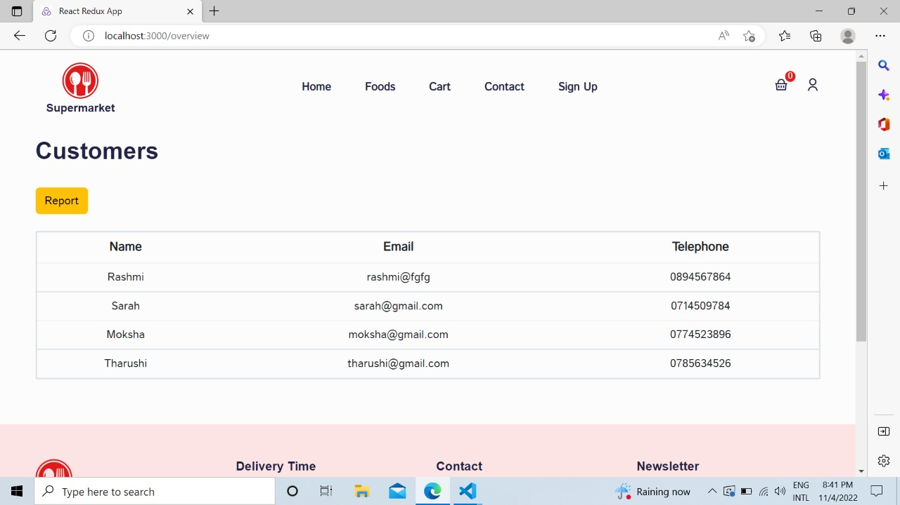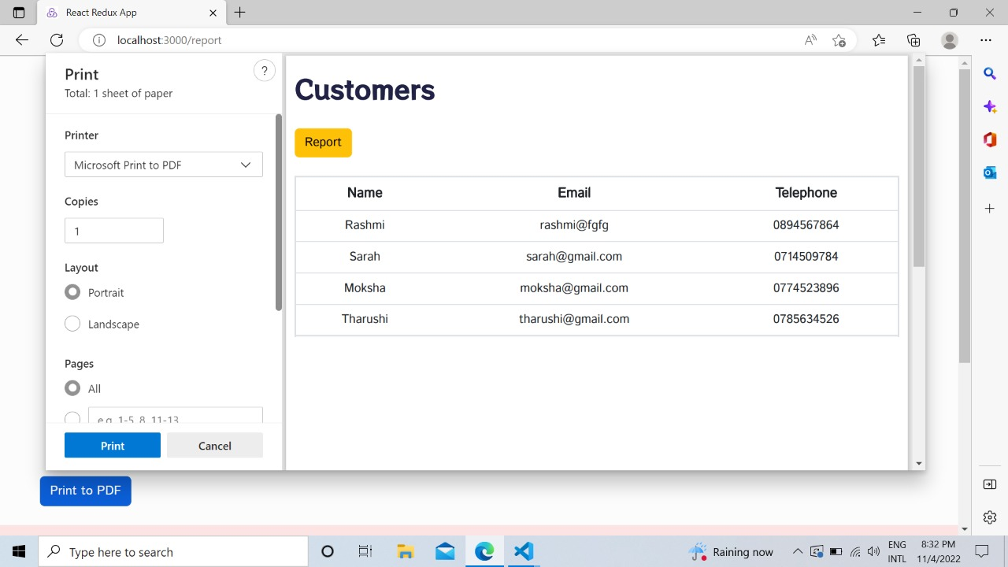

figure -Customers Overview Page

figure -Customer Report Generation

3.5.8.Premises Management

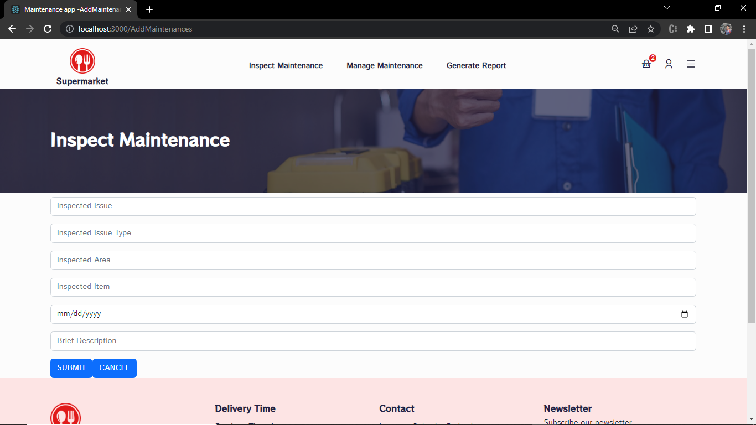

figure -Inspect Maintenance

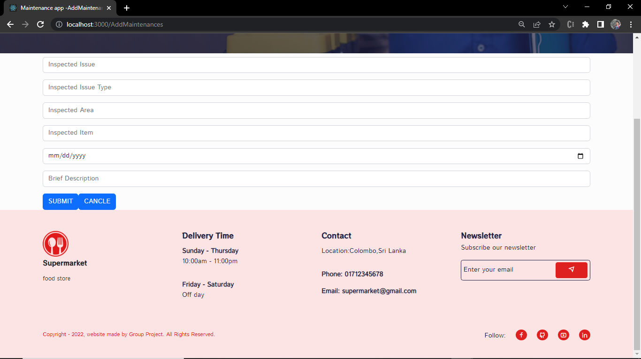

figure -Add Maintenance

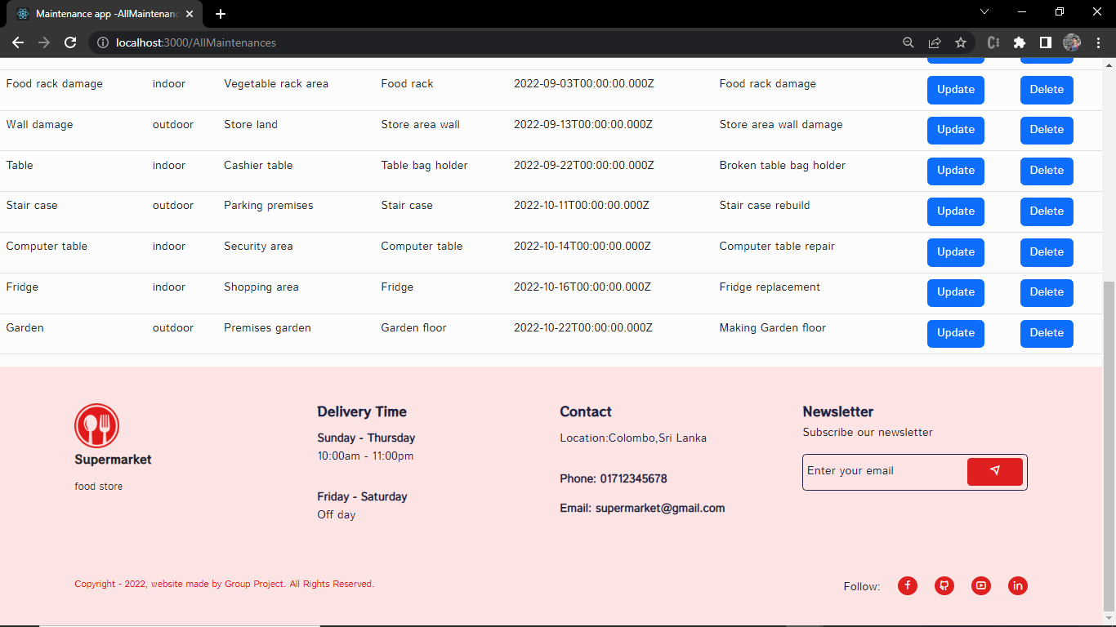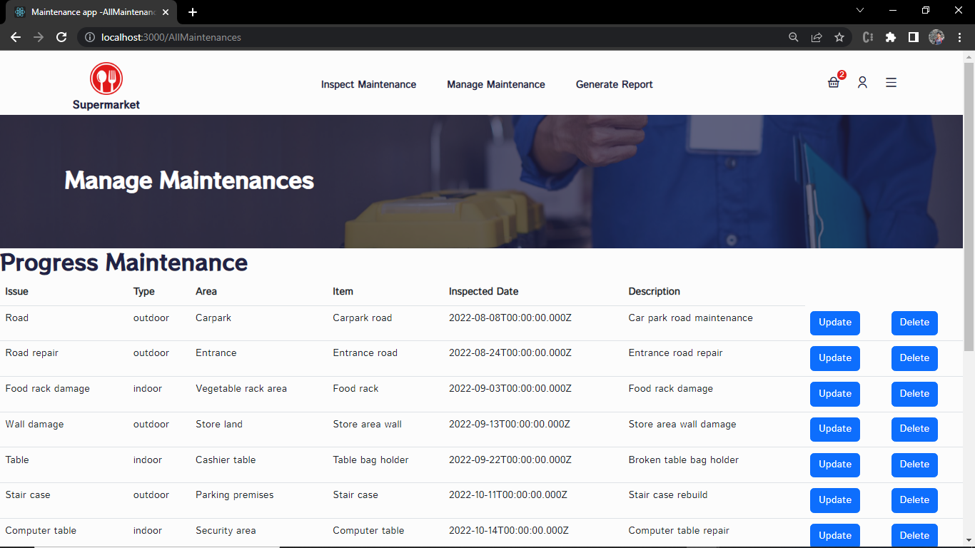

figure -Progress Maintenance

figure -All Maintenance

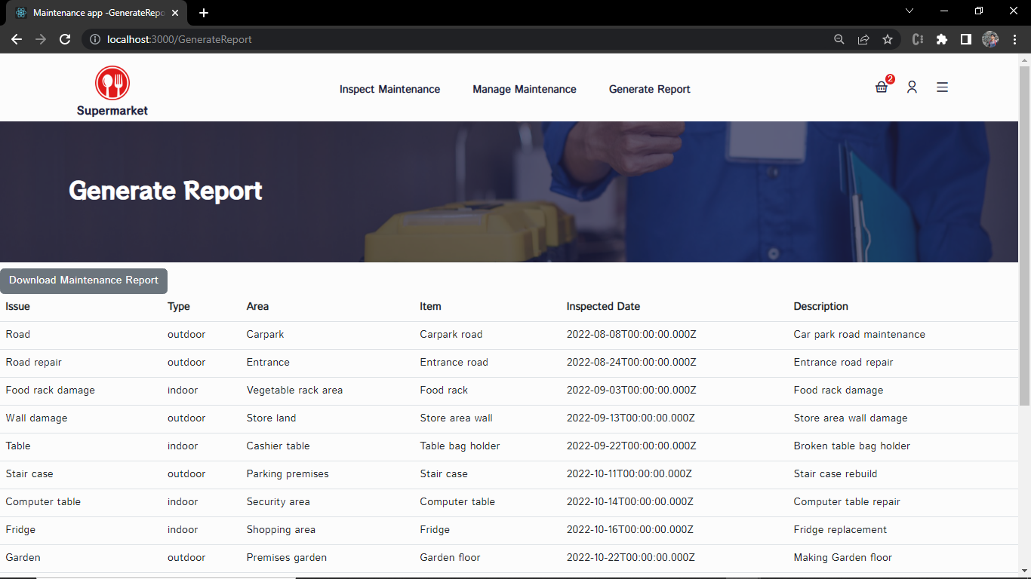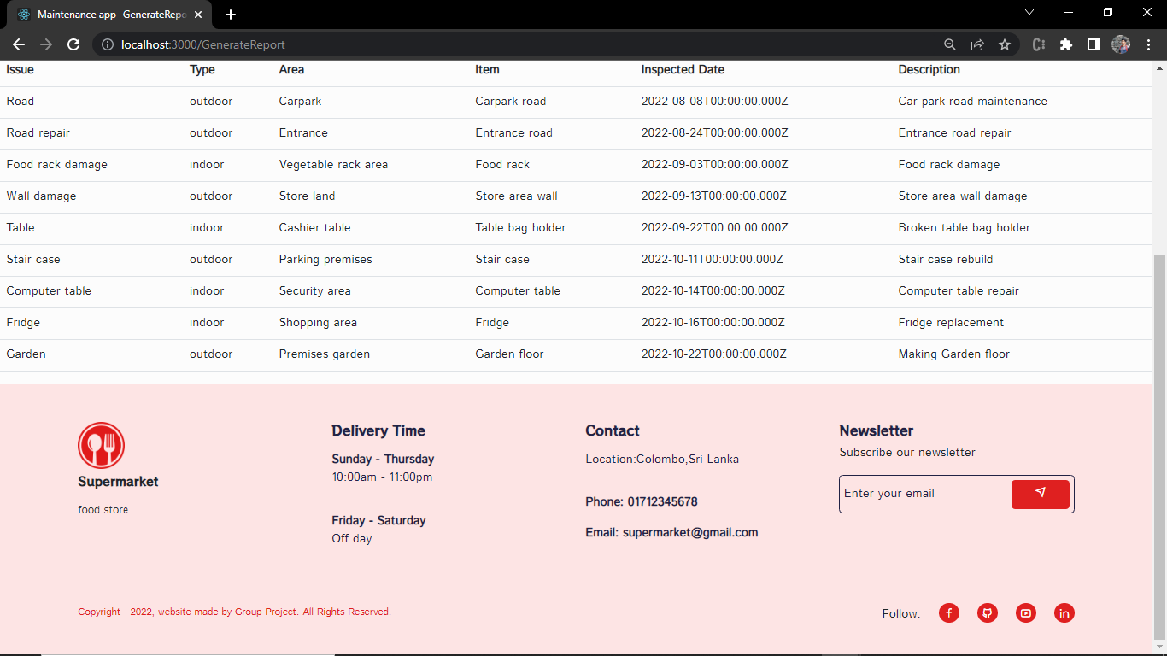

figure -Maintenance Overview Page

figure -Maintenance Generate Report

# Chapter 4.Testing

## 4.1.Stock and Inventory Management

|  |  |
| --- | --- |
| **Group ID : WD_B02_ITP_03** | |
| **Project title: Supermarket Management System** | |
| **Testing Function 1: Inventory Management** | |
| **Test case ID : IM_01** | **Test designed by:**  **Reg. No- IT21006548**  **Name- Liyanage S.D.K**  **Reg. No-**  **Name-**  **Reg. No-**  **Name-** |
| **Test priority (High/Medium/Low):** | High |
| **Test Description: This test is about adding stock details in to the database. All the stocks that are about to store in the store are saved in the databases. Information are about the item name, type, price, availability and reserved.** | |

|  |
| --- |
| **Preconditions (if there are any):** |
| **Dependencies (if there are any):** |

|  |
| --- |
| **Test steps:** |
| 1. **First user try to submit the form without filling any field in the form.** 2. **User try to submit the form without filling one field in the form.** 3. **User then click the submit button after filling the fields successfully** |

|  |
| --- |
| **Pass-condition:**   1. **If user try to submit the form without filling any of the fields. Show message asking to fill the field.** 2. **If user try to submit the form without filling only one field. Show message asking to fill that particular field.** 3. **When user press submit button after filling the fields successfully. Show item added message.** |

Table 2-Inventory and Stock Management Stock Management

|  |  |  |  |  |  |
| --- | --- | --- | --- | --- | --- |
| **Test executed Group ID: WD_B02_ITP_03**  **Test Executed members details:**  **Reg. No- IT21006548**  **Name- Liyanage S.D.K**  **Reg. No-**  **Name-** | | | | | |
| **Test ID** | **Test**  **Inputs** | **Expected Output** | Actual  Output | Result  (Pass/Fail) | Comments |
| **IT_01** | **Click Submit button after filling the input fields** | **Message “Item Added”** | **Message “Item Added”** | **pass** | **System working properly** |
| **IT_02** | **Item Name:**  **Item No:**  **Item Type:**  **Availability:**  **Reserved:**  **Price:** | **Message ”Please fill out this field ”** | **Message ”Please fill out this field ”** | **pass** | **System Working properly** |
| **IT_03** | **Item Name:**  **Item No: 131**  **Item Type: Vegetables**  **Availability: 150**  **Reserved: 500**  **Price: 134** | **Message ”Please fill out this field”** | **Message ”Please fill out this field”** | **pass** | **System working properly** |

Table -Inventory and Stock Management Test Cases

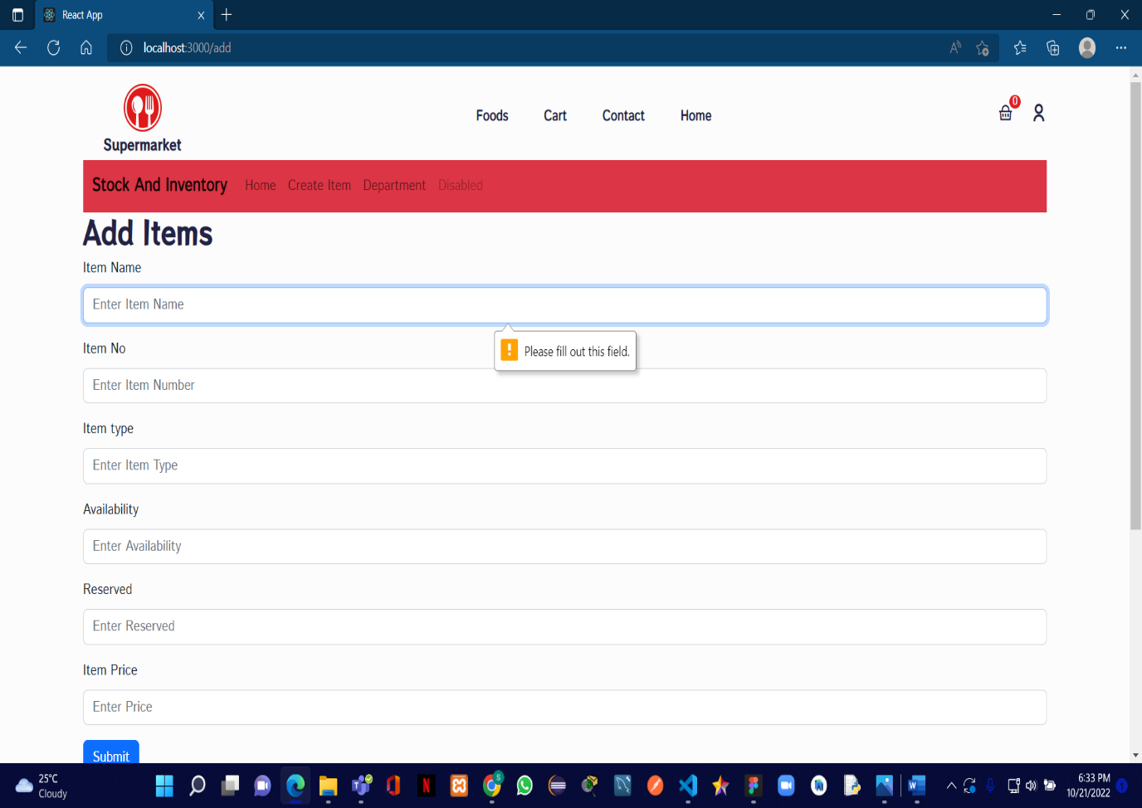

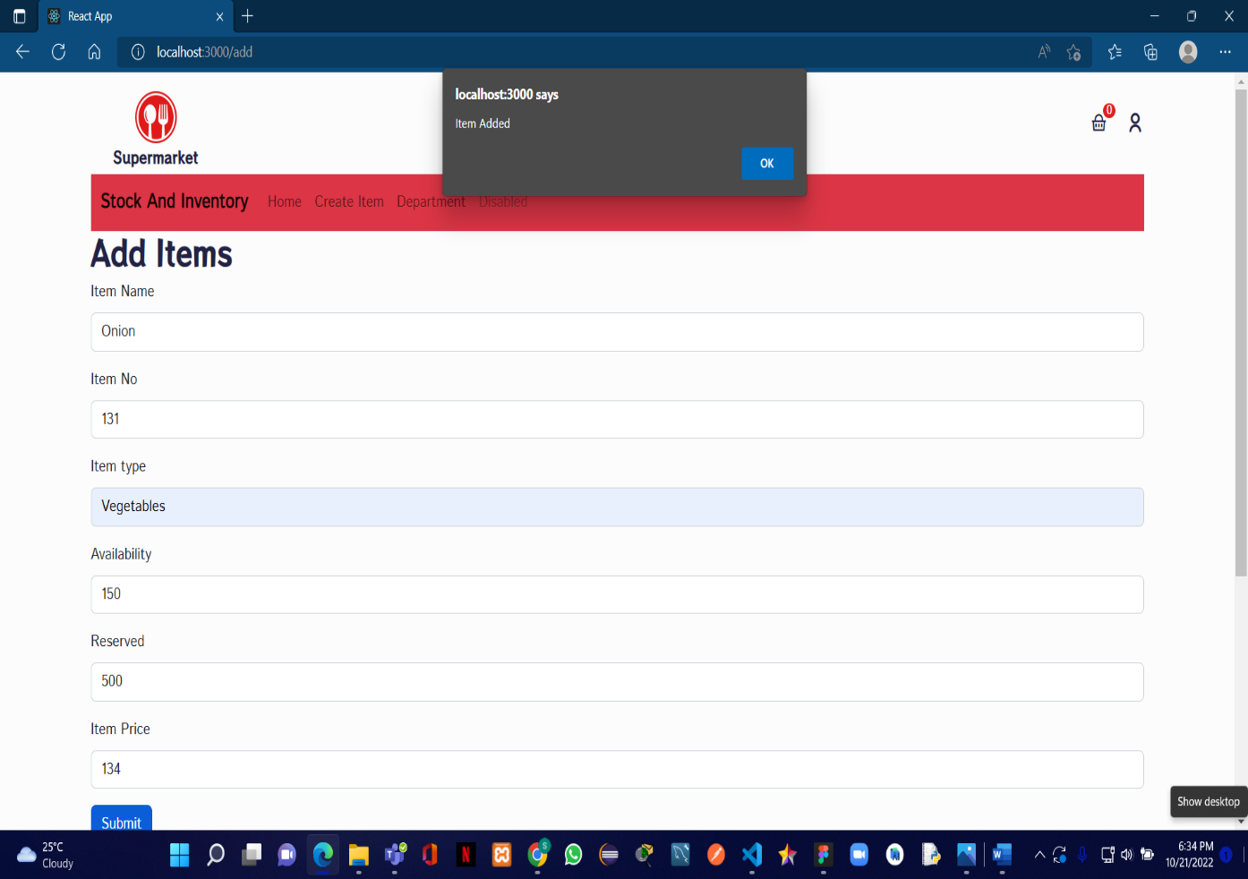

Figure -Add Items Success Message

Figure -Add Items Form Authentication

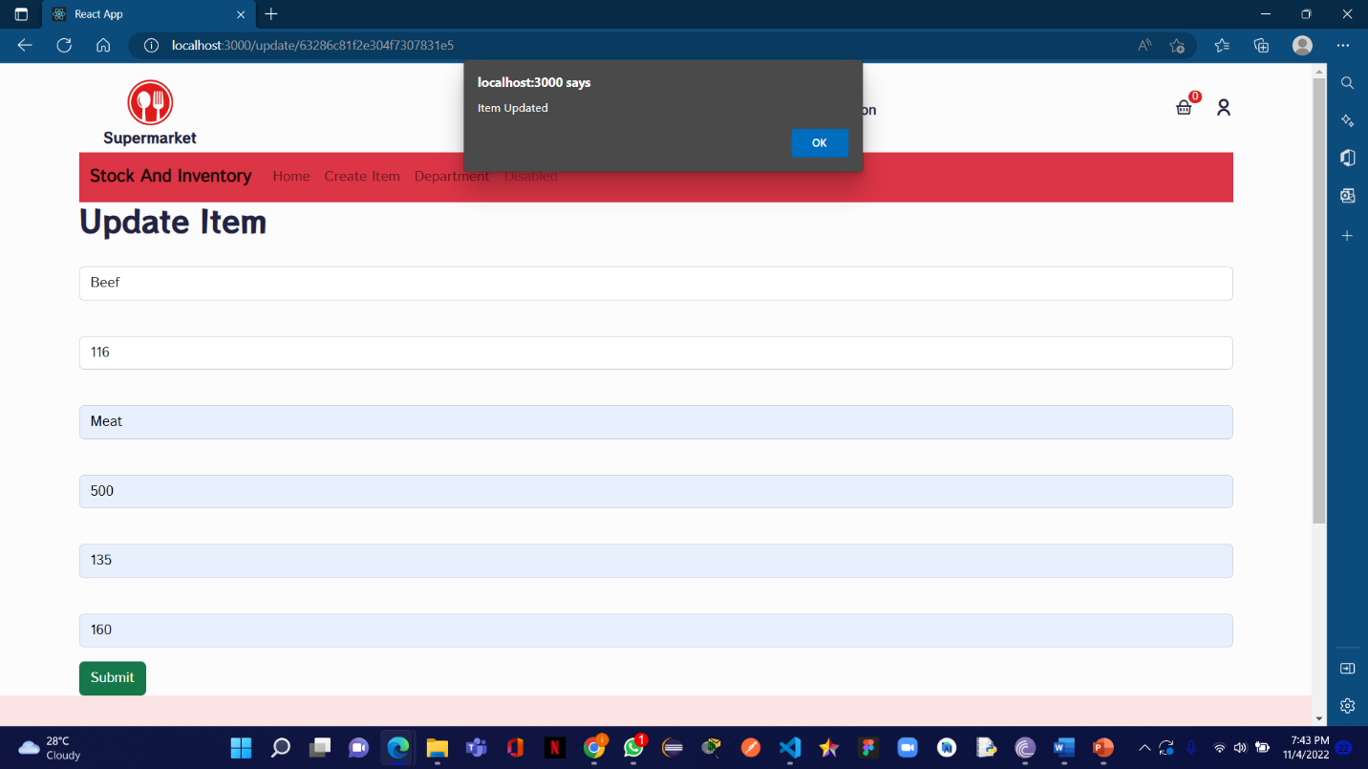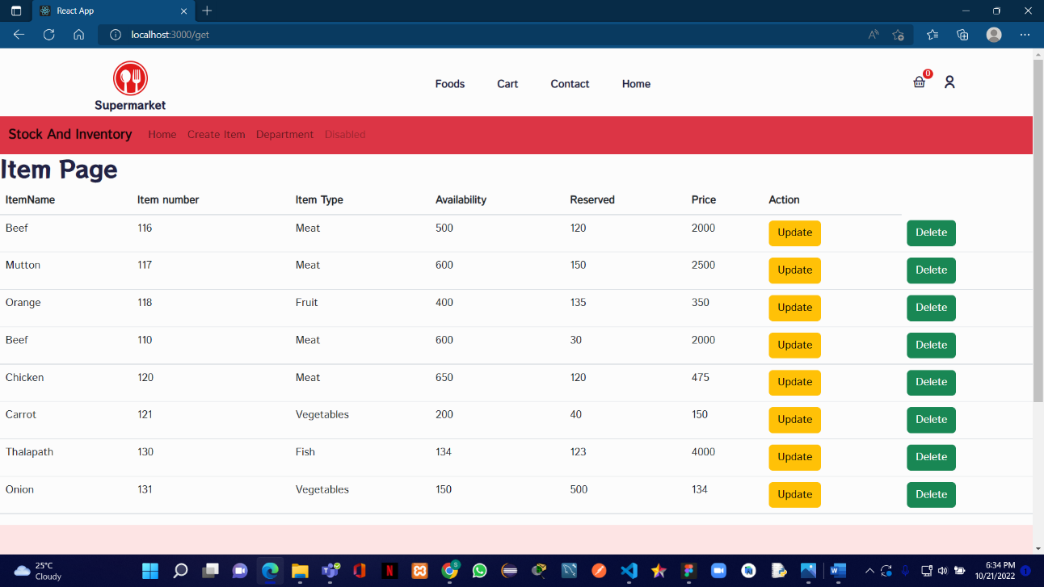

Figure -Update Success Message

Figure -Added Item fetched

## 4.2.Delivery Management

|  |  |
| --- | --- |
| **Group ID : WD_B02_ITP_03** | |
| **Project title: Supermarket Management System** | |
| **Testing Function 1: Delivery Management** | |
| **Test case ID : DM_01** | **Test designed by:**  **Reg. No-** IT21446030  **Name-** Fernando W.C.S  **Reg. No-**  **Name-**  **Reg. No-**  **Name-** |
| **Test priority (High/Medium/Low):** | Medium |
| **Test Description:**  When a customer makes an order, there are validations that need to be done before submitting the information. This test is to check if these validations are working properly. | |

|  |
| --- |
| **Preconditions (if there are any):** |
| **Dependencies (if there are any):** |

|  |
| --- |
| **Test steps:** |
| 1. **Customer fills all the fields successfully, without missing any field.** 2. **Customer tries to submit the form with a wrong phone number format** 3. **Customer tries to submit the form leaving out one field.** |

|  |  |  |  |  |  |
| --- | --- | --- | --- | --- | --- |
| **Test executed Group ID:**  **Test Executed members details:** Fernando W.C.S  **Reg. No-** IT21446030  **Name-**  **Reg. No-**  **Name-** | | | | | |
| **Test ID** | **Test**  **Inputs** | **Expected Output** | **Actual**  **Output** | **Result**  **(Pass/Fail)** | **Comments** |
| DM_01 | Name: Sarah Fernando  Phone Number: 0771562573  Location: Colombo  Date: 10/18/2022  Select Payment Option: Visa Card | Display “Order Success” message | Display “Order Success” message | Pass | System is working properly |
| DM_02 | Name:  Phone Number: 0771562573  Location: Colombo  Date: 10/18/2022  Select Payment Option: Visa Card | Display “Please fill out this field” message | Display “Please fill out this field” message | Pass | Form validations are working properly |
| DM_03 | Name: Sarah Fernando  Phone Number: 07715625739  Location: Colombo  Date: 10/18/2022  Select Payment Option: Visa Card | Display “Must contain 10 digits” message | Display “Must contain 10 digits” message | Pass | Form validations are working properly |

Table -Delivery Management Test Cases

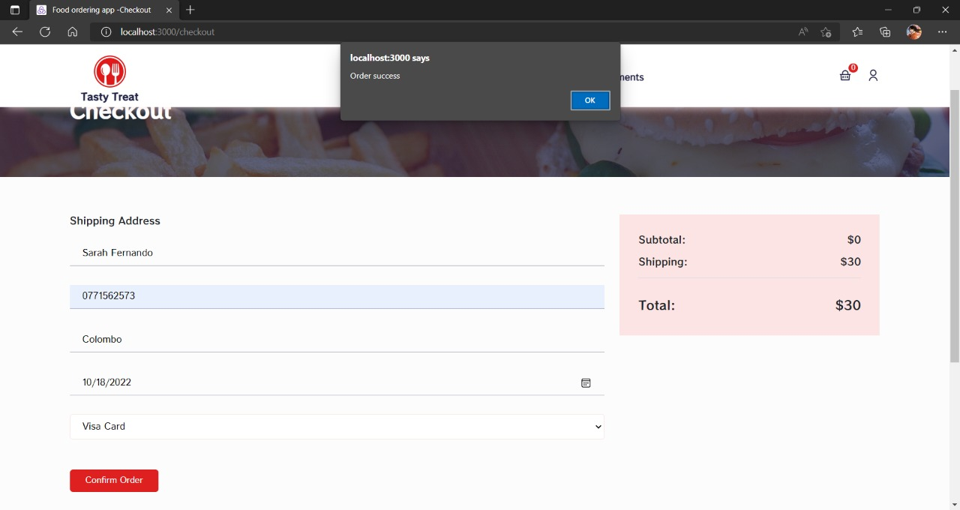

Figure -Order Added Success Message

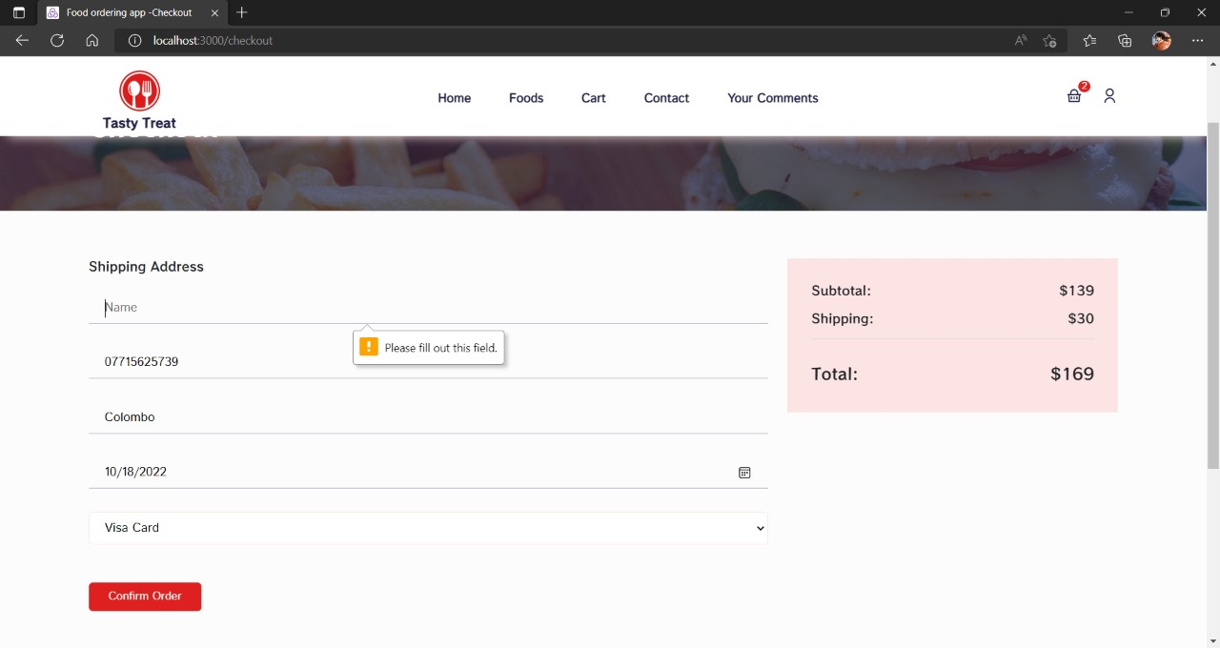

Figure -Checkout Page Name Authentication

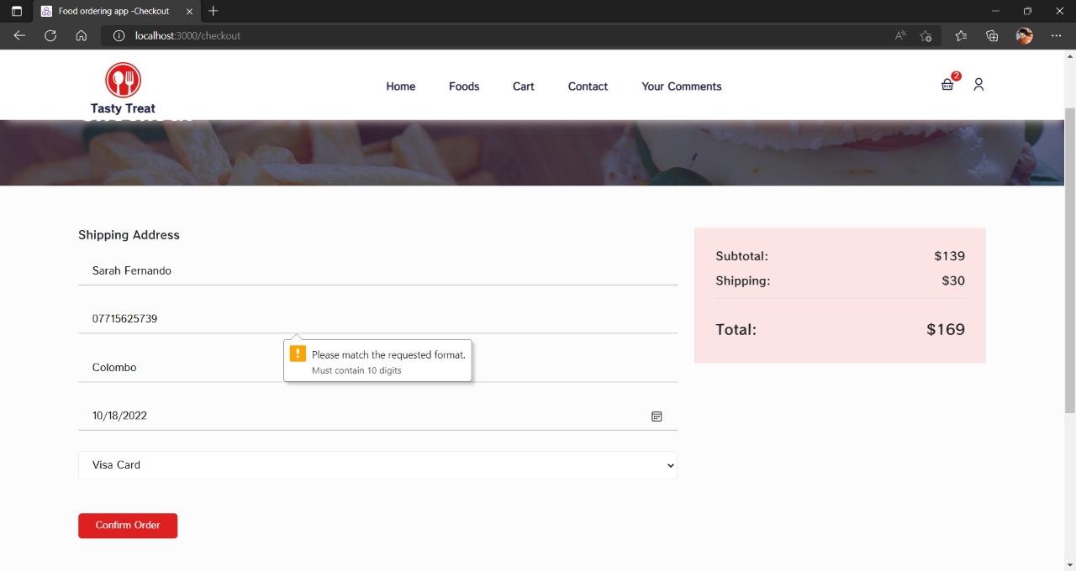

Figure -Requested Format Authentication

## 4.3.Marketing Management

|  |  |
| --- | --- |
| **Group ID : WD_B02_ITP_03** | |
| **Project title: Supermarket Management System** | |
| **Testing Function 1: Marketing Management** | |
| **Test case ID : MTC_01** | **Test designed by:**  **Reg. No-** IT21446108  **Name-** Fernando W.A.M  **Reg. No-**  **Name-**  **Reg. No-**  **Name-** |
| **Test priority (High/Medium/Low):** | Medium |
| **Test Description:**  When a customer wants to submit a comment, there are validations that need to be done before submitting the form. This test is to check if these validations are working properly. | |

|  |
| --- |
| **Preconditions (if there are any):** |
| **Dependencies (if there are any):** |

|  |
| --- |
| **Test steps:** |
| 1. **Customer fills all the fields successfully, without missing any field.** 2. **Customer tries to submit the form with a wrong email format** 3. **Customer tries to submit the form leaving out one field.** |

|  |  |  |  |  |  |
| --- | --- | --- | --- | --- | --- |
| **Test executed Group ID:**  **Test Executed members details:** Fernando W.A.M  **Reg. No-** IT21446108  **Name-**  **Reg. No-**  **Name-** | | | | | |
| **Test ID** | **Test**  **Inputs** | **Expected Output** | **Actual**  **Output** | **Result**  **(Pass/Fail)** | **Comments** |
| **MM_01** | **First Name: Moksha**  **Last Name: Fernando**  **Email: mfernando123@gmail.com**  **Your Comment: I am extremely satisfied with the service** | **Display “Comment submitted” message** | **Display “ Comment submitted ” message** | **Pass** | **System is working properly** |
| **MM_02** | **First Name:**  **Last Name: Fernando**  **Email: mfernando123@gmail.com**  **Your Comment: I am extremely satisfied with the service** | **Display “Please fill out this field” message** | **Display “Please fill out this field” message** | **Pass** | **Form validations are working properly** |
| **MM_03** | **First Name: Moksha**  **Last Name: Fernando**  **Email: mfernando123**  **Your Comment: I am extremely satisfied with the service** | **Display “Please include an ‘@’ in the email address. ‘mfernando123’ is missing an ‘@’**  **” message** | **Display “Please include an ‘@’ in the email address. ‘mfernando123’ is missing an ‘@’**  **” message** | **Pass** | **Form validations are working properly** |

Table -Marketing Management Test Cases

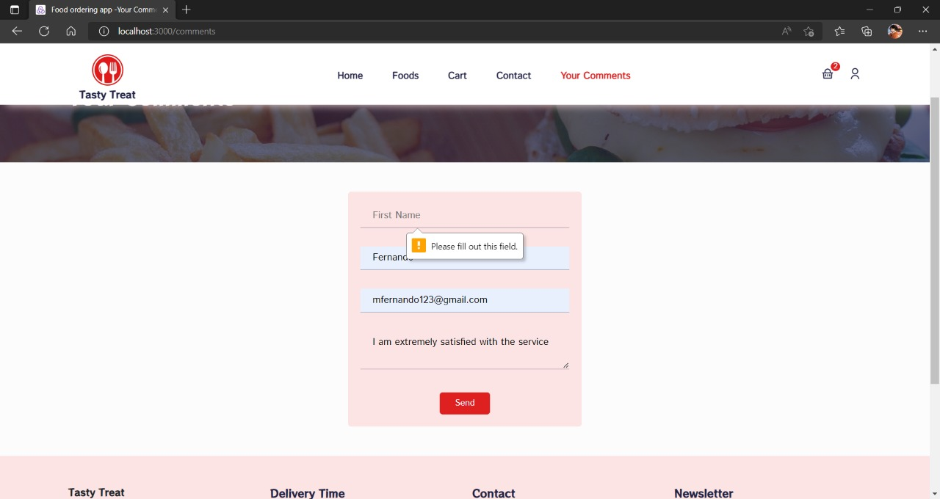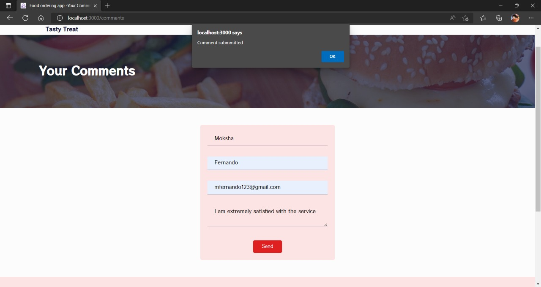

Figure -Add Comment Name Authentication

Figure -Comment Submitted Success Message

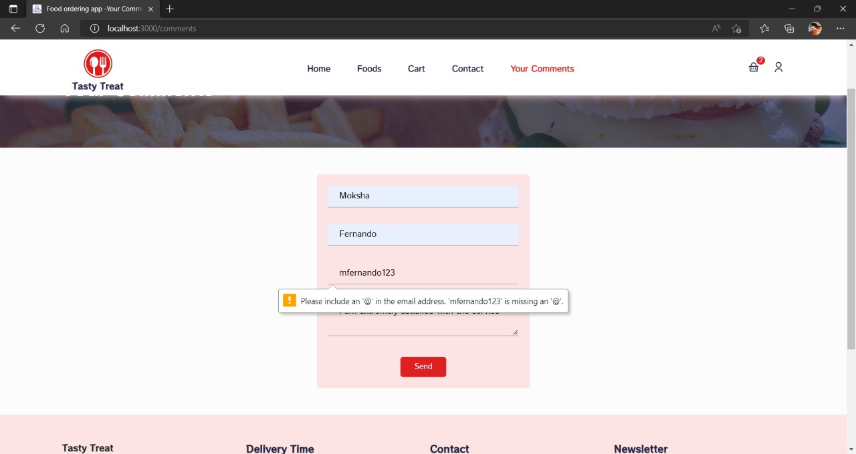

Figure -Add Comment Email Authentication

## 4.4.Customer Management

|  |  |
| --- | --- |
| **Group ID : WD_B02_ITP_03** | |
| **Project title: Supermarket Management System** | |
| **Testing Function 1: Customer Management** | |
| **Test case ID : CM_01** | **Test designed by:**  **Reg. No-**IT21050626  **Name-**Gamage A.G.R.U.  **Reg. No-**  **Name-**  **Reg. No-**  **Name-** |
| **Test priority (High/Medium/Low):** | High |
| **Test Description:**  This test is about registering a customer into the system. Customer should add his name, email address, telephone number and create a password when registering to the system. | |

Table 6-Customer Management Test Cases

|  |
| --- |
| **Preconditions (if there are any):** |
| **Dependencies (if there are any):** |

|  |
| --- |
| **Test steps:** |
| 1. Customer tries to submit the form without filling one field in the form. 2. Customer tries to submit the form entering more than 10 digits to the Telephone Number field. 3. Customer tries to submit the form not creating a password requested by the field. 4. Customer filling every field as requested in the form. 5. Customer then clicks the submit button. |

|  |
| --- |
| **Pass-condition:**   1. If customer tries to submit the form without filling one field, shows a message asking to fill that field. 2. If customer tries to submit the form entering more than 10 digits to the Telephone Number field, shows a message to fill the field with the requested format. 3. If customer tries to submit the form not creating a strong enough password, shows a message to fill the field with the requested format. 4. If customer fills every field as requested in the form, shows Customer Added message. |

|  |  |  |  |  |  |
| --- | --- | --- | --- | --- | --- |
| **Test executed Group ID:**  **Test Executed members details:** Gamage A.G.R.U  **Reg. No-** IT21050626  **Name-**  **Reg. No-**  **Name-** | | | | | |
| **Test ID** | **Test**  **Inputs** | **Expected Output** | Actual  Output | Result  (Pass/Fail) | Comments |
| CM_01 | Full Name: Rashmi Gamage  Email: [rashmi123@gmail.com](mailto:rashmi123@gmail.com)  Password: Rashmi123  Telephone Number: 0735763726 | Display “Customer added” message | Display “Customer added” message | Pass | System is working properly |
| CM_02 | Full Name: Upamalika Silva  Email: [upama25@gmail.com](mailto:upama25@gmail.com)  Password: silva  Telephone Number: 0733928327 | Display “Must contain at least one number and one uppercase and lowercase letter, and at least 8 or more characters  ” message | Display “Must contain at least one number and one uppercase and lowercase letter, and at least 8 or more characters  ” message | Pass | Form validations are working properly |
| CM_03 | Full Name: Upamalika Silva  Email: [upama25@gmail.com](mailto:upama25@gmail.com)  Password: UpamaSilva25  Telephone Number: 073396698753 | Display “Must contain 10 digits  ” message | Display “Must contain 10 digits  ” message | Pass | Form validations are working properly |

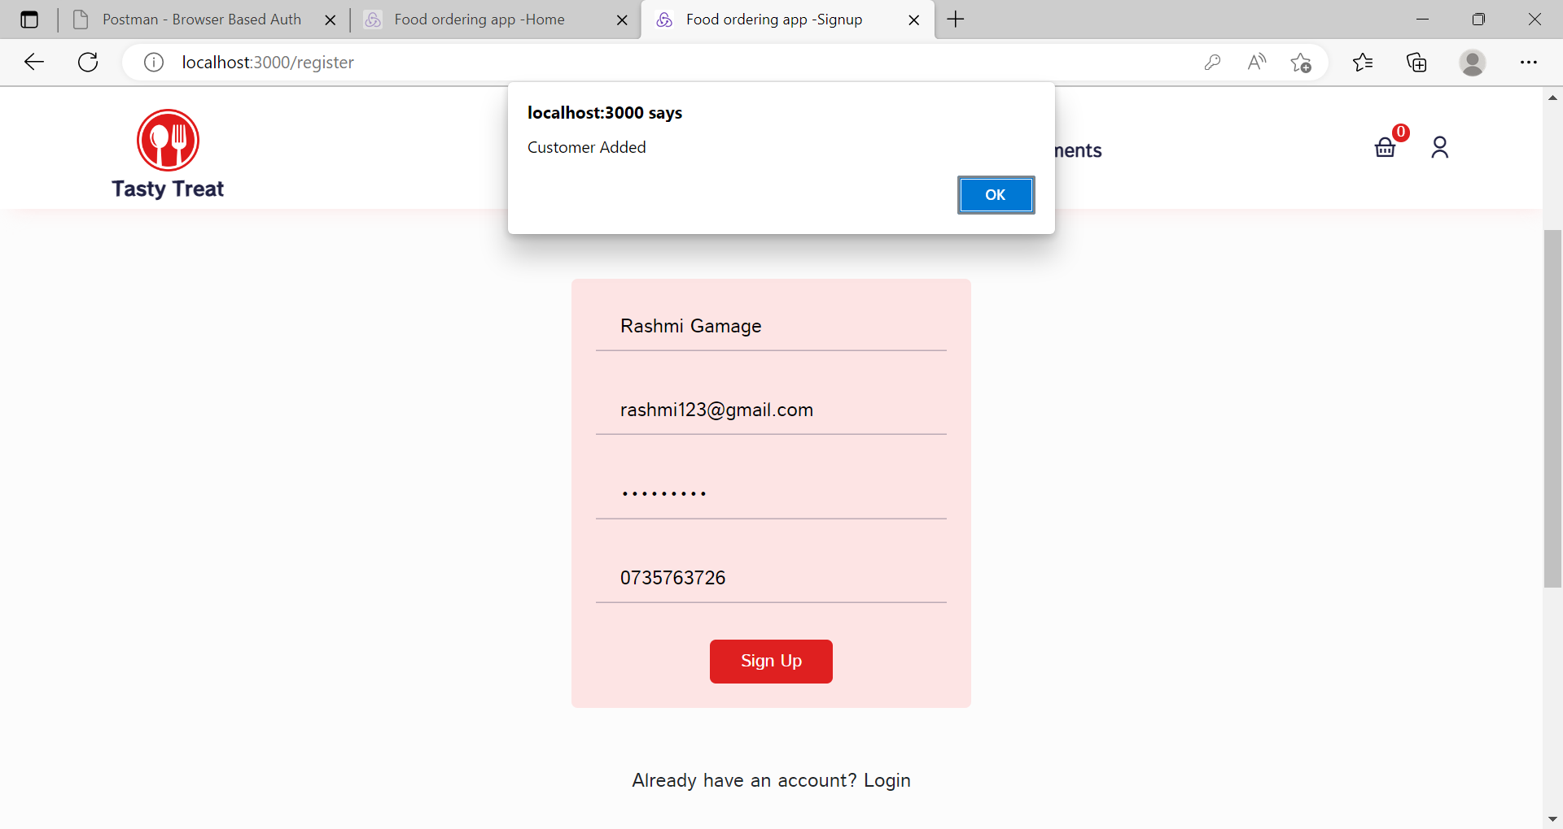

Figure -Customer Added Success Message

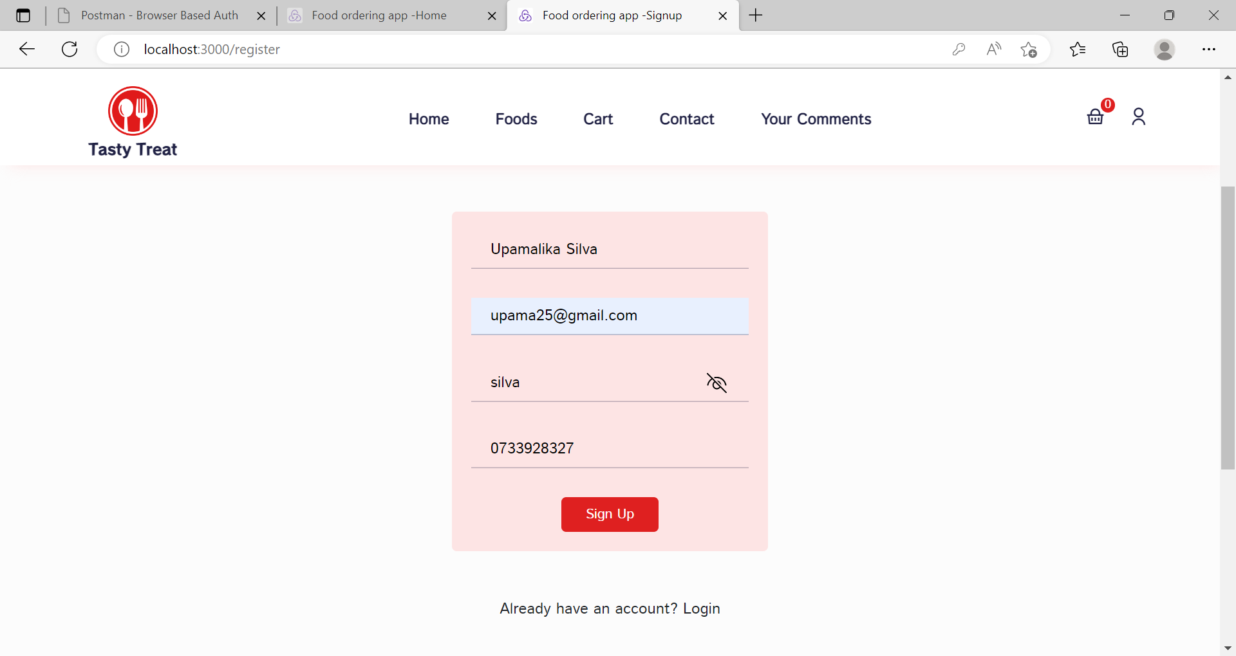

Figure -Customer Adding Process

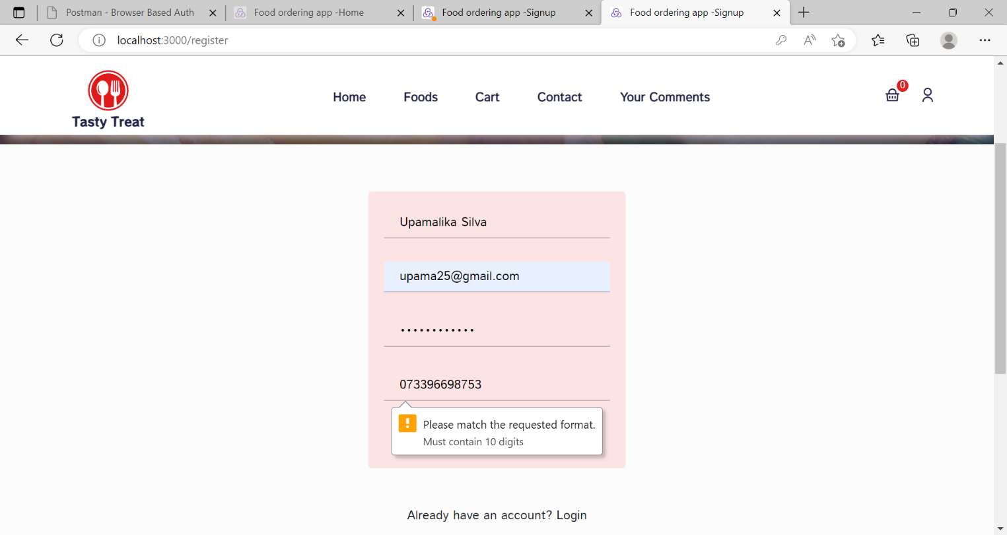

Figure -Phone Number Authentication

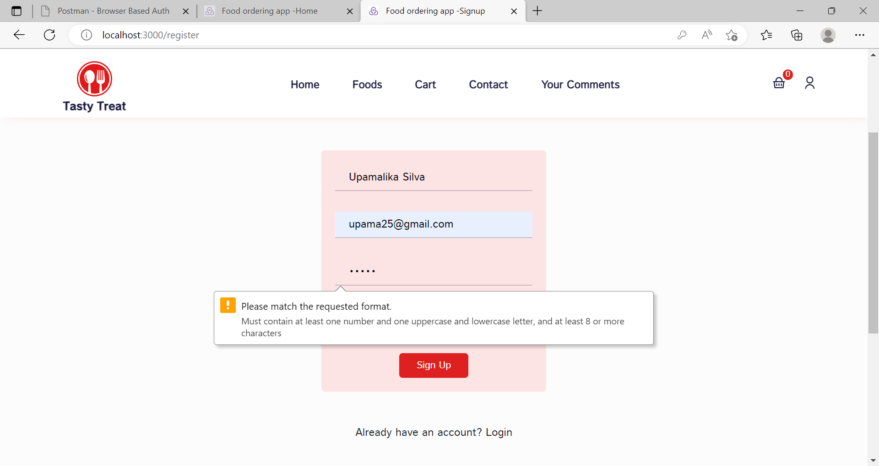

Figure -Password Authentication

## 4.5.Financial Management

|  |  |
| --- | --- |
| **Group ID: WD_B02_ITP_03** | |
| **Project title: Supermarket Management System** | |
| **Testing Function 1: Financial Management** | |
| **Test case ID: IM_01** | **Test Designed by:**  **Reg. No: IT21004186**  **Name: Medawatta H.M.H.N** |
| **Test priority (High/Medium/Low):** | **High** |
| **Test Description: This function is about storing Employee details and Company’s Assets details into database. And it will give the final count of the employee’s total salary amount. Also, the total value of Assets that company holds will display in the Statement Section. So, the Managerial staff able to get the total income of the sector.** | |

|  |
| --- |
| **Preconditions (if there are any):** |
| **Dependencies (if there are any):** |

|  |
| --- |
| **Test Steps:** |
| **1. First User try to submit form without filling any field in the form.**  **2. User try to submit the form with incomplete field.**  **3. User click the submit button after filling the fields successfully.** |

|  |
| --- |
| **Pass-condition:**  **1. If User try to submit the form without filling any of the fields, prompt a message asking to fill the fields.**  **2. If user try to submit the form with incomplete field. Show message asking to fill that**  **field.**  **3. When user press submit button after filling the fields successfully. Show item added message.** |

|  |  |  |  |  |  |
| --- | --- | --- | --- | --- | --- |
| **Test executed Group ID: WD_B02_ITP_03**  **Test Executed members details:**  **Reg. No- IT21004186**  **Name- Medawatta H.M.H.N** | | | | | |
| **Test ID** | **Test Inputs** | **Expected**  **Output** | **Actual Output** | **Result**  **(Pass/Fail)** | **Comments** |
| **ID_01** | **Click Submit**  **button after**  **filling the**  **input fields** | **Message “Item Added”** | **Message**  **“Item Added”** | **pass** | **System working properly** |
| **ID_02** | **EmpID:**  **Name:**  **Age:**  **Gender:**  **Phone:**  **Position:**  **Salary Amount:** | **Message**  **“Please fill out**  **this field”** | **Message**  **“Please fill**  **out this field”** | **pass** | **System working properly** |
| **ID_03** | **EmpID: EM1707**  **Name: Jamal Musiala**  **Age:20**  **Gender: Male**  **Phone:**  **Position: System Analyst**  **Salary Amount:470000** | **Message**  **“Please fill out**  **this field”** | **Message**  **“Please fill**  **out this field”** | **pass** | **System working properly** |

Table -Financial Management Test Cases

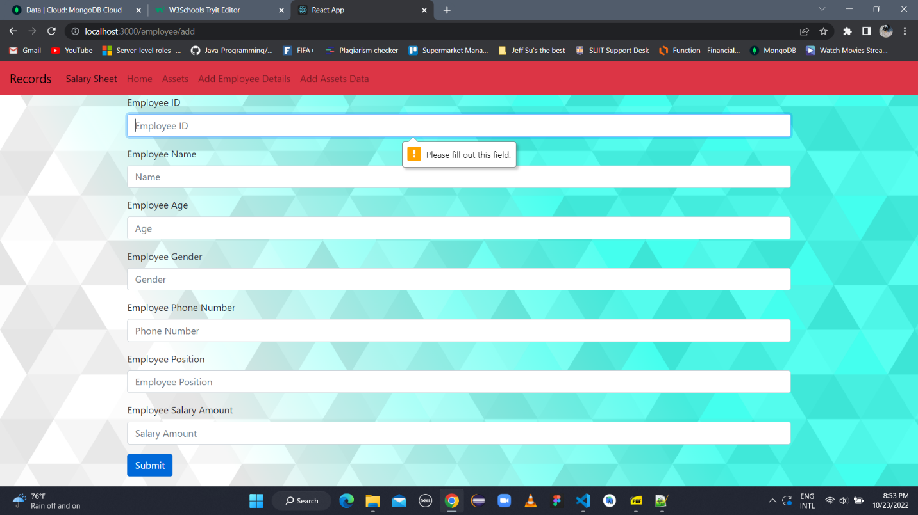

Figure -Add Employee Form Authentication

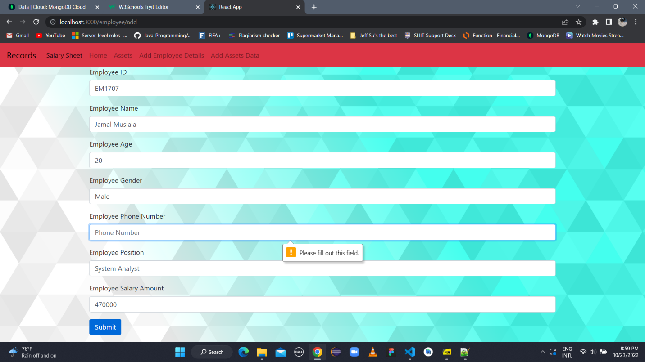

Figure -Add Employee Phone Number Authentication

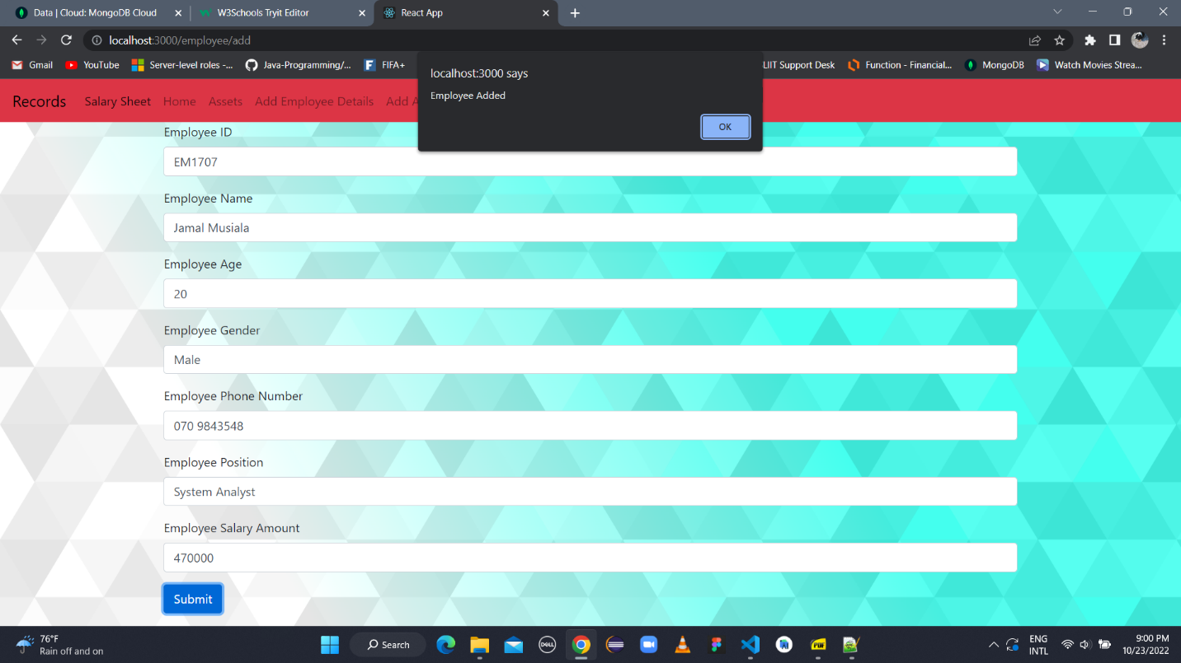

Figure -Employee Added Success Message

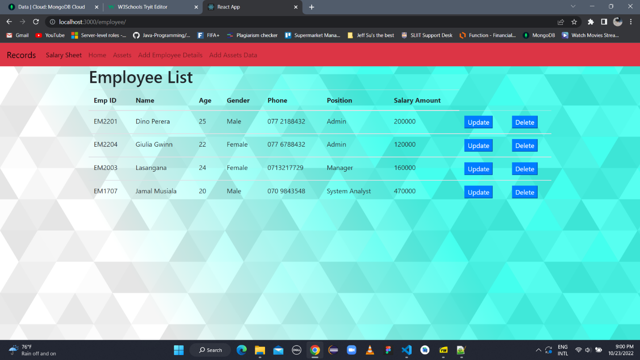

Figure -All Employee List

## 4.6.Premises Management

|  |  |
| --- | --- |
| **Group ID : WD_B02_ITP_03** | |
| **Project title: Supermarket Management System** | |
| **Testing Function 1: Premises Management** | |
| **Test case ID : PM_01** | **Test designed by:**  **Reg. No- IT21001802**  **Name- Panditharathne I.G**  **Reg. No-**  **Name-**  **Reg. No-**  **Name-** |
| **Test priority (High/Medium/Low):** | High |
| **Test Description:**  **This test is about adding maintenance details in to the database.**  **All the maintenances that are about to maintain in the premises are saved in the databases.**  **Information are about the Inspected issue, type, area, item, date and description.** | |

|  |
| --- |
| **Preconditions (if there are any):** |
| **Dependencies (if there are any):** |

|  |
| --- |
| **Test steps:** |
| 1. **Firstly user attempts to submit the form without filling out any of field in the form.** 2. **User attempts to submit the form without filling out even one field in the form.** 3. **After filling out the fields successfully ,the user clicks the submit button.** |

|  |
| --- |
| **Pass-condition:**   1. **If user attempt to submit the form without filling any of the fields, Display a message requesting the user to fill up the field.** 2. **If user attempt to submit the form without filling one or more fields, Display a message requesting the user to fill up that specific particular field.** 3. **When user press submit button after filling the fields successfully, Display item added** 4. **message.** |

|  |  |  |  |  |  |
| --- | --- | --- | --- | --- | --- |
| **Test executed Group ID: WD_B02_ITP_03**  **Test Executed members details:**  **Reg. No- IT21001802**  **Name- Panditharathne I.G**  **Reg. No-**  **Name-** | | | | | |
| **Test ID** | **Test**  **Inputs** | **Expected Output** | Actual  Output | Result  (Pass/Fail) | Comments |
| **IT_01** | **Click Submit button after filling the input fields.**  **Inspected issue: Garden**  **Inspected issue type:outdoor**  **Inspected area:Premises Garden**  **Inspected item: Garden floor**  **Inspected date:10/22/2022**  **Brief description: Making Garden floor** | **Message “Maintenance Added”** | **Message “Maintenance Added”** | **Pass** | **System working properly** |
| **IT_02** | **Inspected issue:**  **Inspected issue type:**  **Inspected area:**  **Inspected item:**  **Inspected date:**  **Brief description:** | **Message “Please fill out this field.”** | **Message “Please fill out this field.”** | **Pass** | **System working properly** |
| **IT_03** | **Inspected issue:**  **Inspected issue type:outdoor**  **Inspected area:Premises Garden**  **Inspected item: Garden floor**  **Inspected date:10/22/2022**  **Brief description: Making Garden floor** | **Message “Please fill out this field.”** | **Message “Please fill out this field.”** | **Pass** | **System working properly** |

Table -Premises Management Test Cases

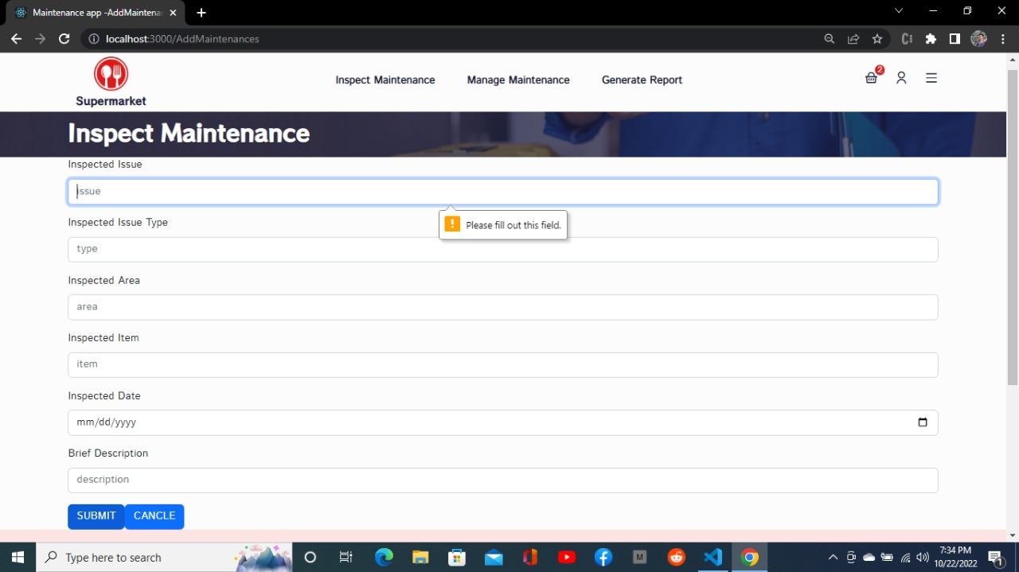

Figure -Insepect Maintenance Form Authentication

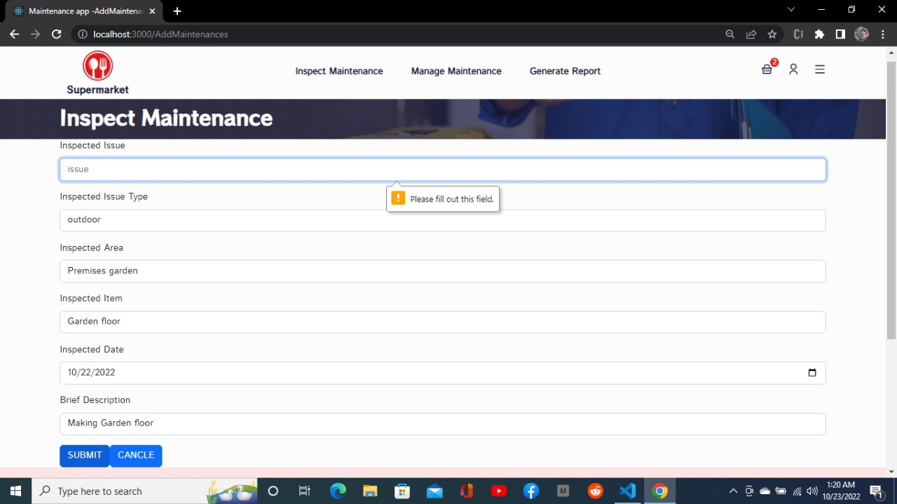

Figure -Maintenance Form Authentication

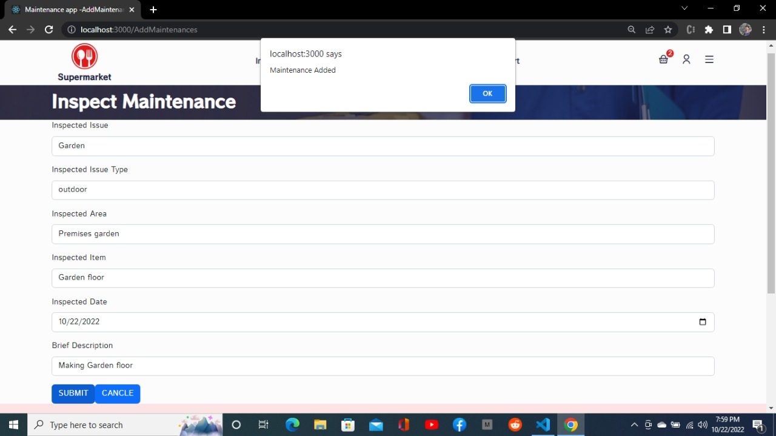

Figure -Maintenance Added Success Message

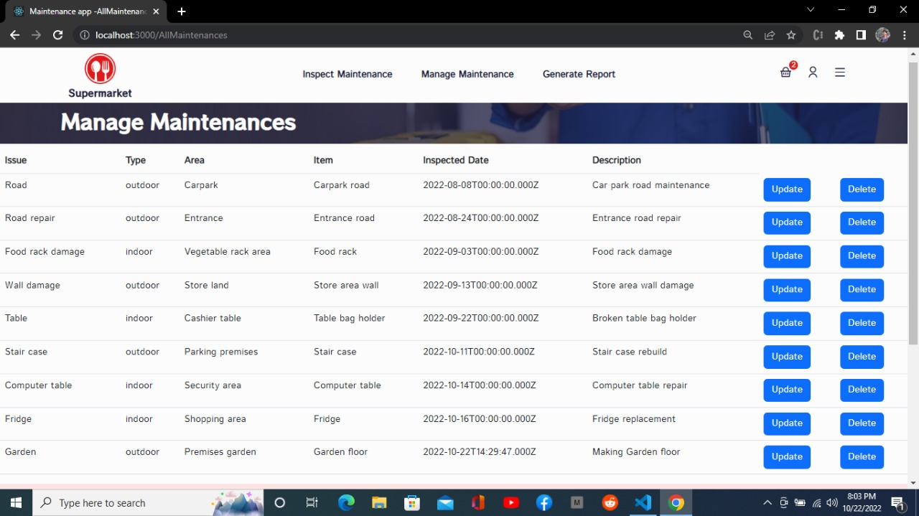

Figure -Manage Maintenance

## 4.7.Sales and Purchase Management

|  |  |
| --- | --- |
| **Group ID : WD_B02_ITP_03** | |
| **Project title: Supermarket Management System** | |
| **Testing Function 1: Sales and purchase management** | |
| **Test case ID : S&P_1** | **Test designed by:**  **Reg. No- IT2102342**  **Name- Yapa D.G.A.B.S**  **Reg. No-**  **Name-**  **Reg. No-**  **Name-** |
| **Test priority (High/Medium/Low):** | High |
| **Test Description:**  **This test is about adding Sales details in to the database.**  **All the Sales that are to maintain are saved in the database.**  **Information are about the Sales ID ,Sales Quantity , Sales Product and Sales Amount.** | |

|  |
| --- |
| **Preconditions (if there are any):** |
| **Dependencies (if there are any):** |

|  |
| --- |
| **Test steps:** |
| 1. **Firstly user attempts to submit the form without filling out any of field in the form.** 2. **User attempts to submit the form without filling out even one field in the form.** 3. **After filling out the fields successfully ,the user clicks the submit button.** |

|  |
| --- |
| **Pass-condition:**   1. **If user attempt to submit the form without filling any of the fields, Display a message requesting the user to fill up the field.** 2. **If user attempt to submit the form without filling one or more fields, Display a message requesting the user to fill up that specific particular field.** 3. **When user press submit button after filling the fields successfully, Display Sale added** 4. **message.** |

|  |  |  |  |  |  |
| --- | --- | --- | --- | --- | --- |
| **Test executed Group ID: WD_B02_ITP_03**  **Test Executed members details:**  **Reg. No- IT21002342**  **Name- Yapa D.G.A.B.S**  **Reg. No-**  **Name-** | | | | | |
| **Test ID** | **Test**  **Inputs** | **Expected Output** | Actual  Output | Result  (Pass/Fail) | Comments |
| **IT_01** | **Click Submit button after filling the input fields.**  **Sales ID: 0007**  **Sales Quantity :250**  **Sales Product :Sprite 150ml**  **Sales Amount: 200** | **Message “ Sale Added”** | **Message “ Sale Added”** | **Pass** | **System working properly** |
| **IT_02** | **Sales ID :**  **Sales Quantity :**  **Sales Product :**  **Sales Amount :** | **Message “Please fill out this field.”** | **Message “Please fill out this field.”** | **Pass** | **System working properly** |
| **IT_03** | **Sales ID:**  **Sales Quantity :250**  **Sales Product :Sprite 150ml**  **Sales Amount: 200** | **Message “Please fill out this field.”** | **Message “Please fill out this field.”** | **Pass** | **System working properly** |

Table -Purchase and Sales Test Cases

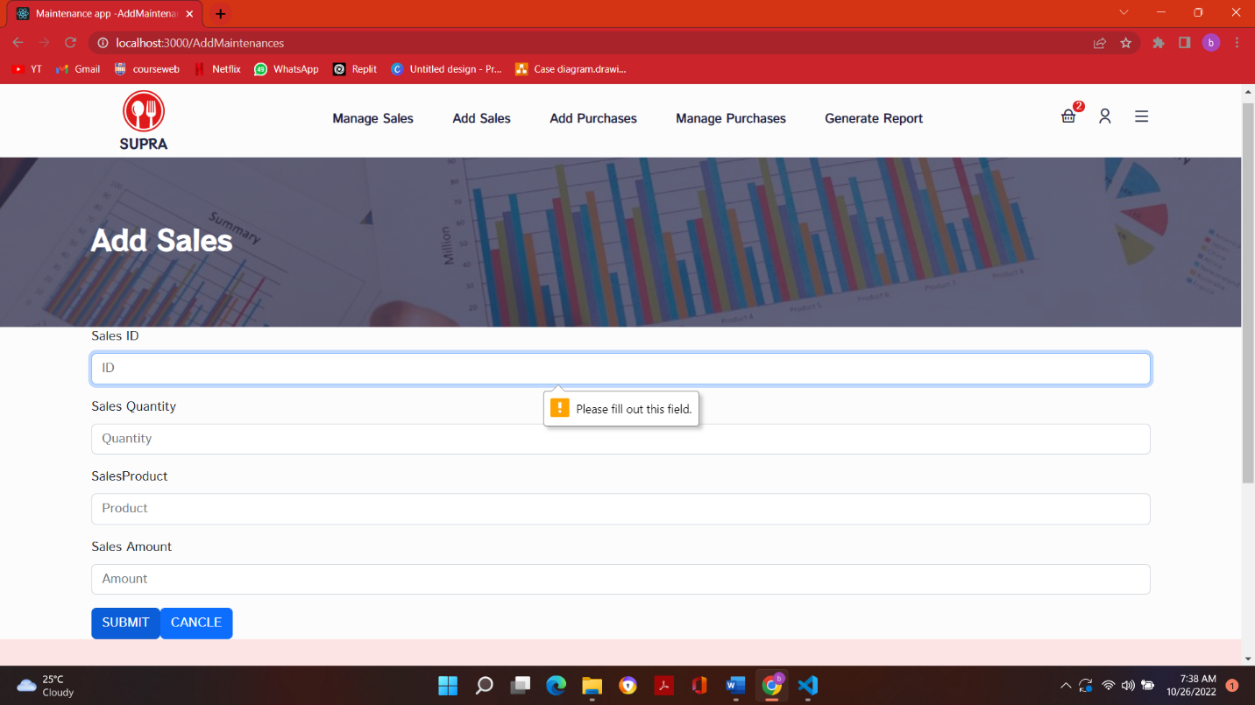

Figure -Add Sales Form Authentication

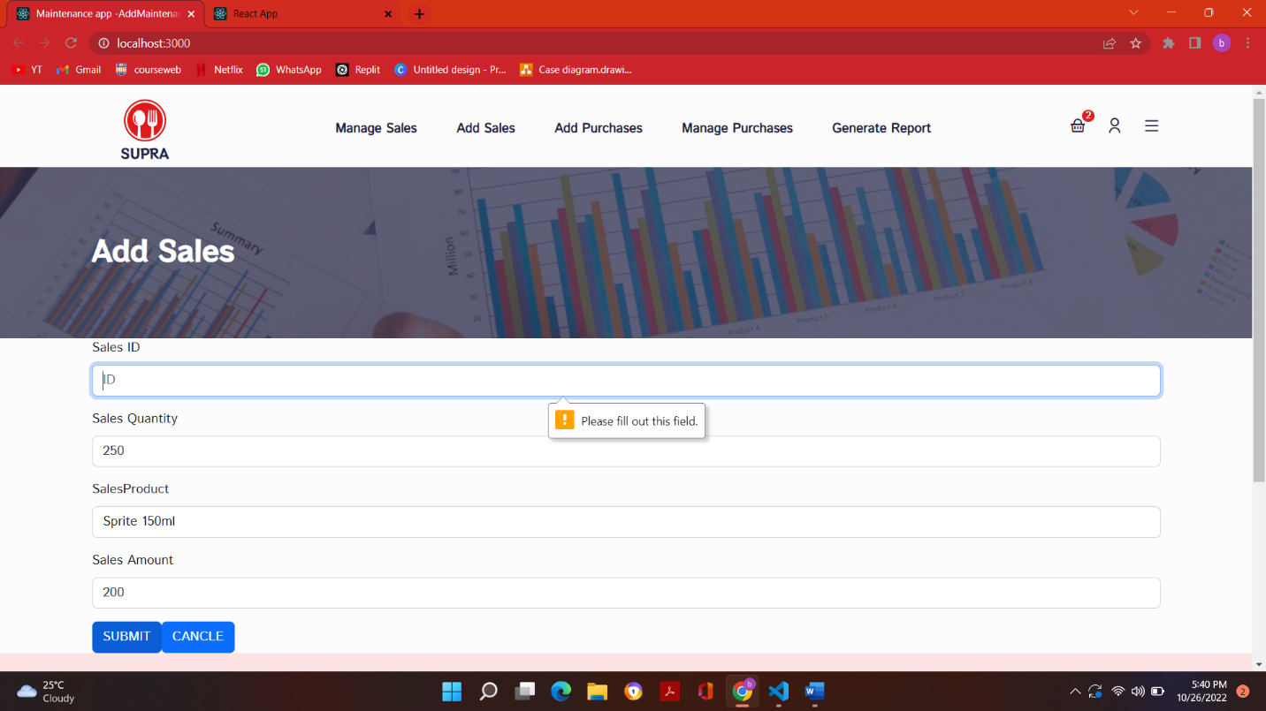

Figure -Add Sales Id Authentication

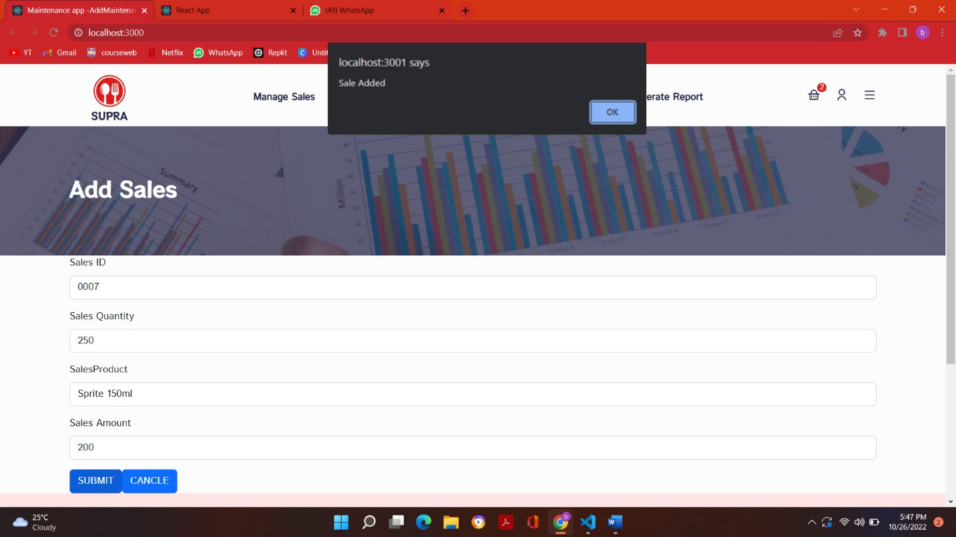

Figure -Sales Added Success Message

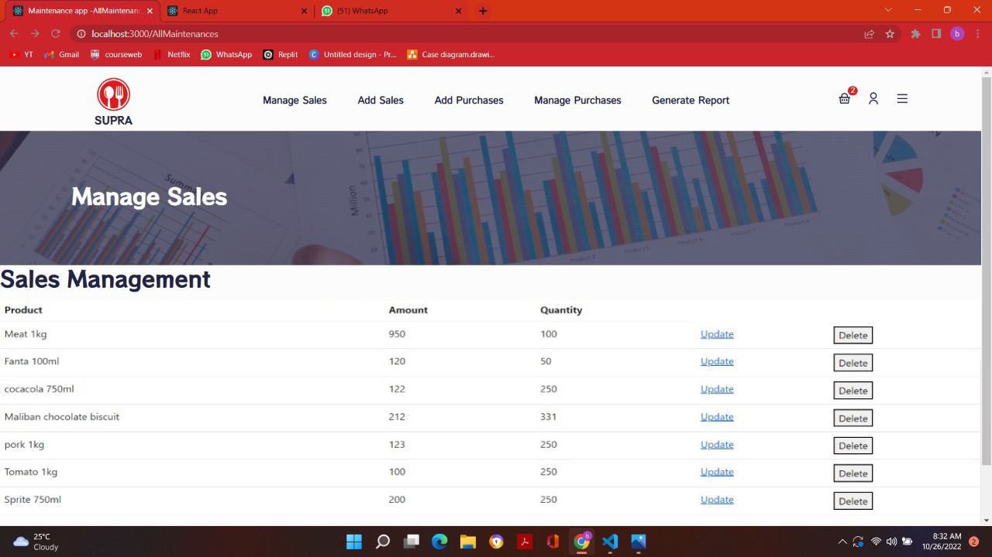

Figure -Manage Sales Page

## 4.8.Staff management

|  |  |
| --- | --- |
| **Group ID :** | |
| **Project title: Super Market Management System** | |
| **Testing Function 1: Staff Management** | |
| **Test case ID :** STM_01 | **Test designed by:**  **Reg. No- IT21060380**  **Name- Lakshan P.R.D**  **Reg. No- IT21060380**  **Name- Lakshan P.R.D**  **Reg. No-IT21060380**  **Name- Lakshan P.R.D** |
| **Test priority (High/Medium/Low): High** |  |
| **Test Description**: It will Check if Staff Member Successfully Added to the System. | |

|  |
| --- |
| **Test steps:** |
| **After Entering Staff Member name, Email Address, Mobile Number, Password and Status and Then Click the Submit Button System will show Added Successfully Alert Message or if not system will show unsuccessful message.** |

|  |
| --- |
| **Preconditions (if there are any):** |
| **Dependencies (if there are any):** |

|  |
| --- |
| **Pass-condition:**  **If you entering Email Address Each staff member has unique Email address and then you will get success message. If multiple members tries to add same email to the system. Then it will reject it.** |

|  |  |  |  |  |  |
| --- | --- | --- | --- | --- | --- |
| **Test executed Group ID:**  **Test Executed members details:**  **Reg. No-IT21060380**  **Name- Lakshan P.R.D**  **Reg. No-IT21060380**  **Name-Lakshan P.R.D** | | | | | |
| **Test ID** | **Test**  **Inputs** | **Expected Output** | Actual  Output | Result  (Pass/Fail) | Comments |
| STM_01 | Name:Ravidu Dilusha Lakhan  Email Address:it21060380@my.sliit.lk  Mobile number:+94771100242  Password:Diludil0112657741  Status:Perment | Display an alert message “Added Successfully” | Display an alert message “Added Successfully” | Pass | System is Working Properly. |
| STM_02 | Email Address:dilu31gmail.com  Password:lakshan0112657741 | should be show an error message “Please include ‘@’ in the email address ‘dilu31gmail.com’ is missing an @” | notification- “Please include ‘@’ in the email address is ‘dilu31gmail.com’ missing an @” | pass | System Form Validation  working Properly |

Table -Staff Management Test Cases

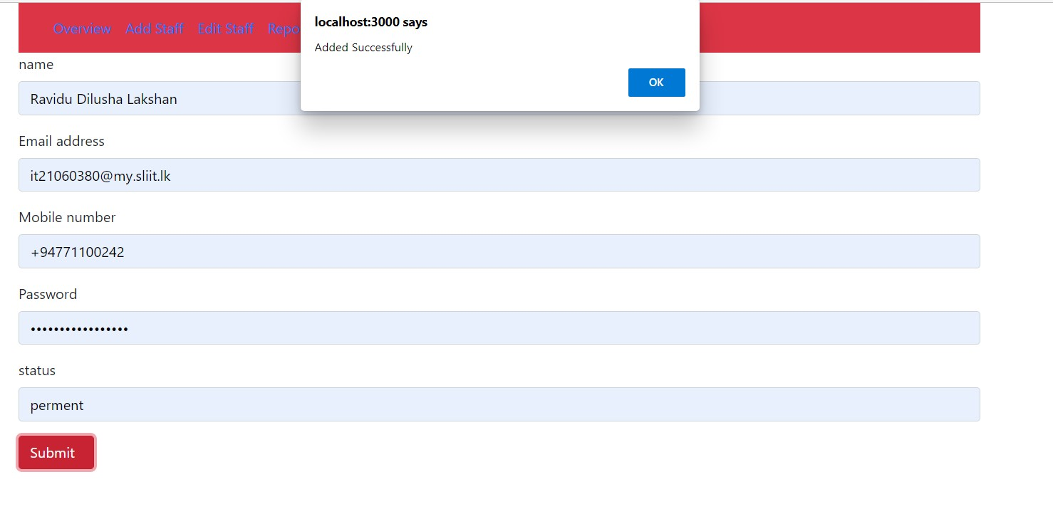

Figure -Staff Member Added Message

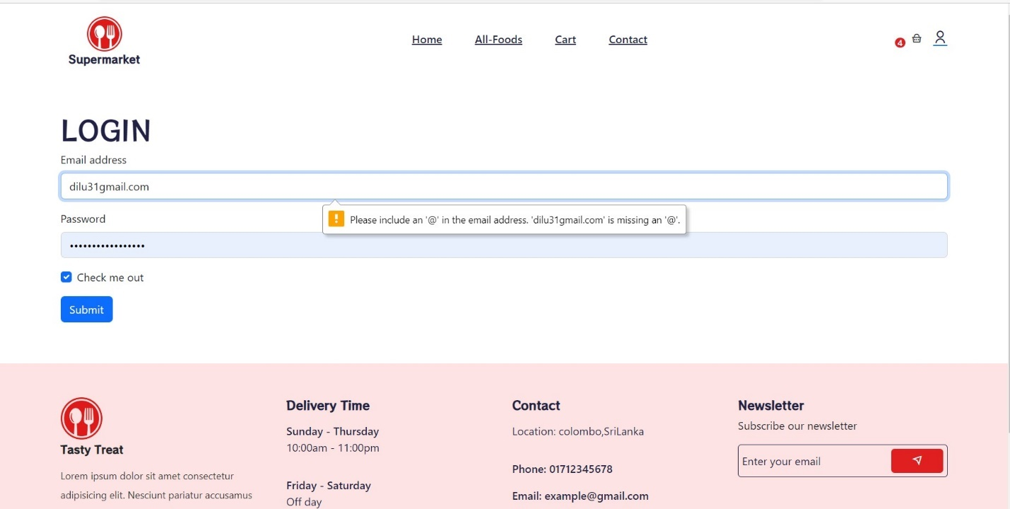

Figure -System Admin Login Authentication

Figure ‑-3.6.2

Figure ‑-3.6.2

Figure ‑-3.6.3Figure ‑-3.6.2

Figure ‑-3.6.2

# Chapter 5. Conclusion

The main objective of this proposed project is to design and implement a computerized and automated online system and web-based application for Supermarket. This full system will be designed for handling inventory and stock management, purchase and sales management, financial management, premises management, delivery management, marketing management, staff management and customer management. In Supermarket. Manual System is not suitable for a supermarket where several number of people interact daily with it. It is a huge task to manage and keep a track of large amount of sensitive data and generate valuable reports. To avoid that and make the process more efficient, productive and convenient for both parties, it is decided to design and implement Supermarket Management System.

The supermarket management system creates several reports that assist the personnel while also saving time. The project implementation was started keeping the system’s future scalability in mind. The project architecture and structure are clearly defined, making it easy to scale new features and add new components to expand the systems offerings.

Figure ‑-3.6.2

Figure ‑-3.6.3Figure ‑-3.6.2

Figure ‑-3.6.3

Figure ‑-3.6.4Figure ‑-3.6.3Figure ‑-3.6.2

Figure ‑-3.6.3Figure ‑-3.6.2

Figure ‑-3.6.3

Figure ‑-3.6.4Figure ‑-3.6.3

Figure ‑-3.6.4

Figure ‑-3.6.4Figure ‑-3.6.3

Figure ‑-3.6.4Figure ‑-3.6.3

Figure ‑-3.6.4

Figure ‑-3.6.4

Figure ‑-3.6.4

Figure ‑-3.6.4

# References

|  |  |
| --- | --- |
| [1] | [Online]. Available: https://app.croneri.co.uk/topics/stock-control-and-stores-management/indepth. |
| [2] | [Online]. Available: https://thegrocerystoreguy.com/how-do-grocery-stores-keep-track-of-inventory/. |
| [3] | [Online]. Available: https://www.tutorialspoint.com/management_concepts/staffing_management_plan.htm. |
| [4] | [Online]. Available: https://en.wikipedia.org/wiki/Staff_management#:~:text=Staff%20management%20is%20the%20management%20of%20subordinates%20in,well-being%20of%20the%20staff%20that%20report%20to%20them. |
| [5] | [Online]. Available: https://www.analyticssteps.com/blogs/marketing-strategies-used-supermarkets. |
| [6] | [Online]. Available: https://www.academia.edu/35185477/. |
| [7] | [Online]. Available: https://www.practicalecommerce.com/. |
| [8] | [Online]. Available: https://www.finance.ucla.edu/corporate-accounting/principles-of-financial-management. |
| [9] | [Online]. Available: https://app.croneri.co.uk/topics/premises-management/indepth. |
| [10] | [Online]. Available: https://www.xenongroup.co.uk/knowledge-centre/foundations-of-facilities-management/the-6-key-management-functions-of-facilities-management. |
| [11] | [Online]. Available: https://www.relexsolutions.com/resources/managing-grocery-retail-supply-chains/. |
| [12] | [Online]. Available: https://www.walmart.com/. |
| [13] | [Online]. Available: https://www.ikea.com/. |
| [14] | [Online]. Available: https://www.keellssuper.com/. |
| [15] | [Online]. Available: https://app.croneri.co.uk/topics/premises-management/indepth. |
| [16] | [Online]. |
| [17] | [Online]. Available: https://www.tutorialspoint.com/management_concepts/staffing_management_plan.htm. |
| [18] | [Online]. Available: https://www.analyticssteps.com/blogs/marketing-strategies-used-supermarkets. |